Question(s): | VQEG |  | Meeting, date: |  |  | Singapore, December 10-13
Study Group: |  | Working Party: |  | Intended type of document (R-C-TD): |  |  | C
Source: | KDDI R&D Laboratories, Inc., Japan
Title: | Comparison of subjective scores between the tests using consumer and professional grade 4K monitors
Contact: | Osamu Sugimoto  KDDI R&D Laboratories, Inc.  Japan |  |  |  | Tel: +81-49-278-7416  Fax: +81-49-278-7439  Email: sugimoto@kddilabs.jp
Please don’t change the structure of this table, just insert the necessary information.

Summary
In the previous meeting, KDDI proposed to include quality assessment of 4K video into the scope of future VQEG tests and VQEG decided that they would start a study of 4K in the HDTV phase2 project (see the notes of June 15, 2012). This contribution shows a result of our preliminary study regarding comparison of subjective scores between the tests using consumer and professional grade 4K monitors. KDDI hopes this will promote the study of 4K video quality assessment in VQEG.

Subjective test conditions
We chose Toshiba 55X3 and Astrodesign DM3410-A for consumer and professional grade monitors, respectively. Table 1 shows the specifications of two monitors.

Table 1 4K monitor specifications
 | Consumer | Professional
Model Num. | Toshiba 55X3 | Astrodesign DM3410-A
Panel Size | 55” | 56”
Panel Resolution | 3840x2160 | 3840x2160
Brightness | N/A | 450cd/m²
Contrast Ratio | 1:5000 | 1:1300

For the subjective test, 10 test sequences from KDDI’s own 4K test sequence pool were used. They have a format of QFHD(3840x2160)@30fps and were coded by HEVC and H.264. Table 2 shows the coding conditions for this experiment. Subjective scores were collected based on the DSCQS test with 24 viewers.

Table 2 Coding conditions
 | HEVC | H.264
Encoder Software | HM6.1 | JM15.1
Coding Bitrate | 4,8,16Mbps | 8,16Mbps
GOP Structure | IBBBBBBBBBBBBBB | IBBPBBPBBPBBPBB
Panel Resolution | 3840x2160 | 3840x2160
Brightness | N/A | 450cd/m²
Contrast Ratio | 1:5000 | 1:1300

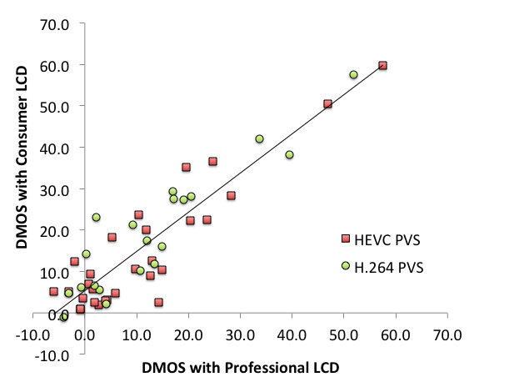
Figure 1 Comparison of subjective scores (Correl. Coef.=0.911)

Comparison of subjective scores
Figure 1 shows a relation between the DMOS scores obtained by the subjective tests using consumer and professional monitors. The DMOS with Consumer LCD has slightly worse DMOS values than those with professional LCD. However, they have a correlation coefficient of 0.911 and this indicates that consumer 4K LCD can be a substitution of the professional 4K LCD.

Conclusions
In this contribution, we compared the subjective scores under the tests using consumer and professional grade 4K monitors. The result shows difference between two display conditions is not so large, and thus we may use consumer grade monitors, which can be obtained at a reasonable price, as well as the professional monitors for quality assessment of 4K video.

