VQEG 3DTV Group
3D Video Format Evaluation
TEST PLAN
In collaboration with DVB

Draft Version 0.14
26 February, 2015

Contacts:
Marcus Barkowsky (Co-Chair) Tel: +33 2 40 68 30 22 Email: Marcus.Barkowsky@univ-nantes.fr
Patrick Le Callet (Co-Chair) Tel: +33 2 40 68 30 47 Email: Patrick.LeCallet@univ-nantes.fr
Quan Huynh-Thu (Co-Chair) Tel: Email: Quan.Huynh-Thu@cisra.canon.com.au
Margaret Pinson (Editor) Tel: +1 303 497 3579 Email: mpinson@its.bldrdoc.gov

Editorial History
Version | Date | Nature of the modification
0.1 | April 22, 2014 | Initial Draft, edited by M. Barkowsky (from Hybrid Testplan 2.11)
0.2 | July 04, 2014 | Updated Pair Comparison part, edited by Jing Li and Marcus Barkowsky
0.3 | July 10, 2014 | VQEG Meeting Stockholm (Co-Chairs)
0.4 | October 17, 2014 | Decisions made in biweekly conference calls and clean-up (Marcus Barkowsky, Jing Li)
0.5 | October 17, 2014 | Corrections done during the conference call (Marcus Barkowsky)
0.6 | October 29, 2014 | Description of DSIS and DSCQS methods (Naeem Ramzan)  Further description of the test setup and the data analysis (Marcus Barkowsky)
0.7 | October 31, 2014 | Further details on subjective experiment: Splitting of test sequences into different labs
0.8 | October 31, 2014 | Changes related to discussions during the conference call
0.9 | November 14, 2014 | Draft of explications of content of the final report
0.10 | November 24, 2014 | Including remarks of Alessandra Mosca, Added draft explanation of final report phrases
0.11 | November 24, 2014 | Grammatical edits by Margaret Pinson
0.12 | November 27, 2014 | Example voting sheet
0.13 | February 11, 2015 | After feedback from DVB, split into two parts: First analysis on significant difference between formats, second, if required, measure of amount of difference
0.14 | February 26, 2015 | VQEG meeting version Santa Clara

Contents
1. Introduction 6
2. Project Synopsis 7
2.1 Objectives and Application Areas 7
2.2 Subjective Assessment Methodologies 7
2.3 Acquiring Ground Truth Data 7
2.4 Objective Model Development 7
2.5 Relation to other Standardization Activities 7
3. List of Definitions 8
4. List of Acronyms 9
5. Overview: DVB, ILG, Tasks and Schedule 10
5.1 Division of Labor 10
5.1.1 Independent Laboratory Group (ILG) 10
5.1.2 DVB 10
5.1.3 VQEG 10
5.2 Overview 10
5.2.1 Testplan Design 11
5.3 Publication of Subjective Data, Objective Data, and Video Sequences 11
5.4 Test Schedule 11
5.5 Source Sequence Processing Overview and Restrictions 11
5.6 SRC Resolution, Frame Rate and Duration 12
5.7 Source Test Material Requirements: Quality, Camera, Use Restrictions. 12
5.8 Source Conversion 12
5.8.1 Software Tools 12
5.8.2 Colour Space Conversion 13
5.8.3 De-Interlacing 13
5.9 Video File Format: Uncompressed AVI in UYVY 13
5.10 Source Test Video Sequence Documentation 14
5.11 Test Materials and Selection Criteria 14
6. HRC Creation and Sequence Processing 16
6.1 Video Bit-Rates 16
6.2 Frame Rates 16
6.3 3D representations 16
6.4 Post-Processing 16
6.5 Coding Schemes 16
7. Experiment Design 17
7.1 Video Sequence and Bit-Stream Naming Convention 17
8. Subjective Evaluation Procedure 18
8.1 Paired comparison 18
8.1.1 Time sequential presentation 18
8.1.2 Time parallel presentation 18
8.2 DSIS – Double Stimulus impairment scale 18
8.3 DSCQS – Double Stimulus continuous quality scale 18
8.3.1 Viewing Distance, Number of Viewers per Monitor, and Viewer Position 18
8.4 Display Specification and Set-up 19
8.4.1 HD Monitor Requirements 19
8.4.2 Viewing Conditions 20
8.5 Subjective Test Video Playback 20
8.6 Evaluators (Viewers) 21
8.6.2 Randomization 22
8.6.3 Test Data Collection 23
8.7 Results Data Format 23
9. Statistical analysis 24
10. Recommendation 25
11. Bibliography 26
ANNEX I Instructions to the Evaluators 27
ANNEX IV Method for Post-Experiment Screening of Evaluators 30

Introduction

This document defines the procedure for evaluating the performance of several image representation formats in 3DTV broadcasting evaluated for the Digital Video Broadcasting (DVB) Consortium by the Video Quality Experts Group (VQEG) and linked to ITU-T Study Groups 9 and 12 and ITU-R Study Group 6. It is based on discussions from various meetings of the VQEG 3DTV working group (3DTV) recorded in the Editorial History section at the beginning of this document.

The principal goal of the VQEG 3DTV group is to evaluate perceived Quality of Experience in the context of 3D services. Evaluations start at the capturing of appropriate content, include the evaluation of encoding and transmission formats, up to the evaluation and development of perceptual quality models suitable for digital video quality measurement in video and multimedia services delivered over an IP network. The VQEG 3DTV group aims at measuring the perceived Quality of Experience including all sensations such as visual discomfort and depth sensation.

This particular testplan documents the setup of an evaluation performed in close collaboration with the Digital Video Broadcasting Consortium on several formats that allow inclusion of the two views of a stereoscopic video into a single Full-HDTV (1080p) frame. The goal is to measure the preference in terms of Quality of Experience.

A final report will be produced after the analysis of test results.

Project Synopsis
This chapter tries to summarize the key elements of the VQEG 3DTV Project. This summary is informational only and in all cases superseded by the detailed description provided in this test plan.

Objectives and Application Areas
The identification of the preference of 3D Full-HD frame compatible formats is the goal of this study. The study’s result will guide DVB in their decision on the future 3D transmission formats. The preference of Quality of Experience (QoE) for the end-consumer has been identified as the decision criterion. The study therefore targets typical future DVB transmission scenarios in terms of bitrate, content, viewing conditions, and so on.

Targeted results
The project aims to identify the preference in terms of QoE of the transmission of two times Full-HD and three frame compatible formats:
- Side-by-side format
- Top-bottom format
- Tile format also known as “Rectangular region frame packaging arrangement”
The preference shall be determined at equal bitrate for the three formats.
The following questions have been posed by DVB:
CR5 questions:
1) The best performing option from amongst the existing solutions
2) Those that offer significant improvements over existing solutions already adopted by the DVB

3) The size of the performance advantage, if any, between (1) and (2)
4) The performance improvement each offers

The first two questions need to be evaluated with a high confidence. The third and fourth depend on the outcome of the second question, i.e. no performance advantage can be evaluated if all formats perform statistically equivalent. The measurement scale for “performance advantage” is not yet fixed, an indication on approximate bitrate savings was discussed. An exact answer on equivalent quality in function of bitrate may however exceed the effort bounds for subjective assessments.
It was decided to potentially split the experiment in two parts, the second being optional.
In the first part, a subjective experiment using Paired Comparison will be conducted and the results will be statistically analyzed to answer the following primary questions:
- Is the Side-by-Side format preferred to top-bottom?
- Is the Side-by-Side format preferred to Tile format?
- Is the Top-bottom format preferred to Side-by-Side format?
- Is the Top-bottom format preferred to Tile format?
- Is the Tile format preferred to Side-by-Side?
- Is the Tile format preferred to Top-bottom?
The term “A is preferred to B” is used in this context as an abbreviation of “A is statistically significant different with 95% confidence and superior to B”.
The result of the primary analysis is binary by design.
In the second part, a secondary analysis may be performed to measure the distance between the stimuli. This provides information about the distance in terms of QoE between the different transmission formats as well as the distance between the selected bitrates when transmission in a specific format is chosen, thus relating the perceived quality of the 3D transmission format to the well-known coding quality differences. For this purpose the two views, i.e. view0 and view1 are also encoded independently such that the sum of the bitrates of view0 and view1 corresponds to the frame packing format, i.e. each Full-HD sized view is encoded at approximately half of the bitrate of the frame packing formats. This format is further referred to as “two times Full-HD”.
Part 1 would allow for evaluation of:
- Number of votes for preference of format A as compared to format B
- Cross-lab agreement analysis
Statistical analysis with Barnard test, for example:
If x observers preferred format A to format B in lab A, the number for lab B should be contained within the interval [x-m, x+n]
- DVB Question 1+2 « which format is preferred per content»
Statistical analysis with Barnard test only, for example:
if at least 33 observers out of 48 voted for format A, it is significantly different from 24/24 (50%)
Part 2 would allow in addition to part 1 to evaluate:
- Scale value analysis for the DVB Question 1+2 “which format is preferred per content”
Statistical analysis using the Bradley-Terry model
- Evaluation of the discrimination performance of the subjective experiment for DVB Question 1+2 with respect to discrimination performance between bitrates. This will provide additional context and potentially improved sensitivity of the statistical analysis.
Statistical analysis of significance, for example:
The three formats are not statistically different for bitrate 1, the difference between bitrate 1 and the 50% lower bitrate 2 is not statistically significant either.
Example for improved sensitivity:
Format A at bitrate 1 is statistically equivalent to format B at bitrate 2, however, Format A at bitrate 2 is statistically better than Format B at bitrate 1. Therefore, we may conclude that Format A is significantly better than Format B.
- Goodness of bitrate selection:
Statistical significant difference between bitrates, for example:
if at least 19 out of 24 observers voted for bitrate A, it is significantly different from 12/12 (50%)
- Comparison of the uncompressed reference in all three formats, notably to determine the visually lossless criterion for the highest bitrate and to facilitate observer rejection
- Goodness of data congruence:
Additional pairs are used to establish an uncertainty value
(e.g. Bradley-Terry goodness of fit analysis), basically:
If A>B and B>C, then A>C
- DVB Question 3+4 « how large is the difference? »
Conversion of votes to scale values (Bradley-Terry model), for example:
For content X, the difference between format A and B was d1 while the difference between bitrate E and F was d2
Please note that part 2 includes all pairs of part 1 as common set. Therefore, part 2 would include part 1. However, if part 1 is run separately, part 2 requires to re-evaluate the part 1 pairs.
VQEG recommends immediately moving forward with part 2 (which effectively includes part 1), because this allows more robust data analysis and also answers all four DVB questions with a reasonable effort.
Further analysis may be performed on the acquired data and included in the final report if all parties agree on the validity of the analysis. Such analysis may be labeled as supplementary.

Relation to other Standardization Activities
This project is linked to ITU standardization activities concerning the choice of the viewing environment (ITU P.3D-disp-req) and the choice of the subjective assessment method (ITU J.3D-SAM)

List of Definitions
Picture quality refers to the quality of 3D images in terms of degradations of the pictorial quality. In most cases, this may also be perceived even on the left and on the right view separately. Typical examples are: blockiness and blurriness.
Visual discomfort is a negative sensation of the observer. It should be seen as a perceived state of the observer, therefore requiring a questionnaire for evaluating its presence and strength. It may be hinted by several symptoms (reported by the observer) and clinical signs (measured objectively). Usually it is supposed to have a steep rise time and a steep fall time, it occurs when watching a particular 3D scene and disappears immediately after the viewing is finished, however, the recovery time may be long (e.g. some of the symptoms and clinical signs may be observed for a longer period).
Visual fatigue shall be defined in this context as a syndrome in the medical sense. Its presence is assessed by the observation of zero, one or several symptoms (reported by the observer) and zero, one or several clinical signs (measured objectively). Usually it is supposed to have a longer rise time and a longer fall time than visual discomfort, it is not instantaneously diagnosed in conjunction with a certain 3D stimulus and remains a certain time after the 3D viewing has finished.
Depth quantity is defined in this context as the amount of depth that the observer perceives in a 3D scene representation. This combines monocular and binocular cues and may therefore not necessarily be correlated to the amount of disparity in the 3D video.
Depth realism (Depth naturalness) is defined in this context as the experience of the reconstruction of the 3D depth that is present in the real 3D scene that has been captured by cameras in a 3D video.
Hypothetical Reference Circuit (HRC) is one test case (e.g., an encoder, transmission path with perhaps errors, and a decoder, all with fixed settings).
Intended frame rate is defined as the number of video frames per second physically stored for some representation of a video sequence. The intended frame rate may be constant or may change with time. Two examples of constant intended frame rates are a BetacamSP tape containing 25 fps and a VQEG FR-TV Phase I compliant 625-line YUV file containing 25 fps; these both have an absolute frame rate of 25 fps. One example of a variable absolute frame rate is a computer file containing only new frames; in this case the intended frame rate exactly matches the effective frame rate. The content of video frames is not considered when determining intended frame rate.
Frame rate is the number of (progressive) frames displayed per second (fps).
Live Network Conditions are defined as errors imposed upon the digital video bit stream as a result of live network conditions. Examples of error sources include packet loss due to heavy network traffic, increased delay due to transmission route changes, multi-path on a broadcast signal, and fingerprints on a DVD. Live network conditions tend to be unpredictable and unrepeatable.
Refresh rate is defined as the rate at which the computer monitor is updated.

List of Acronyms

ACR-HRR Absolute Category Rating with Hidden Reference Removal
ANOVA ANalysis Of VAriance
ARD Adaptive Rectangular Design
ASCII ANSI Standard Code for Information Interchange
BT Bradley-Terry model
CCIR Comite Consultatif International des Radiocommunications
CODEC COder-DECoder
CRC Communications Research Centre (Canada)
DVB Digital Video Broadcasting
DMOS Difference Mean Opinion Score
FR Full Reference
GOP Group Of Pictures
HRC Hypothetical Reference Circuit
HSDPA High-Speed Downlink Packet Access
ILG Independent Laboratory Group
ITU International Telecommunication Union
LSB Least Significant Bit
MM MultiMedia
MOS Mean Opinion Score
MOSp Mean Opinion Score, predicted
MPEG Moving Picture Experts Group
NR No (or Zero) Reference
NTSC National Television Standard Code (60 Hz TV)
ORD Optimized Rectangular Design
OSD Optimized Square Design
PAL Phase Alternating Line standard (50 Hz TV)
PC Pair Comparison
PLR Packet Loss Ratio
PVS Processed Video Sequence

VQR Video Quality Rating (as predicted by an objective model)
RR Reduced Reference
SMPTE Society of Motion Picture and Television Engineers
SRC Source Reference Channel or Circuit
VGA Video Graphics Array (640 x 480 pixels)
VQEG Video Quality Experts Group
WCDMA Wideband Code Division Multiple Access

Overview: DVB, ILG, Tasks and Schedule

Division of Labor
VQEG and DVB Consortium will provide the SRC sequences. DVB will provide the means to perform the required encoding and format conversions. The ILG will run the subjective experiment(s) and perform the statistical data analysis.
A graphical overview of the tasks is provided in the following diagram:
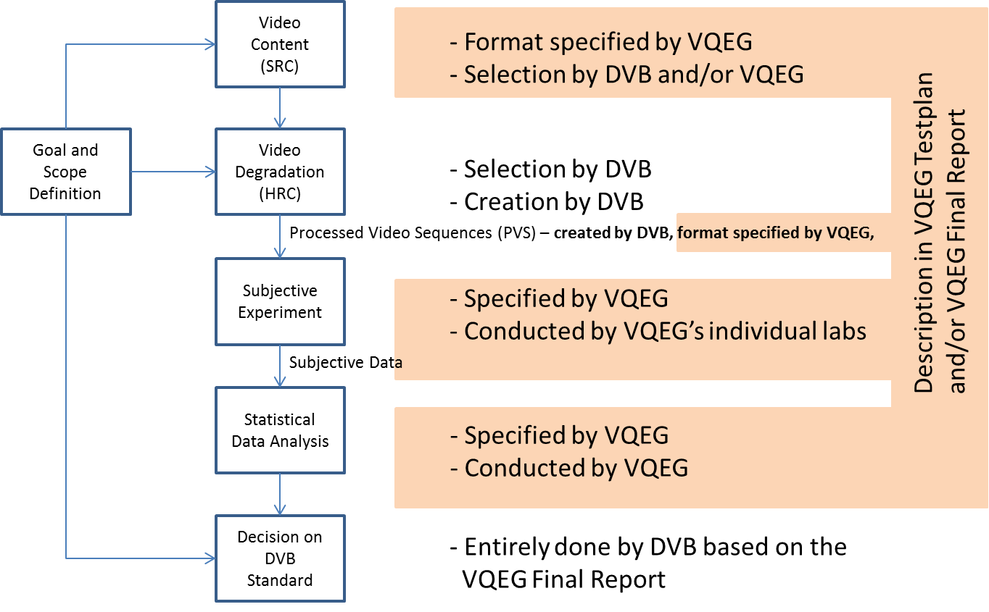

Independent Laboratory Group (ILG)
The independent laboratory group coordinating and performing the subjective experiments has been identified as:
- NTIA/ITS (USA)
- FUB (Italy)
- UWS (UK)
- IRCCyN (France)

The ILG are responsible for the following:
- Editing of the test plan and the final report
- Conducting subjective experiments using appropriate displays owned or rented for the subjective assessment on behalf of the ILG
- Data Analysis

DVB
DVB will
- provide SRC sequences
- Run the HRCs, e.g. convert the SRC to the 3D frame compatible format, encode the four versions of 3D transmission formats, decode, and rescale the frame compatible formats to two times Full-HD
- Potentially, DVB will also provide a playback solution.

VQEG
VQEG will
- Provide the Testplan for the subjective assessment
- Select the SRC sequences (potentially in collaboration with DVB)
- Convert the PVS provided by DVB into the format required for playback
- Perform the subjective experiment
- Perform the statistical data analysis
- Write a detailed final report on the experiment and the statistical analysis

Overview

Test plan Design
The test plan will contain the description of the SRC and the HRC, the planned viewing conditions and the subjective assessment methodology. The final data analysis will be described in detail.
Several different assessment methodologies may be proposed and the statistical analysis should take into consideration the analysis of the results for each of the methods as well as comparisons between the results obtained with different methodologies.

Publication of Subjective Data, Objective Data, and Video Sequences
The final report will be published after reaching consensus in VQEG.
All subjective data for all clips will appear in the Final Report, including the individual votes. This data may be used for further analysis by VQEG or by other parties provided that the source of the data is sufficiently identified and referenced.
Video data will be published provided that:
- Such publication is not disallowed by the source content NDA or copyright
- All participating labs that participated in the creation of a set of PVSs or performed the subjective tests on that set agree to publish the PVSs.
Video data may be released when the final report is published.

Test Schedule
3/10: SRC sequences are selected
17/10: Draft of Testplan, SRC sent to DVB
27/2: Approval of the test plan by VQEG
13/3: PVS sent from DVB to VQEG
20/3: Feedback from DVB: Testplan approval and fee approval
27/3: Subjective experiments
10/4: End of subjective experiments and draft of statistical analysis
24/4: End of statistical analysis and Draft Report, start of final report process jointly by DVB and VQEG
8/5: Approval of final report by VQEG and DVB
22/6: Date of publication of the final report as approved on 8/5 on VQEG’s website

Source Sequence Processing Overview and Restrictions
The source video should have no visible coding artifacts. The final decision whether a source video sequence is admissible will be made by ILGs.
1080p enlarged from 720p or 1080i enlarged from 1366x768 or similar are not valid. 1080p 24fps film footage can be converted and used. Otherwise, the frame rate of the unconverted source must be at least as high as the target SRC.
Uncompressed YUV420 files will be used for subjective and objective tests. The progressive test sequences used in the subjective tests should also be used by the models to produce objective scores. Note that the subjective playback system must introduce no additional visual impairments. It is important to minimize the processing of video source sequences. Hence, we will endeavor to find methods that minimize this processing (e.g., to perform de-interlacing and resizing in one step).

SRC Resolution, Frame Rate and Duration
Separate subjective tests will be performed for the following video sizes:
Resolution | Pixels | Scanning and Frame Rate | Name
HD | 1920x1080 | Progressive, 25fps | 1080p25fps

The length of the unprocessed source sequence is 14 seconds.

Source Test Material Requirements: Quality, Camera, Use Restrictions.
HD source test material should be taken from a professional grade HD camera (e.g., Sony HDR-FX1) or better.
The VQEG 3DTV project expresses a preference for all test material to be open source. At a minimum, source material must be available within the VQEG 3DTV project to ILG for testing (e.g., under non-disclosure agreement if necessary).

Source content may be obtained from content stored on tape or on hard drive, provided it meets the quality requirements outlined in this document.
Note: The source video will only be used in the testing if an expert in the field considers the quality to be good or excellent on an ACR-scale.

Source Conversion
This section describes approved methods for converting source video from one format to another used in this experiment. These tools are known to operate correctly.

Colour Space Conversion
In the absence of known color transformation matrices (e.g., such as what might be used by a video display adapter), the following algorithms will be used to transform between ITU-R Recommendation BT.709 Y'C_{B}'C_{R}' video and R'G'B' video that is in the range [0, 255]. The reference for these color transformation equations is pages 15-16 of ColorFAQ.pdf, which can be downloaded from:

http://www.poynton.com/PDFs/ColorFAQ.pdf

Video File Format: Uncompressed YUV in 420 color sampling
All source and processed video sequences will be stored in uncompressed YUV420 planar files without header information such as used by the Video Coding Experts Group as input to their reference encoder. Two separate files will be used: one for the left view and one for the right view.
The format stores the left top pixel of the Y plane first, followed by the second pixel of the first line of the Y plane, continuing in line-scanning order until arriving at the right bottom pixel of the Y plane. Next, the Cb plane of the Y, Cb, Cr color space is stored in the same format, following by the Cr plane. The two color difference components are subsampled by a factor of two with respect to the Y plane. The file continues with the second frame until all frames are stored.

Source Test Video Sequence Documentation
Preferably, each source video sequence should be documented. The exact process used to create each source video sequence should be documented, listing the following information:
- Camera specifications
- Source region of interest (if the default values were not used)
- Use restrictions (e.g., “open source”)
This documentation is desirable but not required.

Test Materials and Selection Criteria
The test material will be representative of a range of content and applications. The list below identifies the type of test material that forms the basis for selection of sequences.
The SRCs used in each experiment must cover a variety of content categories from this list. The following list of desirable content characteristics has been defined:
- Frequency distribution
  - Horizontal frequencies
  - Vertical frequencies
  - Diagonal frequencies, particularly moving frequencies
  - Natural details
- Motion
  - Translational movement
  - Rotational movement
  - Chaotic movement
  - Camera pan
  - Zoom out
  - Background movement with high frequency
- Depth
  - Pop-out effect
  - Low window violation
  - Varying depth distribution
  - Depth at image edges
  - Motion in depth
  - Depth range
  - Low disparity content
  - Solicitating crosstalk
- Luminance
  - High contrast
  - Low contrast
  - Bright sequence
  - Dark sequence
  - Luminance and contrast distribution at the edges
- Color
  - Colorful
  - Natural colors
- Content types
  - Computer graphics, animation (Cartoons, Overlays, Gaming, …)
  - Typical Broadcast content

HRC Creation and Sequence Processing
The creation process done by the HRCs leading to the PVS consists in the following steps:
- Conversion into 3D representation formats
- Encoding at a fixed bitrate
- Decoding
- Conversion into two times Full-HD format

Video Bit-Rates
1, 2, 3, 4, 6, 8, and 10 Mbit/s will be used. The ILG will choose three out of these seven bitrates for each content in order to have the largest spread of perceptual qualities tested by the observers. It is expected that slow moving sequences with little detail will require low bitrates (1, 2, 4 Mbit/s) while fast moving highly detailed content will require the selection of high bitrates (6, 8, 10 Mbit/s). This selection may be verified by DVB, notably to confirm the minimal requirements for broadcast quality.

Frame Rates
The frame rate will be fixed to 25 frames per second.

3D representations
Four formats have been identified:
- Two times Full-HD (Resolution Right view: 1920x1080, Resolution Left View: 1920x1080)
- Side-by-Side (Resolution Right view: 960x1080, Resolution Left View: 960x1080)
- Top-Bottom (Resolution Right view: 1920x540, Resolution Left View: 1920x540)
- “Tile Format”, (as specified in the AVC standard), or “Rectangular region frame packaging arrangement” (as now specified in the HEVC standard)
(Resolution Right view: 1280x720, Resolution Left View: 1280x720)

Post-Processing
All PVS will be stored in two YUV 420 files with a resolution of 1920x1080 per view.

Coding Schemes
Only the following coding scheme will be used:
- H.265 (HEVC) as specified and executed by DVB. A typical broadcast scenario with GOP length of 12 was configured and the reference software HM in Version x.y was used for encoding with the configuration file given in Annex Z

PVS Selection and verification procedure
The PVS will be visually inspected by the ILG for errors.
21 SRC were selected during the face to face meeting in Stockholm and afterwards. From these 21 SRC, the ILG will select 10 SRC. The ILG will also select for each of the 10 SRC three out of the seven bitrates such that each content is seen in as many perceptual quality levels as possible and typical for broadcast.

Experiment Design

The ILG will determine the test conditions and experiment design in close collaboration with the DVB consortium.

Display
The sequences will be presented on displays that allow for visualizing at least 1080p per eye. The following solutions have been agreed:
- 2160p polarized display
- 2160p active shutter glasses display
- 1080p active shutter glasses display
Solution 1 has been decided as mandatory. Solutions 2 and 3 are additional and optional.

Playback
The playback solution is split in two parts. Firstly, the PVS files (stored in two separate YUV420 1080p files) are converted to the native display resolution and format. Only reordering and upscaling, preferably with Lanczos-3 filtering, shall be performed in this step. Secondly, the created native resolution images are sent to the screen. No processing of the video data shall be performed in this step. The playback solution shall be tested for color calibrated output and continuous playback without frame dropping or frame repetition.
For the solution 1, the following steps will be taken:
- Input is two times Full-HD format in two separate YUV420 files
- Upscaling by Lanczos-3 filtering to two times 2160p
- Interleaving the left view and the right view line by line (i.e. first line left view, second line right view) without filtering leading to one interleaved 2160p sequence stored in RGB, YUV422 or YUV444 format (in order to avoid color subsampling artifacts in the views, YUV420 cannot be used)
- The image is sent in uncompressed format to the screen using HDMI, Display Port, or SDI

Video Sequence and Bit-Stream Naming Convention
The PVS (as seen by subjects) must be named according to the following naming convention:

srcXX_hrcYYY_s1920x1080p25n250v0.yuv
srcXX_hrcYYY_s1920x1080p25n250v1.yuv

Where XX indicates the source sequence number; YYY represents the PVS number. Please note that the filename contains the resolution, the framerate, the number of frames and the view number (0 for left, 1 for right view).
For example: “src05_hrc000_s1920x1080p25n250v0.yuv” contains the left view of the reference sequence as seen by the subjects after cutting the first and the last two seconds of SRC5.

Subjective Evaluation Procedure
Several subjective assessment methodologies are proposed and will be potentially conducted by the same or different labs.

Selection of subjective experiment procedure
In the following, the advantages and disadvantages of each method are discussed. The discussion will take into consideration notably the viewing situation (single stimulus, double stimulus) and the type of voting (absolute scale, relative scale, binary decision).
Please note the following definitions:
- Double Stimulus (DS) refers to a subjective test where the subject watches two or more stimuli and then answers one or more questions.
- Pair Comparison (PC) is a type of DS subjective test where the subject watches two stimuli and rates the difference between the two stimuli.

Pair comparison
Pair comparison, more precisely Forced Choice Pair Comparison, has the advantage that the users directly compare two scenarios which makes this method particularly suited for small differences between stimuli. As the users need to provide a binary choice, no notion of equal quality exists that is statistically difficult to handle as the perceived interval of equal quality is observer dependent. In general, it also enables comparisons on multiple perceptual scales, such as might be expected in 3D by image quality, visual comfort, and depth quality. In the context of VQEG’s Ground Truth Quality 3D1 (GroTruQ3D1) experiment, it has been judged that indicating their preference on first/second or left/right double stimulus presentation is the best choice for naïve observers. Pair Comparison could also avoid the influence from source content which may bias the observer's judgment. The drawback of Paired Comparison is that it requires a larger number of decisions from the observer. The usual PC method as defined in ITU-T P.910 requires that for N stimuli to test, there should be N(N-1)/2 pairs to be compared. When using the Optimized Rectangular Design or Adaptive Rectangular Design to run a reliable subset of all pairs, the time complexity has been reduced to N(√N). In general, it is considered that 40 observers are necessary for the experiment, however, 24 may be considered sufficient in particular cases. For this experiment with 12 HRCs and 10 SRCs, the number of pairs sums up to (3x4+6x3) HRC x 10 SRC = 300 pairs per observer. The analysis of the Forced Choice Pair Comparison binary data allows to distinguish between similar quality cases using Barnard’s exact test. The data can also be converted to scale values using models such as the Bradley Terry model leading to results comparable with absolute quality rating scales (see Section 9 for details).

Decision
The question as originally posed by DVB to VQEG is the following:
“Is there a significant difference in quality between the 3D presentation formats top-bottom, left-right and tiled.”
PC is the only subjective method that allows for a direct comparison between two different impaired versions of the same reference stimuli. Therefore, PC is the best choice to answer this question. All other subjective methods must infer the answer, and by so inferring either the accuracy of the significance tests will drop or more subjects are required.
The primary output of the PC test will be statements like the following:
· Formats A and B are statistically identical at this bitrate
· Format B produces significantly better quality than format B at this bitrate

Mean opinion score (MOS) can be inferred from PC ratings if the subjective test is designed with that goal in mind. By today’s agreement, MOS will be a secondary output of the PC test as designed by VQEG for DVB. Inferring MOS from PC requires some special calculations.
The primary limitations of these inferred MOS is that they are relative, not absolute. The same can be said of all MOS, so we do not consider this a strong reason for opposition. Also note that these MOS do not help answer the question posed by DVB to VQEG—these MOS are added value.
The negative consequence of producing MOS is that the test size increases. That is, if the requirement for MOS were dropped, then the size of the experiment would diminish. Since MOSs seem important to DVB, the subjective test size should be limited by other mechanisms. The way discussed and agreed upon during the audio call on 19th of September 2014 was to avoid a full matrix test design. This allows us to eliminate comparisons that are not interesting. For example, if a SRC appears identical at all bitrates, then there is no advantage to examining multiple bitrates for that SRC—one will suffice. Such decisions will be documented.
The part 1 PVSs and the primary analysis will be conducted on the minimum number of pairs required to determine the statistical difference between the three 3D formats under test at equal bitrate. Comparing each stimulus to each other’s stimulus, three unique pairs are required. Three bitrates will be chosen per 10 contents, leading to 90 pairs in total for subjective evaluation.
The part 2 will employ the ORD method leading to 300 pairs per observer. Preference may be given to those pairs which compare the different 3D representations directly at the same bitrate to enable higher distinguishability by Barnard’s Exact Test in the analysis. The common set evaluated by each participating laboratory will be chosen such that more observations will be available for those conditions.
The subjective assessment and the data analysis will be split between the 4 ILGs (NTIA, FuB, UWS, IRCCyN). Time sequential viewing with one repetition, i.e. viewing order ABAB, was chosen to allow for the observer to judge correctly even if the differences are small and in a spatially small region or temporally in a short period of the video sequence.

Paired comparison
The method of Pair Comparisons implies that the test sequences are presented in pairs, consisting of the same content (SRC) being presented first through one system under test and then through another system.
The systems under tests (HRC1, HRC2, HRC3, etc. here simplified as A, B, C, etc.) are generally combined in all the possible n(n–1)/2 combinations AB, AC, BC, etc. For the whole test, the presentation order of each pair should be balanced among all observers, i.e., the number of observations on AB should be equal to BA. After each pair a judgment is made on which element in a pair is preferred in the context of the test scenario.

Presentation pattern
The Paired Comparison setup should be performed either time parallel (using two screens side by side) or time sequential (using a single screen showing the two stimuli one after the other).

Time sequential presentation
Time-sequential presentation means the stimuli of one pair are presented one after another on a single screen. The time pattern for the time-sequential presentation can be illustrated by Figure 1. The voting time should be less than or equal to 10 seconds, depending upon the voting mechanism used. The presentation time should be about 10 seconds and it may be reduced or increased according to the content of the test material. Paired comparison may be performed without repetition if the stimuli are sufficiently short. A replay feature may be included in the experimental design, allowing the observer to repeat the presentation if required.

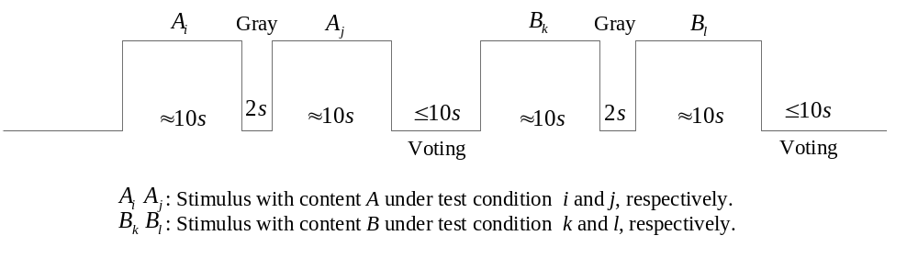
- Time pattern for time-sequential pair comparison presentation.

Voting results can be recorded by a paper sheet, a separate screen (e.g., a touchpad), or on the screen with a voting interface. Voting results MUST be recorded synchronously with all the information of the presented pair, e.g., the presentation order index of this pair, the SRC index, the index of the first HRC, the index of the second HRC, and the corresponding voting result. The method for recording the vote (paper sheet, on-screen or separate screen) should be documented.

Time parallel presentation
Time-parallel presentation means the stimuli of the pair are presented on two screens simultaneously; it is also called "simultaneous presentation" or "side by side presentation".

The advantages in using time-parallel presentation are:

- It reduces considerably the duration of the test.
- It is easier for the subjects to evaluate the differences between the stimuli.
- Since under the same test conditions the time of video presentation is halved, the attention of the subjects is usually higher when the time-parallel presentation is used.
The stimulus pair is displayed, for example side by side, on two screens as shown in Figure 1. In order to reduce eye movements required to switch the attention between the two screens, the distance between the two screen should be as close as possible. The two stimuli must be perfectly synchronized; that means that they both must start and stop at the same frame and that the displaying must be synchronized. The displays also need to be calibrated to provide the same color and luminance reproduction.
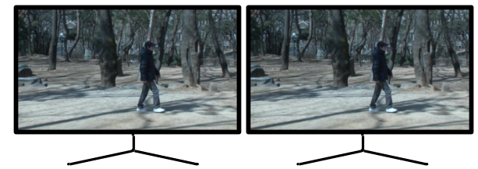
- Example of the position of the two screens in time-parallel presentation

The time pattern for the time-parallel presentation can be illustrated by Figure 3. The voting time should be less than or equal to 10 seconds, depending upon the voting mechanism used. The presentation time should be about 10 seconds and it may be reduced or increased according to the content of the test material.
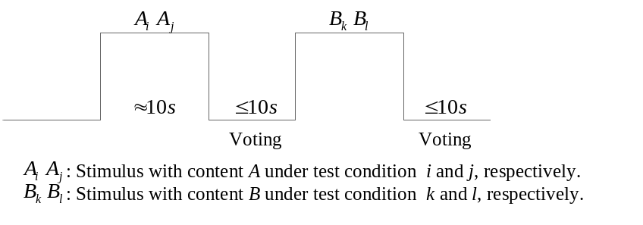
- Time pattern for time-parallel pair comparison presentation.

Voting results can be recorded by a paper sheet, a separate screen (e.g., a touchpad), or on the screen with a voting interface. Voting results MUST be recorded synchronously with all the information of the presented pair, e.g., the presentation order index of this pair, the SRC index, the index of the first HRC, the index of the second HRC, and the corresponding voting result. The method for recording the vote (paper sheet, on-screen or separate screen) should be documented.

Optimization of pair selection
A severe drawback of paired comparison method is that with the increase of the number of stimuli, the number of comparisons increases exponentially and for the cases of large number of stimuli, the test becomes infeasible. To resolve this problem, some designs are proposed which are used to reduce the number of comparisons but maintain the accuracy of the test results.

Optimized Rectangular Design

Optimized Rectangular Design (ORD) is proposed for the condition that the ranking of the stimuli in the test with respect to the question asked to the observers can be estimated based on pre-test results or prior knowledge. Supposing the number of the stimuli  is a divisible number, i.e., 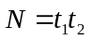, where and are integers. 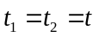is a special case for Rectangular Design and can be called Square Design with abbreviation of OSD (Optimized Square Design).

Supposing the ordering indices of the stimuli (descending or ascending) is 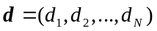. The rectangular matrix is arranged in such a way that the elements of the vector are placed along a spiral as shown in Figure 4, which is defined as matrix .

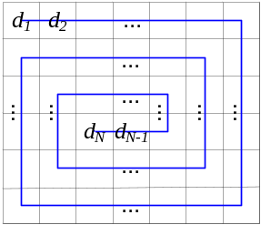
- . The design of the rectangular matrix

The stimulus pair 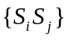is compared if and only if 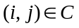, where 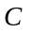is defined as:
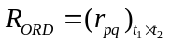, 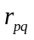is the index of the Stimulus in position 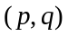. In this design, the matrix is fixed for all observers, i.e., the pairs compared for each observer are the same.

For better understanding, an example is given here. Supposing there are 12 test stimuli. Based on the prior-knowledge, the rank ordering of these stimuli can be estimated, which is = (2, 5, 6, 1, 8, 9, 3, 10, 4, 11, 7, 12). The thus can be designed as follows:
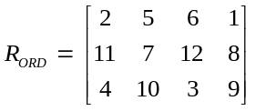
In this way, the adjacent stimulus indices 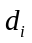and 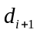are always arranged in the same column or row of the matrix.In this example, = {(2,5), (2,6),(2,1), (5,6), (5,1),(6,1), (11,7), (11,12), ...(2,11), (2,4), (11,4), (5, 7), …}. In the test, each participant compares the stimulus pairs whose indices belong to the set , i.e., stimuli 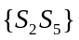, 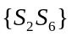, etc. The number of appearances for each stimulus is five for each participant.

Adaptive Rectangular Design
Adaptive Rectangular Design (ARD) is proposed in the way that the matrix is updated for each observer. ASD (Adaptive Square Design) is a special case for ARD, where is a squared matrix. This adaptive design is used for the conditions that previous estimates are not available. The detailed steps of this design are shown as follows:

- For the 1st observer, the indices of the stimuli are randomly placed in . The pair comparison experiment is executed, as specified for ORD, only the pairs whose indices are in the same column or row of are compared.

- According to all obtained k-1 (k ≥2) observations on the pairs, the paired comparison data can be converted to scale values by utilizing the Bradley-Terry model or Thurstone-Mosteller model. The rank ordering indices of the stimuli(descending or ascending) 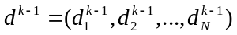can be obtained (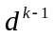represents the vector of ordering indices after k-1 times of observations).

- For the k^{th} observer (k ≥2), based on the ordering vector , the matrix and 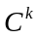are constructed as shown in Fig 6.3.2.1, ( and represents and for the k^{th} observer). The pair comparison experiment is executed, as specified for ORD, only the pairs whose indices are in the setare compared.

- Repeat from step 2, until termination conditions are satisfied (e.g., all observers finished the test or the targeted accuracy based on confidence intervals is obtained).
The following shows an example with 12 stimuli as presented beforehand. As there is no pre-test for the test stimuli, for the first observer, the indices of the stimuli are randomly arranged in the matrix as follows:

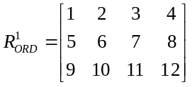
Thus, for the first observer, there are in total 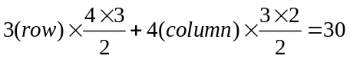 pairs to compare, i.e., {S₁S₂}, {S₁S₃},{S₁S₄},{S₂S₃}, ..., {S₁₁S₁₂}. After the first observer's test, the rank ordering of the quality of the stimuli is estimated as:
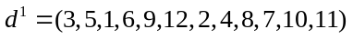.
For the second observer, the matrix is arranged according to this rank ordering in the before-mentioned spiral, thus:
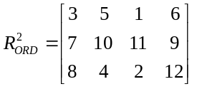
Then, for the third observer, the matrix 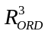is updated based on all previous 2 observers' pair comparison results. This procedure of executing the subjective assessment, calculating the ranking and rearranging the data into the matrix continues until the test is finished.

With a small number of observers (e.g., 20), ARD method would be more accurate and more robust than the ORD method. However, with the increase of the number of observers, i.e., when the number reaches 40, the performance of ARD and ORD are comparable without significant difference.

DSIS – Double Stimulus impairment scale
According to the DSIS methodology, pairs of sequence, i.e. stimuli X and Y, are sequentially presented to the subject as shown in Figure 1 (a). He/she is asked to rate the quality of second stimulus. The subject is told about the presence of reference video having the best expected quality, as stimulus X and he/she is asked to rate the level of annoyance of the visual impairments that he/she observes in stimulus B. The most common rating scale is shown in Figure 1 (b).

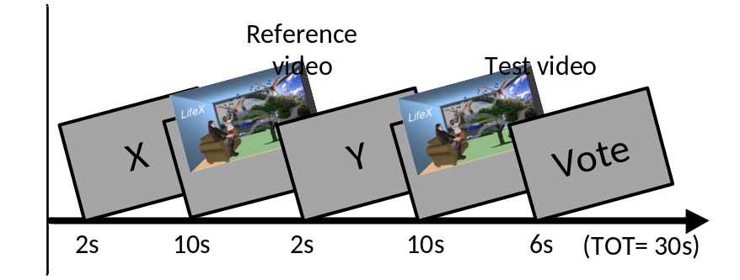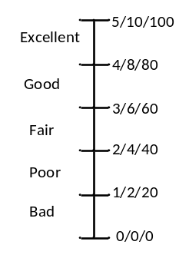
- Presentation (b) Scale
Figure 1: Double Stimulus Impairment Scale (DSIS) Method

DSCQS – Double Stimulus continuous quality scale
In the DSCQS methods, pairs of sequences, i.e. stimuli X and Y are presented twice sequentially to the observer as shown in Figure 2 and then he/she is asked to rate the quality of both stimuli. The stimulus X is always the reference video but the subject is not told about it. The similar rating scale as shown in Figure 1 (b) is used for DSCQS.
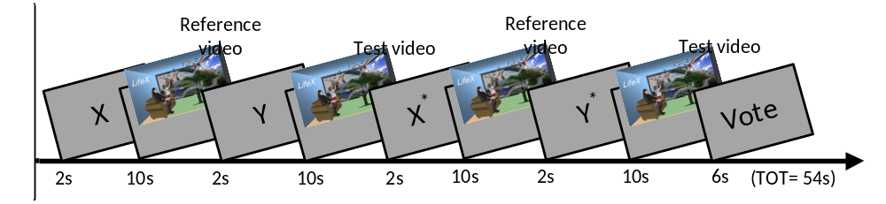
Figure 2: Double Stimulus Continous Quality Scale (DSCQS) Method

Viewing Distance, Number of Viewers per Monitor, and Viewer Position
The test instructions request evaluators to maintain a specified viewing distance from the display device. The viewing distance is as follows:
- 3H
H = Picture Heights (picture is defined as the size of the video window)
Three parallel observers are allowed in front of the screen, provided that the viewing distance is respected for each viewer.
It is recommended that viewers be seated facing the center of the video display at the specified viewing distance. That means that viewer's eyes are positioned opposite to the video display's center (i.e. if possible, centered both vertically and horizontally). If two or three viewers are run simultaneously using a single display, then viewers should be centered evenly in front of the monitor. The viewer’s eyes shall be centered vertically, i.e. by using height-adjustable chairs in order to avoid crosstalk on the 3D polarized screen resulting from suboptimal viewing position.
The viewing distance of 3H assures a worst-case visualization situation in the sense that a viewer with normal (or corrected to normal) visual acuity is at the limit of distinguishing two subsequent lines of the displayed video. Seating the observer further from the screen reduces his capability of seeing differences in the displayed signal while approaching the screen would lead to the perception of the pixel grid on the screen.
It should be noted that 3H corresponds to the distance required for Full-HD displaying, that is: When displaying 1080 lines, each line covers approximately 1arcmin for an observer situated at three times the display height. In this subjective experiment, an UHD screen is used but the content that is shown only has Full-HD resolution. Using polarized 3D displays also implies that only half of the lines is perceived by each eye, reducing the vertical resolution by a factor of two, i.e. to 1080 lines. Horizontally 3940 pixels are displayed but they have been generated from a video sequence containing only 1920 pixels horizontally by appropriate upscaling methods.

Display Specification and Set-up
Note that in all subjective tests 1 pixel of video will be displayed as 1 pixel native display. No upsampling or downsampling of the video is allowed at the player.
Labs must post to the reflector what monitor they plan to use.

UHD Monitor Requirements
All subjective experiments will use LCD monitors. Only high-end consumer TV should be used: UHD polarized for the mandatory experiment or Full HD for the optional analysis. LCD PC monitors may be used, provided that the monitor meets the other specifications (below) and is color calibrated for video.
Given that the subjective tests will use different (U)HD display technologies, it is necessary to ensure that each test laboratory selects an appropriate display and common set-up techniques are employed. Due to the fact that most consumer grade displays employ some kind of display processing that will be difficult to account for in the models, all subjective facilities doing testing shall use a full resolution display.
All labs that will run viewers must post to the 3DTV reflector information about the model to be used. If a proponent or ILG has serious technical objections to the monitor, the proponent or ILG should post the objection with detailed explanation within one week. The decision to use the monitor will be decided by a majority vote among ILGs.
The smallest monitor that can be used is a 40” LCD.
A valid UHDTV monitor should support the full-UHD resolution (3840 by 2160). In other words, when the UHDTV monitor is used as a PC monitor, its native resolution should be 3840 by 2160.
All local image post processing features or parameters of the TV set (e.g. noise reduction, dynamic contrast engine etc.) must be disabled or set to "0". Resizing is not allowed, i.e. each pixel sent from the graphics card must be reproduced on one physical pixel on the display (1:1 reproduction).

Viewing Conditions
Viewing conditions should generally follow those described in International Telecommunications Union Recommendation ITU-T Recommendation P.910, 1999. Particular viewing conditions are as follows:
- It is recommended to position the display at sufficient distance to the wall to avoid that the displayed content interferes with the real-world environment. The rendered depth position of objects with a given pixel disparity can be seen in Figure x. The chosen content is expected to be in the range of up to 40 pixel uncrossed disparity, i.e. for a 65inch display, the optimal distance to the wall would be larger than 1.2m.
- The room lighting shall be chosen by the experimenter such that reflections on the screen are minimized. Immersion in the 3D content shall be facilitated. If possible, the illumination behind the screen shall correspond to 15% of the maximum screen brightness when seen through the glasses in order to allow for optimal adaptation of the pupil size
- A maximum of three observers per session may be allowed provided that the seating position (height) of each observer is adapted individually to allow for optimal 3D viewing with minimum crosstalk

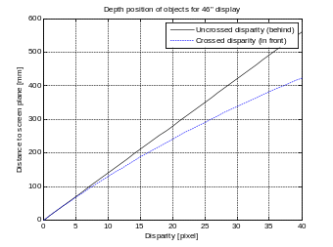 | 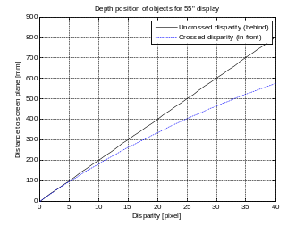 | 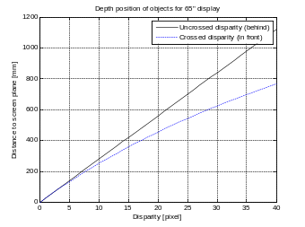
Object position for 46” | Object position for 55” | Object position for 65”
Figure 1: Depth position of objects in function of pixel disparity and display diagonal

Subjective Test Video Playback
All subjective tests will where possible be run using the same software package, provided by IRCCyN. The software package will include the following components:
- Test screens (prompts to users, grey panel, ACR scale, response input, data capture, data storage)
- Timing control
- Correct video play-out check
- Video player
The observer will be informed about the stimulus either by a screen inserted before each presentation (i.e. "Video A") or by an audio track ("You are now watching video A") or by a second side screen or similar. The voting takes place after the last presentation. The observer is allowed to vote during the repetition.
No additional visual impairments must be introduced by the subjective playback system. The minimum requirements to run this experiment are:
- PC architecture running Windows7, 64bit
- 16Gbyte RAM
- Storage system allowing for 600Mbyte/s sustained data transfer (e.g. 3 SSD as Raid0) with 500Gbyte of disk space per session (max. 25 minutes)
The experiment may either be performed as automatic playback with the voting taking place asynchronously to the playback, for example on paper sheets or using an interactive voting interface.

Evaluators (Viewers)
Exactly 24 viewers per experiment will be used for data analysis.
Different subjective experiments will be conducted by several test laboratories. A valid viewer means a viewer whose ratings are accepted after post-experiment results screening. Post-experiment results screening is necessary to discard viewers who are suspected to have voted randomly. The rejection criteria verify the level of consistency of the scores of one viewer according to the mean score of all observers over the entire experiment. The method for post-experiment results screening is described in Annex IV. Only scores from valid viewers will be reported in the results spreadsheets.
It is preferred that each viewer be given a different randomized order of video sequences where possible. Otherwise, the viewers will be assigned to sub-groups, which will see the test sessions in different randomized orders. A maximum of 6 viewers may be presented with the same ordering of test sequences per subjective test.
Only non-expert viewers will participate. The term non-expert is used in the sense that the viewers’ work does not involve video picture quality and they are not experienced assessors. They must not have participated in a subjective quality test over a period of six months.
Prior to a session, the observers should usually be screened for normal visual acuity or corrected-to-normal acuity, for normal color vision, and for 3D acuity. Acuity will be checked according to the method specified in ITU-T P.910 or ITU-R Rec. 500, which is as follows. Concerning acuity, no errors on the 20/30 line of a standard eye chart should be made. The chart should be scaled for the test viewing distance and the acuity test performed at the same location where the video images will be viewed (i.e. lean the eye chart up against the monitor) and have the evaluators seated. Ishihara or Pseudo Isochromatic plates may be used for colour screening. When using either colour test please refer to usage guidelines when determining whether evaluators have passed (e.g. standard definition of normal colour vision in the Ishihara test is considered to be 17 plates correct out of a 38 plate test; ITU-T Rec. P.910 states that no more than 2 plates may be failed in a 12 plate test. The 3D acuity shall be evaluated by the Randot Stereo Test or equivalent. All results shall be reported alongside with the given votes. Evaluators should also have sufficient familiarity with the language to comprehend instructions and to provide valid responses using the semantic judgment terms expressed in that language.

Instructions for Evaluators and Selection of Valid Evaluators

For many labs, obtaining a reasonably representative sample of evaluators is difficult. Therefore, obtaining and retaining a valid data set from each evaluator is important. The following procedures are highly recommended to ensure valid subjective data:
- Write out a set of instructions that the experimenter will read to each test viewer. The instructions should clearly explain why the test is being run, what the evaluator will see, and what the evaluator should do. Pre-test the instructions with non-experts to make sure they are clear; revise as necessary.
- Explain that it is important for evaluators to pay attention to the video on each trial.
- There are no “correct” ratings. The instructions should not suggest that there is a correct rating or provide any feedback as to the “correctness” of any response. The instructions should emphasize that the test is being conducted to learn viewers’ judgments of the quality of the samples, and that it is the viewer’s opinion that determines the appropriate rating.
If it is suspected that an evaluator is not responding to the video stimuli or is responding in a manner contrary to the instructions, their data may be discarded and a replacement evaluator can be tested. The experimenter will report the number of evaluators’ datasets discarded and the criteria for doing so. Example criteria for discarding subjective data sets are:
- The same rating is used for all or most of the PVSs.
- The evaluator’s ratings correlate poorly with the average ratings from the other evaluators (see Annex IV).

Randomization
It is preferred that each evaluator be given a different randomized order of video sequences where possible. If this is not possible, the viewers will be assigned to sub-groups, which will see the test sessions in different randomized orders. A maximum of 6 evaluators may be presented with the same ordering of test sequences per subjective test.

For each subjective test, a randomization process will be used to generate orders of presentation (playlists) of video sequences. Playlists can be pre-generated offline (e.g. using separate piece of code or software) or generated by the subjective test software itself. In generating random presentation order playlists the same scene content may not be presented in two successive trials.

Randomization refers to a random permutation of the set of PVSs used in that test. Shifting is not permitted, e.g.
Subject1 = [PVS4 PVS2 PVS1 PVS3]
Subject2 = [PVS2 PVS1 PVS3 PVS4]
Subject3 = [PVS1 PVS3 PVS4 PVS2]
…

If a random number generator is used (as stated in section 4.1.1), it is necessary to use a different starting seed for different tests.

Example script in Matlab that generates playlists (i.e. randomized orders of presentation) is given below:

rand('state',sum(100*clock)); % generates a random starting seed
Npvs=200; % number of PVSs in the test
Nsubj=24; % number of evaluators in the test
playlists=zeros(Npvs,Nsubj);
for i=1:Nsubj
playlists(:,i)=randperm(Npvs);
end

Test Data Collection
The responsibility for the collection and organization of the data files containing the votes will be with the ILG. The collection of data will be supervised by the ILG and distributed to test participants for verification.

Common set and splitting into sessions
For part one, the same video sequences would be used by all test labs.
For part 2, the total number of unique pairs in the subjective experiment is 300 pairs. As several subjective assessment labs participate in the evaluation, the pairs are going to be divided into the different test labs.
A common set is being created. The common set is defined as a set of video sequence pairs that are evaluated by more than one lab. Four ILG are participating in the experiment. The test sequences have been divided for evaluation by each ILG as follows:
- The 300 pairs are divided into two sets, one which contains the pairs of the primary analysis (90 pairs in which the 3D representation formats are compared at the same bitrate) and the remaining 210 pairs that allow for comparison of the distance between 3D format representations with respect to low bitrate coding induced degradations
- Each lab evaluates 97 or 98 pairs as follows:
  - The primary analysis pairs are evaluated by two labs each, i.e. 45 sequences per lab. These sequences form a common set that is shared between two labs each (i.e. labA evaluates 23 sequences in common with labB and 22 sequences in common with labC etc.).
  - The secondary analysis pairs are split equally amongst the test labs, i.e. 210/4=52.5 pairs (labA and labB evaluate 52 pairs, labC and labD evaluate 53 pairs)
Please note: The common set has been chosen such that the results benefit the primary analysis results, i.e. the pairs in which the 3D representation formats are compared at the same bitrate are evaluated twice as often.

Number of sessions
Each test lab is going to run the sequences in several sessions in order to avoid fatigue of the observers. As the sequence length is 10 seconds, evaluating one pair in ABAB order is supposed to take 4*10seconds + 4*0.5seconds for intermediate screens plus 4.5 seconds for voting + 0.5 seconds for gray screen = 47seconds.
In part 1, it is proposed to evaluate the 90 pairs in 4 sessions with 47*90/4 = approx. 18 minutes per session followed by a break of at least 5 minutes. As the pairs are expected to be very similar in quality, shorter session time may be preferred and longer breaks may be beneficial. The experimenter will assure that the subjects stay concentrated and do not experience fatigue including 3D visual fatigue.
In part 2, a similar procedure is proposed to evaluate the 97 or 98 pairs in 4 sessions with 47*98/4 = approx. 20 minutes per session followed by a break of at least 5 minutes.

Results Data Format
In order to simplify the processing, the following data formats are specified for reporting by each lab.

ACR test results
The following format is designed to facilitate data analysis of the subjective data results file.

The subjective data will be stored in a Microsoft Excel 97-2003 (i.e., *.xls) spreadsheet. Each spreadsheet will contain all of the data for one experiment. The top row of this file will be a header. Each row below the header will contain one video sequence. The columns are as follows, in this order: experiment number, SRC number, HRC number, file name, subject #1’s ACR score, subject #2’s ACR score, … subject #24’s ACR score.

Missing ACR values will be left blank.

Figure 10.3 contains an example, showing 12 of the 24 subjects’ scores, and only six PVS.

Experiment | SRC Num | HRC Num | File | SUBJECT'S RESULTS
1 | 1 | 1 | hybrid1_s01_hrc01.avi | 2 | 3 | 1 | 2 | 2 | 1 | 3 | 1 | 3 | 2 | 2 | 3
1 | 1 | 2 | hybrid1_s01_hrc02.avi | 2 | 2 | 1 | 2 | 1 | 2 | 3 | 2 | 3 | 3 | 1 | 2
1 | 1 | 3 | hybrid1_s01_hrc03.avi | 1 | 1 | 1 | 1 | 1 | 2 | 2 | 1 | 3 | 1 | 1 | 1
1 | 1 | 4 | hybrid1_s01_hrc04.avi | 1 | 1 | 1 | 1 | 1 | 1 | 3 | 1 | 1 | 1 | 1 | 1
1 | 1 | 5 | hybrid1_s01_hrc05.avi | 2 | 2 | 2 | 2 | 2 | 1 | 3 | 2 | 3 | 2 | 1 | 1
Figure 10.3. Format for subjective data spreadsheet.

Pair comparison test results

For paired comparison test, the following information should be contained for EACH observer:
- Presentation order index
- Source ID Number
- HRC ID Number left (or first)
- HRC ID Number right (or second)
- Video File name (with version control)
- Observer's voting time
- Observer's voting result

- Presentation order index records the order of the pairs that observer watches.
- Source ID Number records the source content that the observer watches.
- HRC ID Number left specifies which HRC is displayed on the left screen (or displayed first in time-sequential method). Similar for HRC ID Number right. These information are used for analysis later.
Video file name specifies the video pair names, with the current HRC version ( in case further revision is made).
- Voting time is the time that observer has used for comparing this pair.
- Observer's voting result is binary, either L(for HRC-left) or R(for HRC-right).
An example of this table is shown as follows:

Observer 1 's results:

Order | SRC | HRC- left | HRC- right | Video file name | Voting duration (s) | Voting result
1 | 1 | 0 | 2 | src1_hrc0_v01.avi src1_hrc2_v01.avi | 4.1 | L
2 | 3 | 1 | 4 | Src3_hrc1_v01.avi src3_hrc4_v01.avi | 2.2 | L
3 | 7 | 2 | 3 | Src7_hrc2_v01.avi src7_hrc3_v01.avi | 3.4 | L
4 | 4 | 2 | 4 | Src4_hrc2_v01.avi src4_hrc4_v01.avi | 5.6 | R
5 | 6 | 3 | 5 | Src6_hrc3_v01.avi src6_hrc5_v01.avi | 3.1 | R
6 | 8 | 5 | 9 | Src8_hrc5_v01.avi src8_hrc9_v01.avi | 4.8 | L
...

Data analysis

Barnard’s Exact Test
This analysis can be performed on the data obtained in part 1 and in part 2.
It is important to distinguish two proportional values statistically. Conditional and unconditional tests are frequently used methods in this scenario and they are usually applied on the food taste related area. A contingency table as shown in Table 1 is used here to help illustrate the objectives of this section. Supposing in a paired comparison test for the pair AB in observer Group 1, m₁ out of N₁ participants prefer A over B while in Group 2 this ratio is m₂/N₂. m1 and m2 are two independent binomial variables.
To measure if m₁/N₁ is significantly different from m₂/N₂, the Barnard's exact test is applied which provides an exact p-value. If the p-value is less than 0.05, we may consider that the two ratios are significantly different at a significance level of 0.05.
- An example of 2 × 2 contingency table.
For pair AB | Group 1 | Group 2 | Total
Choose A | m₁ | m₂ | m = m₁ + m₂
Choose B | N₁- m₁ | N₂- m₂ | N-m
Total number | N₁ | N₂ | N
In this VQEG testplan, Barnard’s exact test is notably applied to distinguish whether the measured vote distribution for a particular pair is different from 50% with statistical significance. Notably, the 3D format representations will be directly compared by observers for each bitrate and Barnard’s test will show for which condition (two 3D formats at one bitrate for one content), the difference is significant on a 95% confidence interval. The percentage of content that leads to statistical difference at a specific bitrate and for all bitrates summarized will also be reported. The percentage of conditions in which one format is statistically significantly superior to another format may then be used by DVB to draw conclusions.

Bradley-Terry model for Pair Comparison data
This analysis can only be performed on the data obtained in part 2.
The outcome of a paired comparison test is a pair comparison matrix A, where A = (a_{ij})_{m×m}. a_{ij} is the total count of preference of stimulus i over j for all observers. a_{ii} = 0 for i = 1,2,...,m. If there is no comparison for stimulus i and j, then a_{ij} = 0. The total number of comparisons for stimulus pair i and j is n_{ij} = a_{ij}+a_{ji}.
For example, the obtained pair comparison results for one particular SRC (e.g., SRC1) can be arranged into a matrix A as shown in Table 2. For each pair, the total number of comparison is 20, or there are in total 20 observations for each pair in the test. For the pair HRC1 vs HRC2, 9 observers chose HRC1 and 11 observers chose HRC2. Similar for HRC1 vs HRC7, 13 observers chose HRC1 while 7 observers chose HRC7.

- An example of the matrix A for paired comparison results.
HRC | 1 | 2 | 3 | 4 | 5 | 6 | 7 | 8 | 9
1 | 0 | 9 | 9 | 10 | 10 | 10 | 13 | 9 | 13
2 | 11 | 0 | 10 | 11 | 11 | 11 | 14 | 10 | 14
3 | 11 | 10 | 0 | 11 | 11 | 11 | 14 | 10 | 14
4 | 10 | 9 | 9 | 0 | 10 | 10 | 13 | 9 | 13
5 | 10 | 9 | 9 | 10 | 0 | 10 | 13 | 9 | 13
6 | 10 | 9 | 9 | 10 | 10 | 0 | 13 | 10 | 13
7 | 7 | 6 | 6 | 7 | 7 | 7 | 0 | 6 | 10
8 | 11 | 10 | 10 | 11 | 11 | 10 | 14 | 0 | 14
9 | 7 | 6 | 6 | 7 | 7 | 7 | 10 | 6 | 0

Pair comparison models are mathematical tools to convert the pair comparison data to scale values for all stimuli. Meanwhile, the corresponding confidence intervals, goodness of model fit and some statistical hypothesis tests are also provided. Bradley-Terry (BT) model and Thurstone-Mosteller (TM) model are two well-known models for this purpose. In this test, we suggest use Bradley-Terry model due to its well development on statistics.

The BT model is defined as follows:

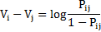
represents the probability that HRC i is preferred to HRC j. can be estimated by , where when is large enough. The outputs are the differences of the BT scale values between stimuli HRC i and HRC j, i.e.,. By utilizing the least squares estimation or the maximum likelihood estimation, the scale value for each HRC i, i=1,...,m can be estimated. The corresponding BT score for Table 2 is shown in Figure 5.
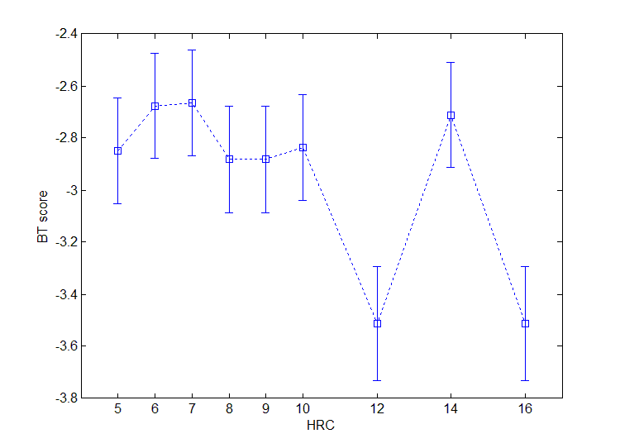
- The BT scores and confidence intervals of the pair comparison results shown in Table 2.

Please note that the scale value is a relative value which can be added with an offset, but cannot be re-scaled by a factor. Higher BT value represents higher preference.
The confidence intervals provided by Bradley-Terry’s data analysis indicate the extent of correctness of model fit. It is thus a measure indicating the plausibility of the obtained results.
In this testplan, the Bradley-Terry scores will be used to determine the relative distance between the 3D formats with respect to the choice of bitrate. As each tested video sequence obtains a score on a continuous scale, differences in terms of chosen bitrate may be compared to differences in terms of 3D format. This may show, in addition to Barnard’s exact test, that the influence of the bitrate for a given content supersedes the choice of the 3D format despite the fact that the observers were able to see significant differences at the same bitrate.
The confidence intervals will indicate whether the experiment led to congruent results in the sense that the measured preference per evaluated pair of video sequences is consistent across the complete experiment. A simple example is that if A is preferred to B and B is preferred to C, then A should be preferred to C as well.

Content of the final report
The final report will contain
- Statistical analysis of the primary questions as described in Section 2.2
- Statistical analysis of the secondary questions
- Statistical analysis of the accuracy of the subjective results obtained by the participating labs
- Optionally additional analysis

This chapter provides information about the analysis results and the way of reporting in the final report of VQEG. Any information provided in the example phrases is meant for illustration only.

Please note that the final report will inform DVB about the outcome of the conducted subjective experiment and the statistical analysis. It will thus provide to the maximum extent possible information that can be obtained by the experiment described in this testplan. It will further provide information about the reliability of the obtained results as it is evident that only a tiny subset of broadcasted content can be tested on a very limited number of broadcast consumers. The report will in this way guide DVB towards an informed decision. The final report will compare the performance of the three frame compatible formats with respect to different bitrates and it will also include the results with respect to the two-times Full-HD transmission format.
Please note that no decision will be recommended or expressed concerning the usage of any of these formats for broadcasting applications or for inclusion in international standards. This type of decision can only be taken by the standardization organizations themselves.

Executive Summary
The purpose of the executive summary in VQEG’s final report is to provide an aggregation of the chapters in the final report. Its main purpose is to draw the reader’s attention to the main analysis results. It starts with an introduction and a brief description of the experimental setup, then provides aggregated result analysis.
In this experiment, the executive summary will provide notably summary information concerning the preference of the observers for the three frame-compatible 3D representation formats summarized over the different contents that were used in the experiment.
The following example phrases are provided based on previous reports. They may or may not appear in the final report. They are only provided to illustrate the Section’s content. Example phrases may include:
- For X of 10 scenes, the side-by-side format had significantly better quality than the top-bottom format.
- X of 48 observers preferred the top-bottom format to the side-by-side format for all sequences and bitrates.
- At the lowest bitrate setting, the side-by-side format had significantly better quality than the top-bottom format for X scenes and had statistically worse quality for Y scenes. These two formats had statistically equivalent quality for the remaining Z of 10 scenes.
- Aggregate analyses indicate that the side-by-side and top-bottom formats have statistically equivalent quality. This aggregate analysis treats each stimulus (i.e., bitrate × scene) as a random sample drawn from the pool of all possible video sequences.

Primary analysis
The primary analysis compares the data of 48 observations for each of three bitrates on each of the 10 contents and for each of the three 3D format representations as expressed in Section 2.2. Besides a table giving the individual results, the Section will explain the aggregation procedure performed across bitrates and contents. While the executive summary focuses on the overall conclusions, particularities such as outliers may be discussed in this Section.
Most of the primary analysis will be presented within tables. An example table for one bitrate follows. Each cell of the table would contain either one or zero. One indicates that this for this stimulus (i.e., scene × bit-rate), the given format either had the best quality or statistically equivalent to the best quality. Zero indicates that the given format had statistically worse quality than the best quality format.
 | SRC1 | SRC2 | SRC3 | SRC4 | SRC5 | SRC6 | SRC7 | SRC8 | SRC9 | SRC10
Side-by-side
Top-bottom
Tiled

Secondary analysis
The secondary analysis will be conducted for part 2. It will contain the scale values obtained from the Bradley-Terry model. This enables the analysis of distances between data points on a perceptual scale for a particular sequence or with respect to the reference sequence.
The analysis allows in particular analyzing the distance between all 3D formats in comparison to the bitrates.
These scores will be presented within tables. Example phrases may include:
- For SRC3, the top-bottom format at X Mbit/s is significantly better than the side-by-side format at Y Mbit/s.
- The scale values for the four 3D representations, top-bottom, side-by-side, tile, and two-times-full-HD are depicted in Figures x-y for the 10 SRC for the three bitrates.
- On average over all contents, top-bottom received a higher score (X) than side-by-side (Y). This difference was not statistically significant and may be considered small when comparing the average score received by each format at each of the three bitrate settings.

Inter-laboratory analysis
The inter-laboratory analysis Section of the final report provides information about the reproducibility of the results in between the four sites where the subjective experiment has been performed. It serves two main purposes. First, it validates any further analysis and determines the limits to which conclusions can be drawn. Second, it allows estimating to which extent the obtained results differ in different cultures and/or broadcasting areas.
The main data used in this analysis is the common set. Each two labs share a certain number of votes for pre-determined sequence pairs. In this experiment, Barnard’s exact test may be used in order to determine in how many cases differing conclusions would be drawn from the data obtained in one ILG lab as compared to another ILG lab. As the common set is chosen such that it covers the primary analysis votes, important insight may be obtained.
Example phrases may include:
- Comparing the results between labX and labY, the vote distribution differs in X out of Y cases with the repartitioning as shown in Table X.
- Particular interest may be seen in the inversion of the results, i.e. when top-bottom was preferred to side-by-side in one lab while it was the opposite way in another lab. This has happened x times. The individual labs, SRC and bitrates are listed in Table Y. No particular tendency was determined and the number of cases remains small compared to the total amount of common set votes.

Recommendation
The VQEG will perform the statistical data analysis in detail following the statistical analysis proposed prior to conducting the subjective assessments. VQEG members will discuss the results. The DVB consortium will make the final decision(s). The ITU Study Groups in which members of VQEG are involved (ITU-T SG 12, ITU-T SG 9, and ITU-R SG 6) may take the results into consideration for improving ITU Recommendations.

Bibliography
- Vector quantization and signal compression, by A. Gersho and R. M. Gray. Kluwer Academic Publisher, SECS159, 0-7923-9181-0.
- Recommendation ITU-R BT.500-10.
- Recommendation ITU-R BT.709
- Document 10-11Q/TEMP/28-R1.
- RR/NR-TV Test Plan
- HDTV Test plan

ANNEX I Instructions to the Evaluators

Notes: The items in parentheses are generic sections for an Evaluator Instructions Template. They would be removed from the final text. The instructions are written so that they can be read identically by the experimenter to all participants.

(greeting) Thank you for coming in today to participate in our study. The study examines the Quality of Experience of 3D video sequences; it’s being financed by the Digital Video Broadcasting Consortium. This industry consortium is interested in what looks good to you, the potential user of next-generation devices.

(vision tests) Before we get started, we’d like to check your vision in three tests, one for acuity, one for color vision, and one for depth acuity. (These tests will probably differ for the different labs, so one common set of instructions is not possible.)

(overview of task: watch, then rate) What we’re going to ask you to do is to watch a number of short video sequences to judge each of them for “quality” -- we’ll say more in a minute about what we mean by “quality.” These videos have been processed by different systems, so they may or may not look different to you. We’ll ask you to watch two video sequences in a row and to express your preference for one of them after you’ve seen both of them.

(physical setup) When we get started with the study, we’d like you to sit here (point) and the videos will be displayed on the screen there. You can move around some to stay comfortable, but we would like you to keep your head reasonably close to this position indicated by this mark (point to mark on table, floor, wall, etc.). This is because the videos might look a little different from different positions, and we would like everyone to judge the videos from about the same position. I (the experimenter) will be over there (point).

(room & lighting explanation, if necessary) The room we show the videos in, and the lighting, may seem unusual. They’re built to satisfy international standards for testing video systems.

(presentation timing and order; number of trials, blocks) Each video presentation will be (insert number) seconds long. A pair of video sequences, say video A and video B, will be presented to you. The videos will be replayed a second time, in case you want to re-examine part of the video presentation. So the presentation will show video A, video B, video A, and then video B. Afterward, you will have a short time to make your judgment of the video’s quality and indicate your rating. You may record your judgment either while the videos replay or afterward. (insert number) video sequences will be presented for your rating, then we’ll have a break. Then there will be another similar session. All our judges make it through these sessions just fine.

(what you do: judging -- what to look for) Your task is to judge the quality of each image -- not the content of the image, but how well the system displays that content for you. There is no right answer in this task; just rely on your own taste and judgment.

(what you do: rating scale; how to respond, assuming presentation on a PC) After judging the quality of each of the two videos, please rate the quality of the videos in terms of preference. If you prefer Video A to Video B, then you indicate your choice as Video A. If you prefer Video B to Video A, then you indicate your choice as Video B. Here is the rating sheet we’d like you to use (also have a printed version, either hardcopy or electronic):
Presentation 10: I prefer video A
I prefer video B

Please indicate your rating by pushing the appropriate button on the screen (numeric key on the keyboard). If you push the wrong button and need to change your answer, press the correct button instead. Once you are satisfied with your vote, press the “validate button”. [If using paper voting: If you ticked the wrong preference, please write out your choice clearly after the printed form, i.e. when you ticked A, you would write a “B” to the right of the printed form for this presentation]

(practice trials: these should include the different size formats and should cover the range of likely quality) Now we will present a few practice videos so you can get a feel for the setup and how to make your ratings. Also, you’ll get a sense of what the videos are going to be like, and what the pace of the experiment is like; it may seem a little fast at first, but you get used to it.

(questions) Do you have any questions before we begin?

(evaluator consent form, if applicable; following is an example)
The 3DTV Experiment is being conducted at the (name of your lab) lab. The purpose, procedure, and risks of participating in this experiment have been explained to me. I voluntarily agree to participate in this experiment. I understand that I may ask questions, and that I have the right to withdraw from the experiment at any time. I also understand that (name of lab) lab may exclude me from the experiment at any time. I understand that any data I contribute to this experiment will not be identified with me personally, but will only be reported as a statistical average.

Signature of participant Signature of experimenter
Name of participant Date Name of experimenter

ANNEX II Example voting sheet
This Section presents an example voting sheet that may be used by the test labs when voting on paper is used.

First page (filled by experimenter):

Observer Number: _____________________________________________

Date and hour of the Session: _____________________________________________

Session number: _____________________________________________

Acuity for far vision, left eye: _____________________________________________

Acuity for far vision, right eye: _____________________________________________

Acuity for near vision, left eye: _____________________________________________

Acuity for near vision, right eye: _____________________________________________

Color vision: _____________________________________________

3D acuity: _____________________________________________

Directing eye: _____________________________________________

Age: _____________________________________________

Eyewear: Yes/No
If yes, then farsighted, nearsighted, or other vision anomaly (please strike out)

Second page (filled by observer):

Which video presentation do you prefer?

Vote 1) Video A Video B

Vote 2) Video A Video B

Vote 3) Video A Video B

…

ITU-R. BT.500-13: Methodology for the subjective assessment of the quality of television pictures (2012) http://www.itu.int/dms_pubrec/itu-r/rec/bt/R-REC-BT.500-13-201201-I!!PDF-E.pdf
Test laboratories can keep data from invalid viewers if they consider this to be of valuable information to them but they must not include them in the VQEG data.
Grahm-Field Catalogue Number 13-1240.

