 | INTERNATIONAL TELECOMMUNICATION UNION  TELECOMMUNICATION  STANDARDIZATION SECTOR  STUDY PERIOD 2017-2020 |  |  | SG12-C.n
 |  |  |  | STUDY GROUP 12
 |  |  |  | Original: English
Question(s): |  | Q13/12 | Krakow, 28-29 Nov 2017
CONTRIBUTION
Source: |  | Huawei Technologies Co. Ltd.
Title: |  | An update on the MPEG work relating to VR QoE
Purpose: |  | [Choose a purpose from the dropdown list]
Contact: |  | Haoping Yu  Futurewei Technologies Inc.  USA |  |  | Tel: +1 317 9659895  Fax:  E-mail: haoping.yu@huawei.com
Contact: |  | Rachel Huang  Huawei Technologies Co. Ltd.  China |  |  | Tel: +86 25 56623633  Fax:  E-mail: rachel.huang @huawei.com

Keywords: | Virtual Reality, QoE
Abstract: | This contribution reports the recent MPEG activities on the subject of VR QoE evaluation and measurement.

Information

Recently MPEG held its 120th meeting in Macau, China, from Oct. 23 to 27. During this meeting, MPEG continued the discussion on VR QoE related topics, in particular immersive media metrics. It was highlighted that a consistent monitoring of the quality observed by the user, especially in streaming environment, provides opportunities for service debugging, improvements and evaluation.

In response to the request from the MPEG participants, MPEG decided to institute a new part of MPEG-I, Part 6 (i.e. ISO/IEC 230090-6), for Immersive Media Metrics. This new part specifies immersive media metrics and measurement framework to enhance the immersive media quality and experiences. This part also includes a client reference model with observation and measurement points to define the interfaces for the collection of the metrics. Below is the current timeline for this new part:

2018-01: Committee Draft (CD)

2018-04: Draft of International Standards (DIS)

2018-10: Final Draft of International Standards (FDIS)

A reference model for the MPEG VR metrics in a VR client was adopted in this meeting. It is shown in Figure 1 below. More details about this model as well as some of the metrics under consideration are available in [1].

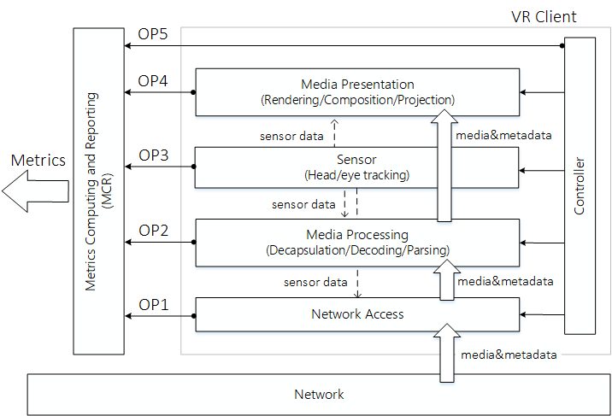

Figure 1 VR-Metrics client reference model

For the interim period till Jan. 2018before the next MPEG meeting, a new mandate has been added to AHG on MPEG-I Architecture, which says “develop immersive media quality metrics, their measurability in immersive services and guidelines for evaluating such quality” [2]. It is expected more proposals and contributions relating to VR QoE will be produced and proposed to the MPEG 121st meeting.

A liaison letter to ITU-T SG 12 on QoE-VR was also produced during the MPEG 120th meeting, which informs the new addition of MPEG-I Part 6 as well as its current status [3].

References

[1]v m41720 “MPEG-I] Proposed Working Draft on Part 6: Metrics”, MPEG 120, Oct. 2017

[2] N17100 “List of AHGs Established at the 120th Meeting”, MPEG 120, Oct. 2017

[3] N17171 “Liaison statement to ITU-T SG12 on QoE-VR”, MPEG 120, Oct. 2017

_______________________

