VQEG meeting @ Shenzhen – October 14-18, 2019

Wuhan University/Tencent welcome VQEG members to the next meeting that will be held at Shenzhen, China from October 14-18, 2019.

Meeting venue
The meeting location is:
Tencent Building, No. 10000 Shennan Ave., Shenzhen, China. (深圳市南山区深南大道10000号，腾讯大厦) [View via Google Map] [View via Baidu Map]

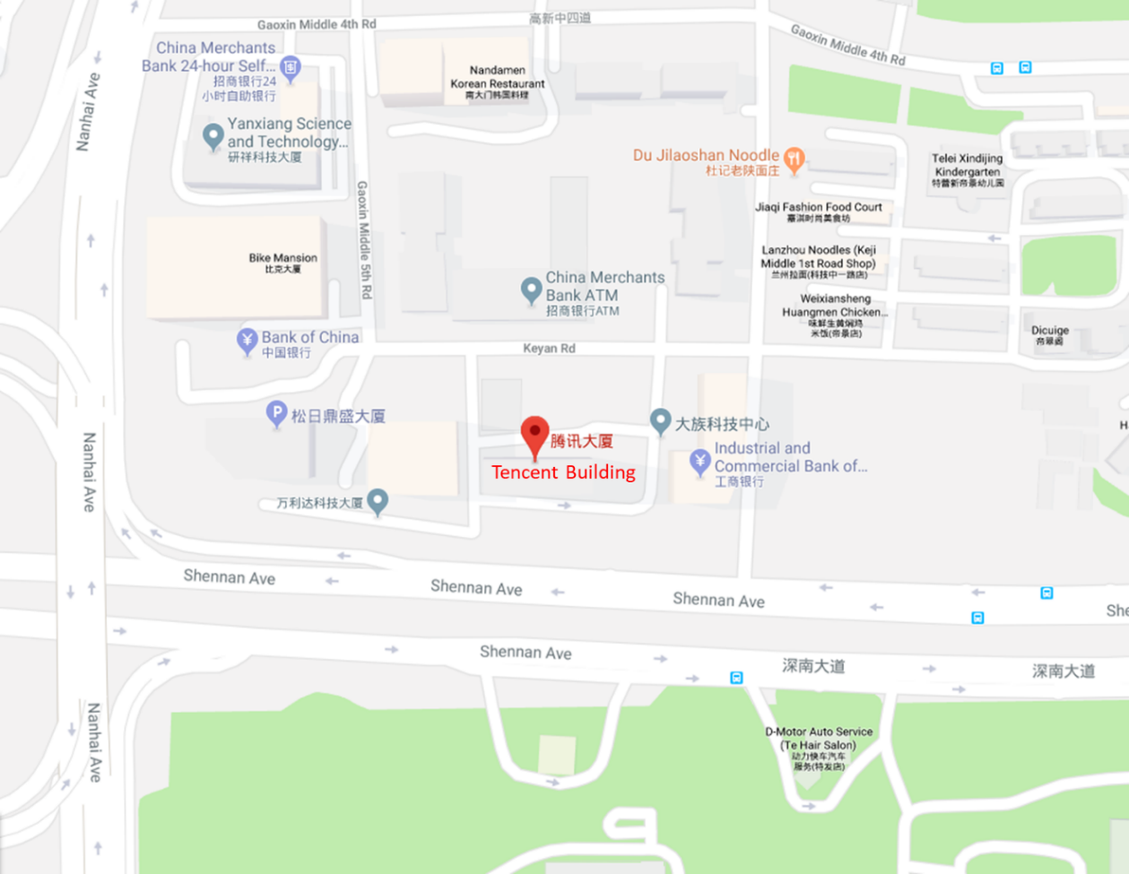

Travel information

Airport
The local airport is Shenzhen Bao’an International Airport (深圳宝安国际机场, IATA code: SZX, ICAO code: ZGSZ), about 21 km from the meeting location.

Local Transportation
Metro and Taxis are available from the airport. There will be signposts in the airport for both metro station and taxi pick-up spots. Rideshare app “Didi” could also be used, which is similar as Uber. But a Chinese phone number may be needed to register.

Google Map may be limited in the area. Instead, Baidu Map is recommended.
- Public Transport from the airport:
Metro line 11 (direction: “Futian福田”) to the station “Qianhaiwan前海湾” ->
Change Metro line 1 (direction: “Luohu罗湖”) to the station “Shenda深大” ->
leave at Exit A2 and walk for 1.3 km to reach Tencent Building (cost about 1 h 11 min, 6RMB)

- Taxi from the airport:
About 35 min, 60-80RMB (Meeting location in Chinese: 深圳市南山区深南大道10000号，腾讯大厦)

Hotel Information
There are many hotels around the area. A few of the closest ones to the meeting location are listed below. You could also search on your own as there are many other options around.

- Shenzhen FY Hotel (高新富悦酒店) – 0.34km from meeting location. About 700RMB/night (includes taxes)
- Shenzhen Nanshan L'Hermitage (兰赫美特酒店) – 0.74km from meeting location. About 800RMB/night (includes taxes)
- Vienna Hotel Shenzhen Nanxin Road (维也纳酒店深圳南新路店) – 2.1km from meeting location. About 450RMB/night (includes taxes)

Restaurant Information
Here we list some recommended restaurants close to the meeting location, which you could consider for daily lunch. We could provide English translations of their menus if necessary:
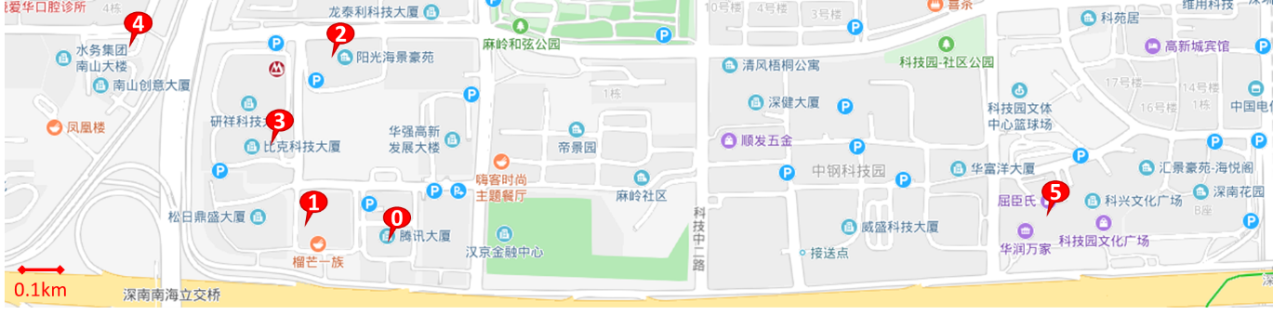
0. The meeting location.
1. Laowanhui noodles – Noodles of Northwest China. About 36RMB per person. 3 minutes walking distance.
2. Yonghe King – Chinese style set meal (courses + rice/noodles + drinks). About 26RMB per person. 6 minutes walking distance.
3. McDonald’s – Fast food including burgers, French fries, fried chicken, drinks, etc. About 30RMB per person. 4 minutes walking distance.

The following two are a bit far from the meeting location:
4. Miaoshi Buffet (in the first floor of L'Hermitage Hotel) - Buffet, serving both Cinese and Western-style courses. 132RMB per person. 11 minutes walking distance.
5. Pizza Hut – Pizzas and snacks. About 60RMB per person. 13 minutes walking distance. There are also some other restaurants around this location.

Visa Information
If you require an invitation for visa application, please feel free to contact at meeting@vqeg.org. (Please also send a copy to grace@whu.edu.cn in case the address may be not stable sometimes)
Your email must include the following information (and also any other information you need in the letter) in order to be processed in time:

- First Name:
- Last name:
- Gender:
- Passport Number:
- Date of Birth (day/month/year):
- Nationality:

Note that the invitation letter may take about 2-3 weeks to be processed. Besides, if a hard copy of the letter is required, please also let us know in the email.

Meeting Details
VQEG website will present the most up to date information regarding registration, meeting schedule, and presentation lists. Please register in advance so that we could arrange the meeting logistics in time.

Attendees will be required to check-in upon arrival. A reception desk will be set up at the ground floor to help you check in and reach the meeting room.

Internet access will be provided in the building. It is the Guest Wi-Fi of Tencent and could be used free of charge.

Remote access is possible through WebEx. We will host a test remote meeting some days before the meeting so that the remote attendees can test their connectivity. Detailed connection information will be sent in advance.

Additional Information
- Time zone: UTC+8 (Beijing)
- Voltage: 220V, be sure you have the correct adapter.

If you have any other particular need or question, please feel free to contact meeting@vqeg.org or the local host.

Local Contact
Host: Wuhan University/Tencent
Contact: Grace Yingxue Zhang
Email: grace@whu.edu.cn
Tel: +86 159 7222 3352

