 | INTERNATIONAL TELECOMMUNICATION UNION  TELECOMMUNICATION  STANDARDIZATION SECTOR  STUDY PERIOD 2022-2024 |  | SG12-TD450R2
 |  |  | STUDY GROUP 12
 |  |  | Original: English
Question(s): |  | 10/12 |  | Mexico City, 19-28 September 2023
TD
Source: |  | Editors G.TeleMeTax
Title: |  | Draft new Recommendation ITU-T G.TeleMeTax: Taxonomy of telemeetings from a QoE perspective (for consent)
Contact: |  | Janto Skowronek  Ilmenau University of Technology  Germany |  |  | Tel: +49 711 8926 2326  E-mail: janto.skowronek@hft-stuttgart.de
Contact: |  | Gunilla Berndtsson  Telefon AB - LM Ericsson  Sweden |  |  | Tel: +46 761011119  E-mail: gunilla.berndtsson@ericsson.com
Contact: |  | Alexander Raake  Ilmenau University of Technology  Germany |  |  | Tel: +49 3677 691468  E-mail: alexander.raake@tu-ilmenau.de
Contact: |  | Markus Fiedler  Blekinge Institute of Technology (BTH)  Sweden |  |  | Tel: +46708537339  E-mail: markus.fiedler@bth.se
Contact: |  | David Lindero  Telefon AB - LM Ericsson  Sweden |  |  | Tel: +46761153483  E-mail: david.lindero@ericsson.com

Abstract: | This document presents the draft recommendation text that is proposed for consent at the SG12 meeting in September 2023.

Recommendation ITU-T <No.>
Taxonomy of telemeetings from a QoE perspective
Summary
This recommendation provides a taxonomy on the different possible types of telemeetings, focussing on aspects that are crucial for Quality of Experience (QoE) assessment. The purpose is to facilitate the selection of appropriate quality assessment methods as well as an appropriate reporting and interpretation of results.
Keywords
Telemeeting, taxonomy, QoE, assessment

1 Scope
Telemeeting systems can be realized in numerous ways, ranging from telephone conference bridges over audiovisual computer-based solutions to high-end telepresence systems and XR meetings. The solutions can differ in various aspects such as required devices with different form factors and setup complexity, used transmission technology and communication modality, included collaboration and management features, etc.
For a proper quality assessment of telemeeting systems a structured method to characterize these different types of systems is required. On the one hand, this will facilitate precise comparison of telemeeting systems and their quality. On the other hand, this will help to avoid misinterpretation of assessment results, which may arise due to comparing results of different telemeeting systems that are too different in their character.
For that reason, the present recommendation provides a taxonomy for characterizing telemeeting systems, focussing on those aspects that are crucial for Quality of Experience (QoE) assessment. The present recommendation builds on existing definitions as given in ITU recommendations G.100/P.10, G.1000, and P.1301. Moreover, the present recommendation outlines how such a characterization can be used for choosing appropriate QoE assessment methods by referring to relevant ITU recommendations such as G.1011, P.1301 and P.1310.

2 References
The following ITU-T Recommendations and other references contain provisions which, through reference in this text, constitute provisions of this Recommendation. At the time of publication, the editions indicated were valid. All Recommendations and other references are subject to revision; users of this Recommendation are therefore encouraged to investigate the possibility of applying the most recent edition of the Recommendations and other references listed below. A list of the currently valid ITU-T Recommendations is regularly published. The reference to a document within this Recommendation does not give it, as a stand-alone document, the status of a Recommendation.
[ITU-T G.100/P.10] Recommendation ITU-T P.10/G.100 (2017), Vocabulary for performance, quality of service and quality of experience.
[ITU-T G.1011] Recommendation ITU-T G.1011 (2015), Reference guide to quality of experience assessment methodologies.
[ITU-T G.1035] Recommendation ITU-T G.1035 (2021), Influencing factors on quality of experience for virtual reality (VR) services.
[ITU-T P.1301] Recommendation ITU-T P.1301 (2017), Subjective quality evaluation of audio and audiovisual multiparty telemeetings.
[ITU-T P.1310] Recommendation ITU-T P.1310 (2017), Spatial audio meetings quality evaluation.
[ITU-T P.1320] Recommendation ITU-T P.1320 (2022), Quality of experience assessment of extended reality meetings.

3 Definitions

3.1 Terms defined elsewhere
This Recommendation uses the following terms defined elsewhere:
3.1.1 QoE [G.100/P.10].
3.1.2 QoS [G.100/P.10].
3.1.3 Virtual reality (VR) [P.1320].
3.1.4 Augmented reality (AR) [P.1320].
3.1.5 Extended reality (XR) [P.1320].
3.1.6 QoE influencing factors [ITU-T G.100/P.10].
3.1.7 Telemeeting [P.1301].
3.1.8 Degree of Freedom (DoF) [G.1035].

3.2 Terms defined in this Recommendation
This Recommendation defines the following terms:
3.2.1 None.

4 Abbreviations and acronyms
This Recommendation uses the following abbreviations and acronyms:
AR Augmented Reality
CIF Context Influence Factor
DoF Degree of Freedom
HIF Human Influence Factor
HMD Head-Mounted Display
HOA Higher Order Ambisonics
HRTF Head-Related Transfer Functions
MR Mixed Reality
QIF Quality Influence Factor
QoE Quality of Experience
QoS Quality of Service
SIF System Influence Factor
VBAP Vector Base Amplitude Panning
VR Virtual Reality
WFS Wave Field Synthesis
XR Extended Reality

5 Conventions
None.

6 Purpose and Use Cases
This recommendation builds on a tool to systematically characterize technical and non-technical aspects of telemeetings from a QoE perspective, here referred to as Telemeeting Profile Template. As described in Clause 8 of this Recommendation, this tool can be seen as a kind of checklist that is based on the concept of attribute-value pairs: The attributes refer to the characteristic aspects of the telemeeting; the values represent possible instantiations for each aspect.
In that respect, this tool can serve different purposes, depending on the actual application scenario. To illustrate this, three examples are given that address researchers and practitioners who are conducting QoE assessment of telemeeting systems, either during development or when the system is already in operation.
Application Scenario 1) Finding an appropriate QoE assessment method
First, the Telemeeting Profile Template can help to obtain a more systematic characterization of the telemeeting, which can assist to better specify the assessment scenario and subsequently to find an appropriate QoE assessment method. Second, such a detailed characterization of telemeetings can also help to identify whether an existing assessment method may be used without change, whether an existing method needs to be modified, or whether a new method needs to be developed.
Application Scenario 2) Communicating about Telemeeting QoE
Since telemeetings can be very different in their character, a precise communication about them can become challenging. For instance, when a researcher or practitioner is reporting about a comparison between different telemeeting systems in terms of QoE, the reporting person needs to be able to correctly interpret results in the context of the respective use case and system instances. Here, the Telemeeting Profile Template can help to clarify the characteristics of the telemeetings that have been addressed in the assessment campaign, which in turn minimizes the risk of misinterpretation and miscommunication.
In order to balance between concise communication and using the extensive list of attributes provided by the Telemeeting Profile Template, see Clause 8, it is recommended to separate between an analysis/comparison step and a communication step. This means that the full template is used to identify all relevant commonalities or differences between the evaluated telemeetings, while only a limited set of main aspects - those that have been identified during the QoE assessment to be highly relevant - is used in the communication.
Application Scenario 3) Describe a telemeeting use case in terms of needs and identify necessary requirements from a QoE perspective
The Telemeeting Profile Template may be used by a system developer to identify a list of qualitative requirements that need to be considered from a QoE perspective. It should be emphasized that it is not the purpose to specify quantitative requirements in terms of values or the like, as this is subject to other standards. Instead, the aspects in the Telemeeting Profile Template are discussed from the perspective of the users and should be seen as qualitative requirements, with the intention to strive for a better understanding of the link between use cases and appropriate technology.
Starting point is to describe the social interaction use cases by adopting the Telemeeting Profile Template to identify both relevant attributes in terms of needs that characterize the use case and relevant attributes for which requirements should be defined depending on the needs.
After having obtained this overview of relevant aspects, the next step is to plan the technical work to be done and, if applicable, to identify respective standards on technical requirements.

7 How to apply the Telemeeting Profile Template
While the exact application of the Telemeeting Profile Template depends on the actual application scenario, a generic five-step procedure is recommended as follows:
1. Examine the application scenario in terms of the purpose of the QoE assessment at hand as well as the use cases in terms of the telemeeting scenarios to be investigated
2. Go through the Telemeeting Profile Template, i.e., the list of attributes outlined in Clause 8 of this recommendation
3. Determine which of those attributes are relevant, typical or characteristic for the telemeeting use cases and, if applicable, also the QoE assessment scenario
4. If necessary or desired: identify, measure or write down descriptors for each considered attribute
5. Use the structured characterization obtained in this way, i.e., the list of relevant attributes with or without corresponding descriptors, as required by the application scenario at hand
Notes:
Appendix I gives examples on how Steps 1 – 3 can be performed.
Appendix II gives examples for descriptors that could be used for Step 4.
Specific advice for implementing Step 5 is not part of this recommendation. However, the examples in Clause 6 may be used for orientation on how to proceed.
This Recommendation includes an electronic attachment containing the Telemeeting Profile Template in spreadsheet format.

8 Description of the Telemeeting Profile Template

8.1 General concept of the Telemeeting Profile Template
The Telemeeting Profile Template can be seen as a kind of checklist that is based on the concept of attribute-value pairs: The attributes refer to the characteristic aspects of the telemeeting; the values represent possible instantiations for each aspect. As an example, one attribute is the communication mode, and possible values are audio, visual, audiovisual, tactile, text type, and graphics. Combinations of values are possible as well, e.g., audiovisual communication with additional text chat and so forth. As the example shows, the values are not per se numerical values. Hence, to avoid confusion, the instantiations of an attribute are referred to as descriptors in the remainder of this recommendation.
Concerning the list of attributes, this recommendation uses the Quality Influence Factors (QIFs), see [b-Qualinet, b-Reiter, ITU-T Rec. P.1320] and QoE constituents, see ITU-T Rec. P.1320 and [b-Skowronek2022a], as a tool to characterize telemeetings. This list of attributes has been developed over the last few years within the context of writing the aforementioned documents and it should be emphasized that the list is expected to evolve further with the progress of new XR-based telemeeting systems.
Concerning the descriptors, a good balance between covering all different possibilities and keeping the Telemeeting Profile Template manageable and comparable is necessary. This, for instance, is the case when an attribute refers to some technology aspect which can have many different implementations and thus many different descriptors. For that reason, a higher-level description is recommended, such as monotic, diotic, stereo, binaural, multichannel as example descriptors for the attribute spatial audio reproduction.

8.2 List of Quality Influence Factors as attributes for the Telemeeting Profile Template
Quality Influence Factors (QIFs) have been introduced in [b-Qualinet] as: “Any characteristic of a user, system, service, application, or context whose actual state or setting may have influence on the Quality of Experience for the user.” ITU-T Recommendation P.10 defines QoE influencing factors to “include the type and characteristics of the application or service, context of use, the user's expectations with respect to the application or service and their fulfillment, the user's cultural background, socio-economic issues, psychological profiles, emotional state of the user, and other factors whose number will likely expand with further research.”
The variety of Quality Influence Factors given by these definitions has been structured into three main categories Human Influence Factors (HIFs), System Influence Factors (SIFs) and Context Influence Factors (CIFs), see [b-Qualitet, b-Reiter].
Moreover, as these three main categories of QIFs are not always fully separable [b-Reiter], the Telemeeting Profile Template considers in addition Mixed Influence Factors (MIFs), which represent those QIFs that fall between two or even all three categories. In addition, it should be noted that several Quality Influence Factors are strongly linked to or can be considered as Quality of Service (QoS) parameters, especially the System Influence Factors.
To further structure the list for the Telemeeting Profile Template, the different categories are divided in several sub-categories, each consisting of individual QIFs that share some common aspects.
Figure 1 visualizes the categories and sub-categories, while the full list of QIFs is given Figures 2 and 3. Note that the figures were created by merging the lists of QIFs discussed in ITU-T Rec. P.1320 and in [b-Skowronek2022a]. Further background information about the individual QIFs can be found in ITU-T Rec. P.1320, in [b-Skowronek2022a], in the supplementary material of that paper in [b-Skowronek2022b] and in [b-Skowronek2022c].

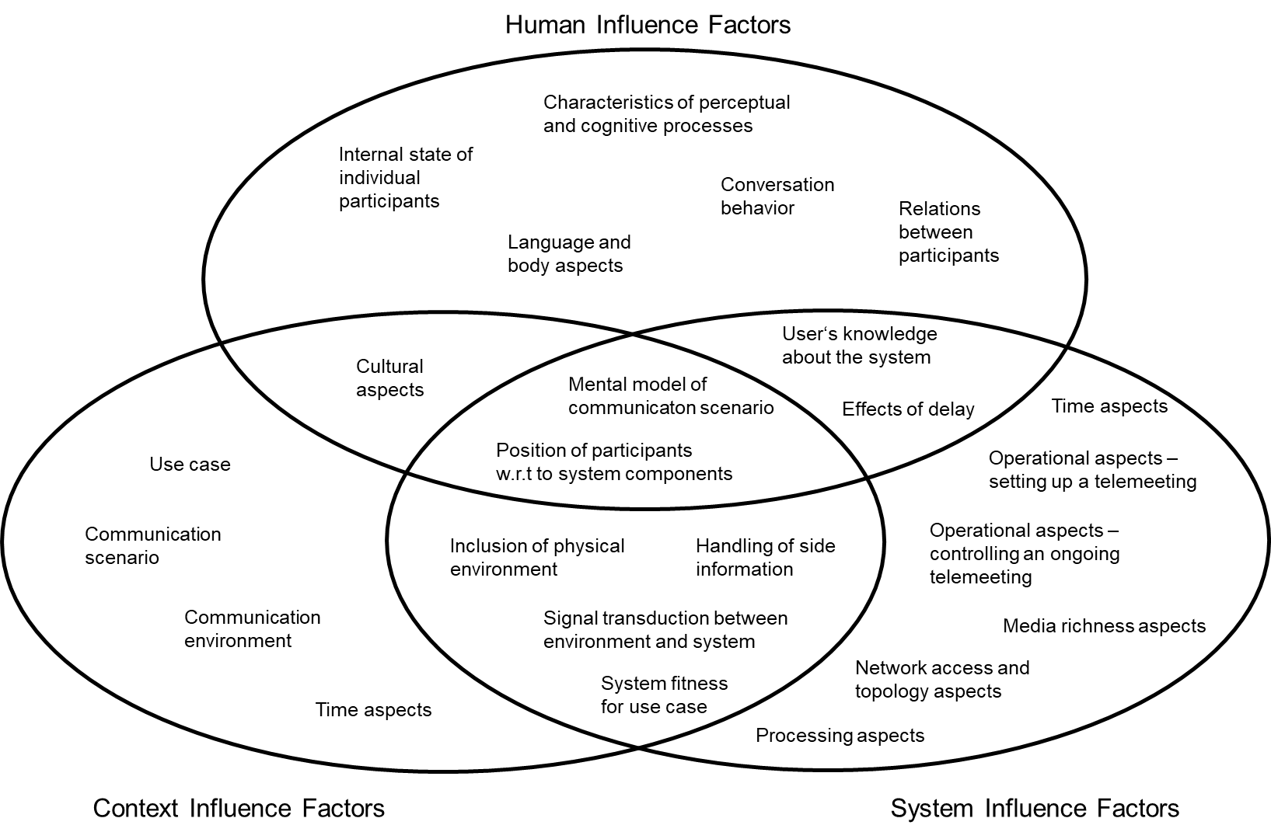

FIGURE 1. Visualization of the different categories and subcategories of Quality Influence Factors (QIFs) used for the Telemeeting Profile Template, previously presented in [b-Skowronek2022a]. The categories are expressed as Human, Context and System Influence Factors and their combinations (Mixed Influence Factors). Each category contains several subcategories which in turn consist of individual QIFs.
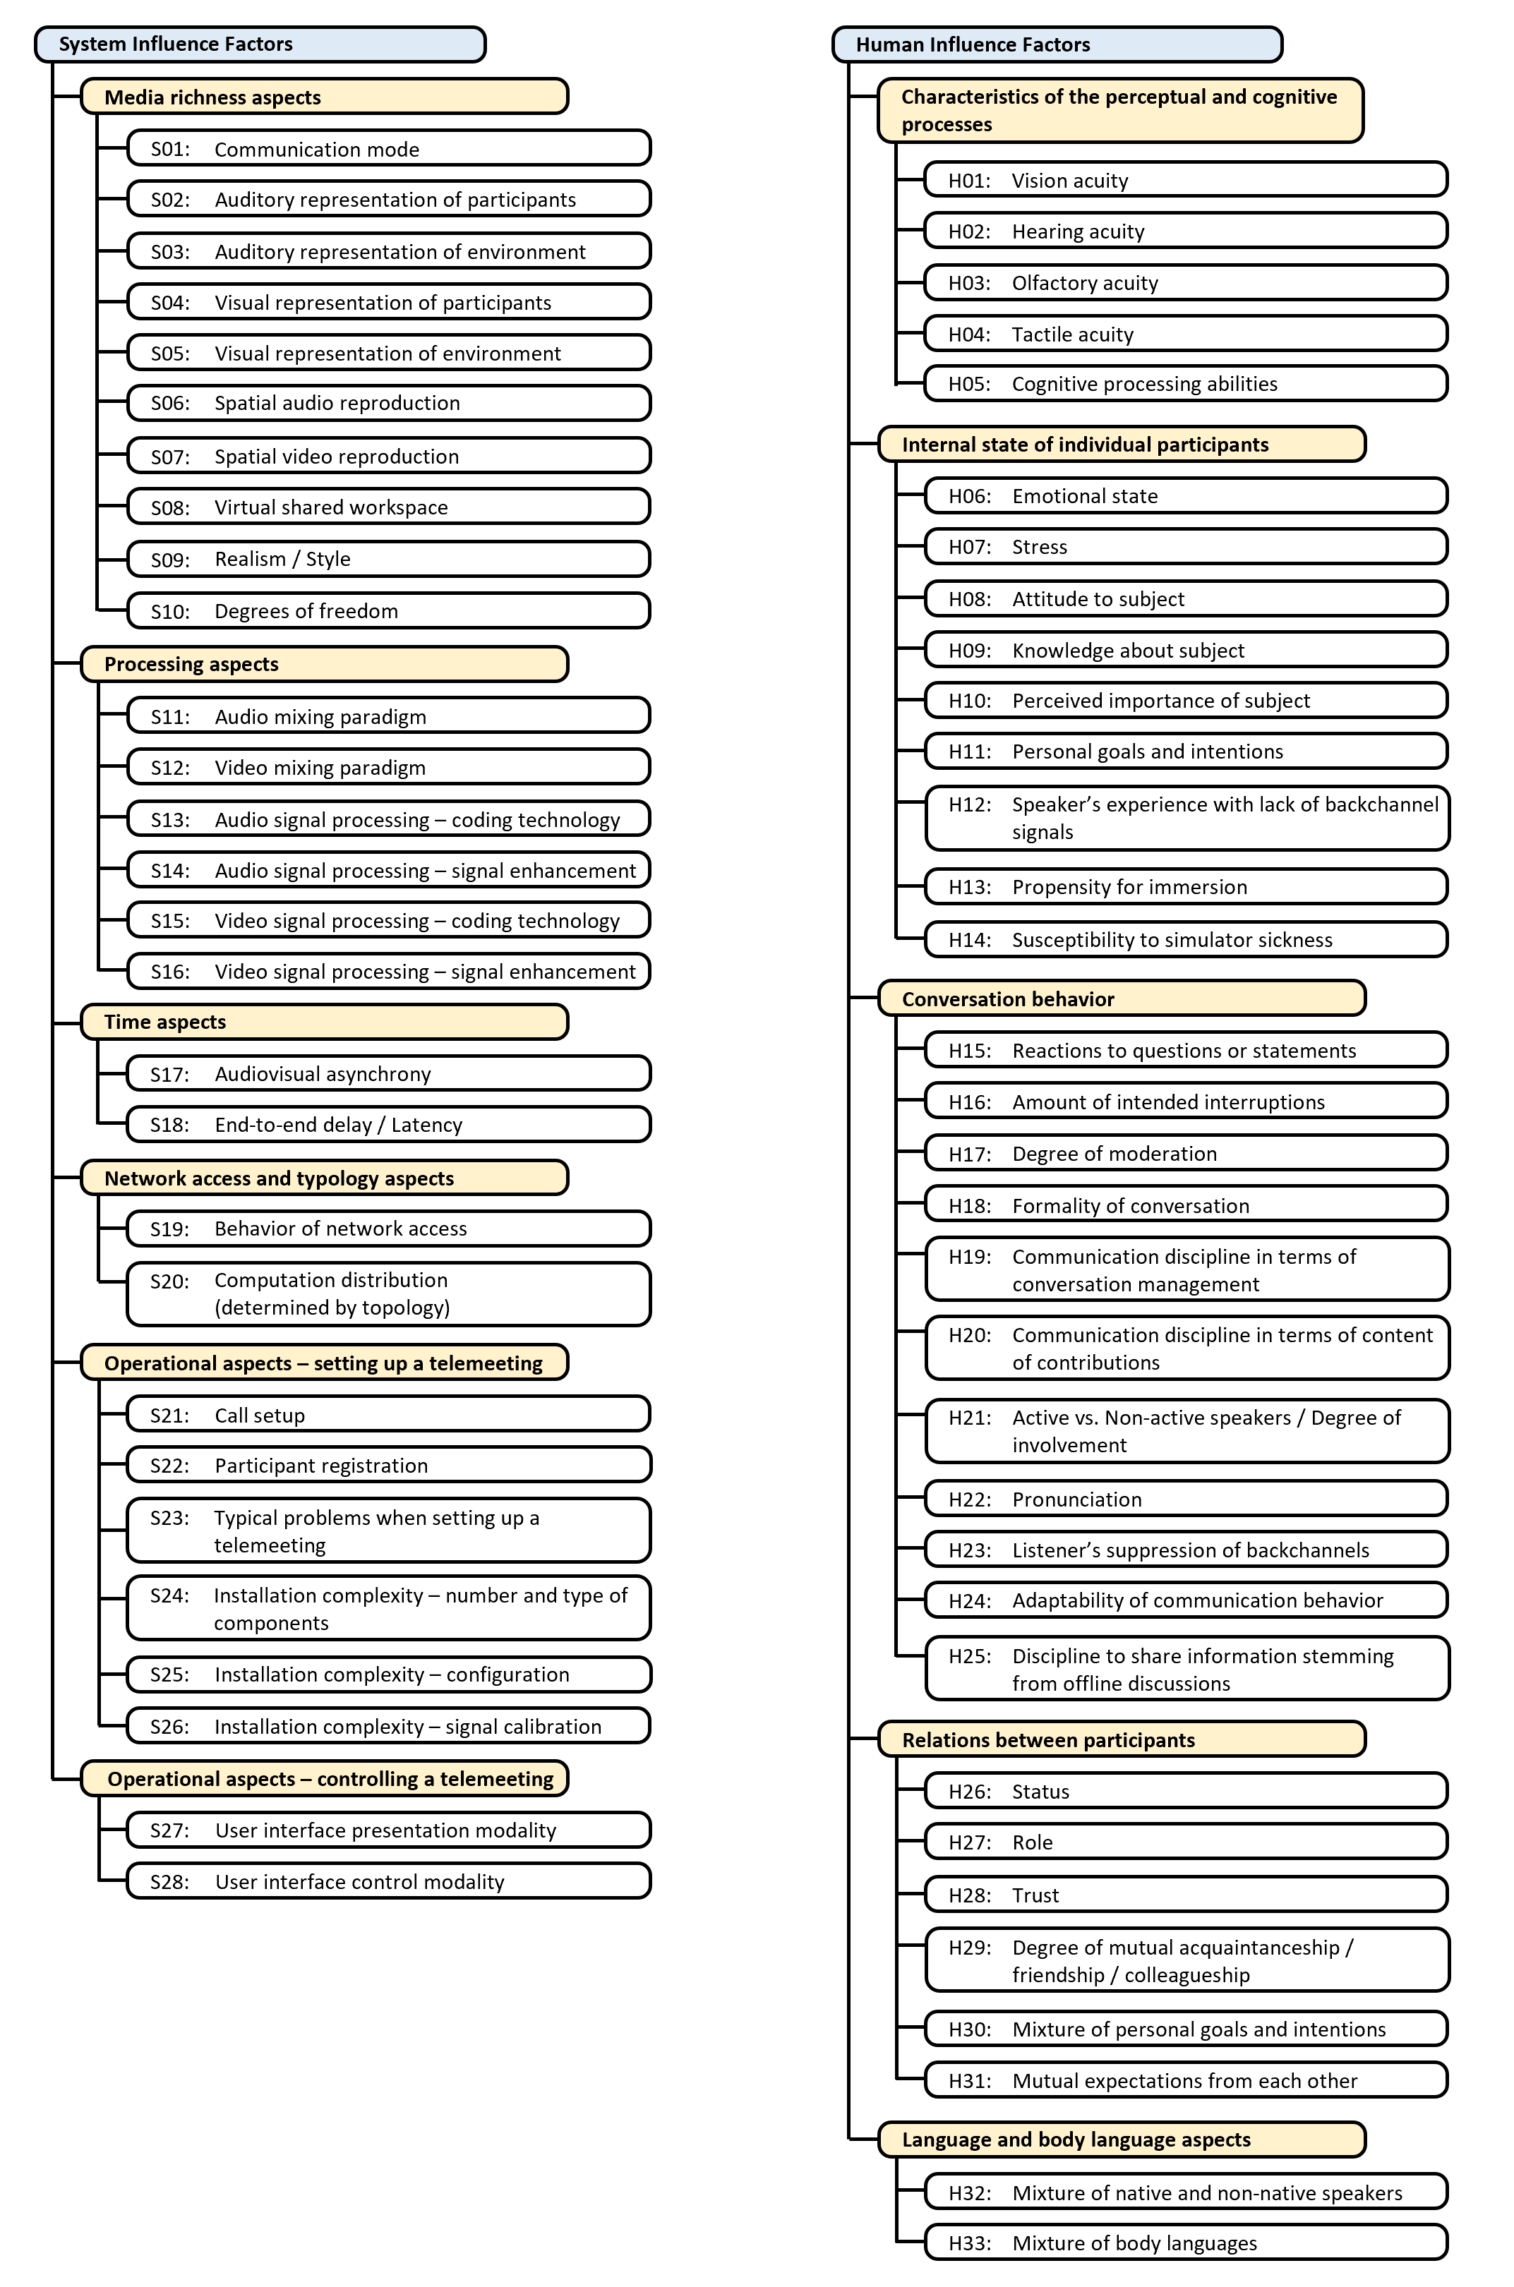
FIGURE 2. System and Human Influence Factors used for the Telemeeting Profile Template.
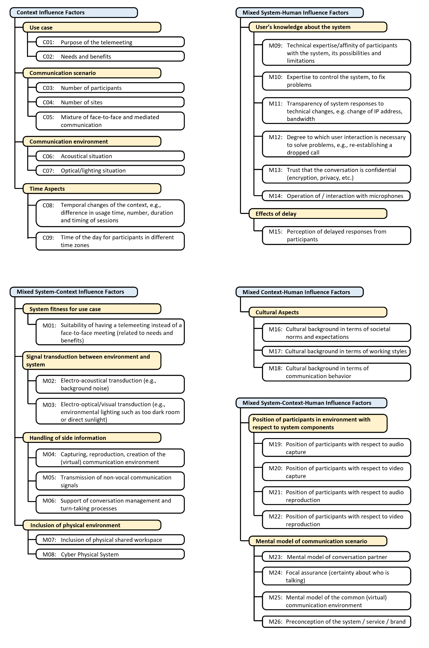
FIGURE 3. Context and Mixed Influence Factors used for the Telemeeting Profile Template.

8.3 List of QoE constituents as attributes for the Telemeeting Profile Template

According to ITU-T Rec. P.1320, a “QoE constituent is formed during an individual's experience of a service and contributes to its QoE”, which means that QoE constituents cover additional QoE-relevant characteristics of a telemeeting and are therefore included in the Telemeeting Profile Template.
Moreover, ITU-T Rec. P.1320 explains that “a QoE constituent can encompass aspects that are linked to the perception of speech, audio or video signals as well as other aspects such as, for instance, simulator sickness, immersion, feeling of presence, feeling of co-presence or usability.”
Furthermore, ITU-T Rec. P.1320 differentiates between QIFs and QoE constituents by highlighting that QoE constituents are formed inside the QoE formation process in the experiencing person's mind, while QIFs can either influence this QoE formation process or can influence all signals and contextual information of the telemeeting that form the input to the QoE formation process. For a more detailed discussion on the relation between QIFs and QoE constituents, the reader is referred to ITU-T Rec. P.1320 and [b-Skowronek2022a].
Figure 4 lists the QoE constituents used for the Telemeeting Profile Template, which was created by merging the QoE constituents discussed in ITU-T Rec. P.1320 and in [b-Skowronek2022a].

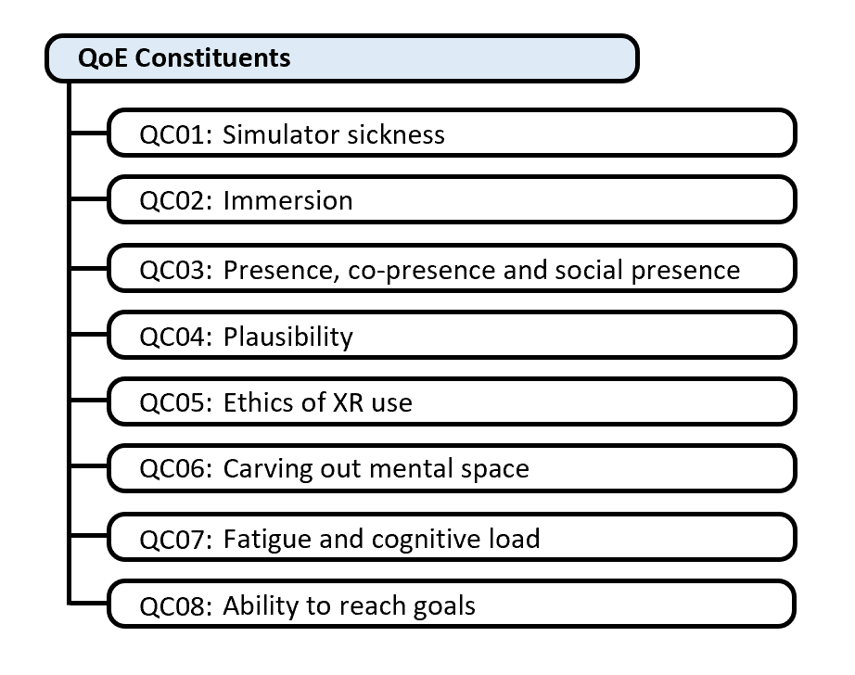
FIGURE 4. QoE constituents used for the Telemeeting Profile Template.

Appendix I
Using the Telemeeting Profile Template to describe use cases
(This appendix does not form an integral part of this Recommendation.)
This appendix describes in more detail how the Telemeeting Profile Template may be used to describe three use cases in which immersive sound technologies (also referred to as spatial audio technologies) are applied, and in which a system developer is interested to identify a list of requirements that need to be considered from a QoE perspective. Hence, this appendix refers to the third application scenario outlined in Clause 6 of the main body of this recommendation.
Focussing on social interaction scenarios, this appendix outlines a way of finding an optimal mapping of the technology and the use case. As a disclaimer, it is not the purpose to specify quantitative requirements in terms of values or the like, as this is subject to other standards. Instead, the aspects in this appendix are discussed from the perspective of the users and should be seen as qualitative requirements, with the intention to strive for a better understanding of the link between use cases of social interaction and appropriate technology for immersive sound.
Starting point is to describe the social interaction use cases by adopting the Telemeeting Profile Template to identify a subset of relevant attributes (i.e., QIFs and QoE constituents) and to structure this subset in two parts: The first part contains a list of attributes that characterize the use case in terms of needs; the second part contains a list of attributes for which requirements should be defined depending on the items in the first part.
Practically, this can be done by taking the Telemeeting Profile Template and marking the relevant attributes with an N for needs and R for requirements. Doing this for the three use cases described in the subsections below leads to three lists with Ns and Rs. In Figures I.1 to I.5 these lists are combined across the three use cases for illustration purposes. After having obtained this overview of relevant aspects, the next step is to discuss the needs and respective technical requirements, which is exemplarily done in the next paragraphs.

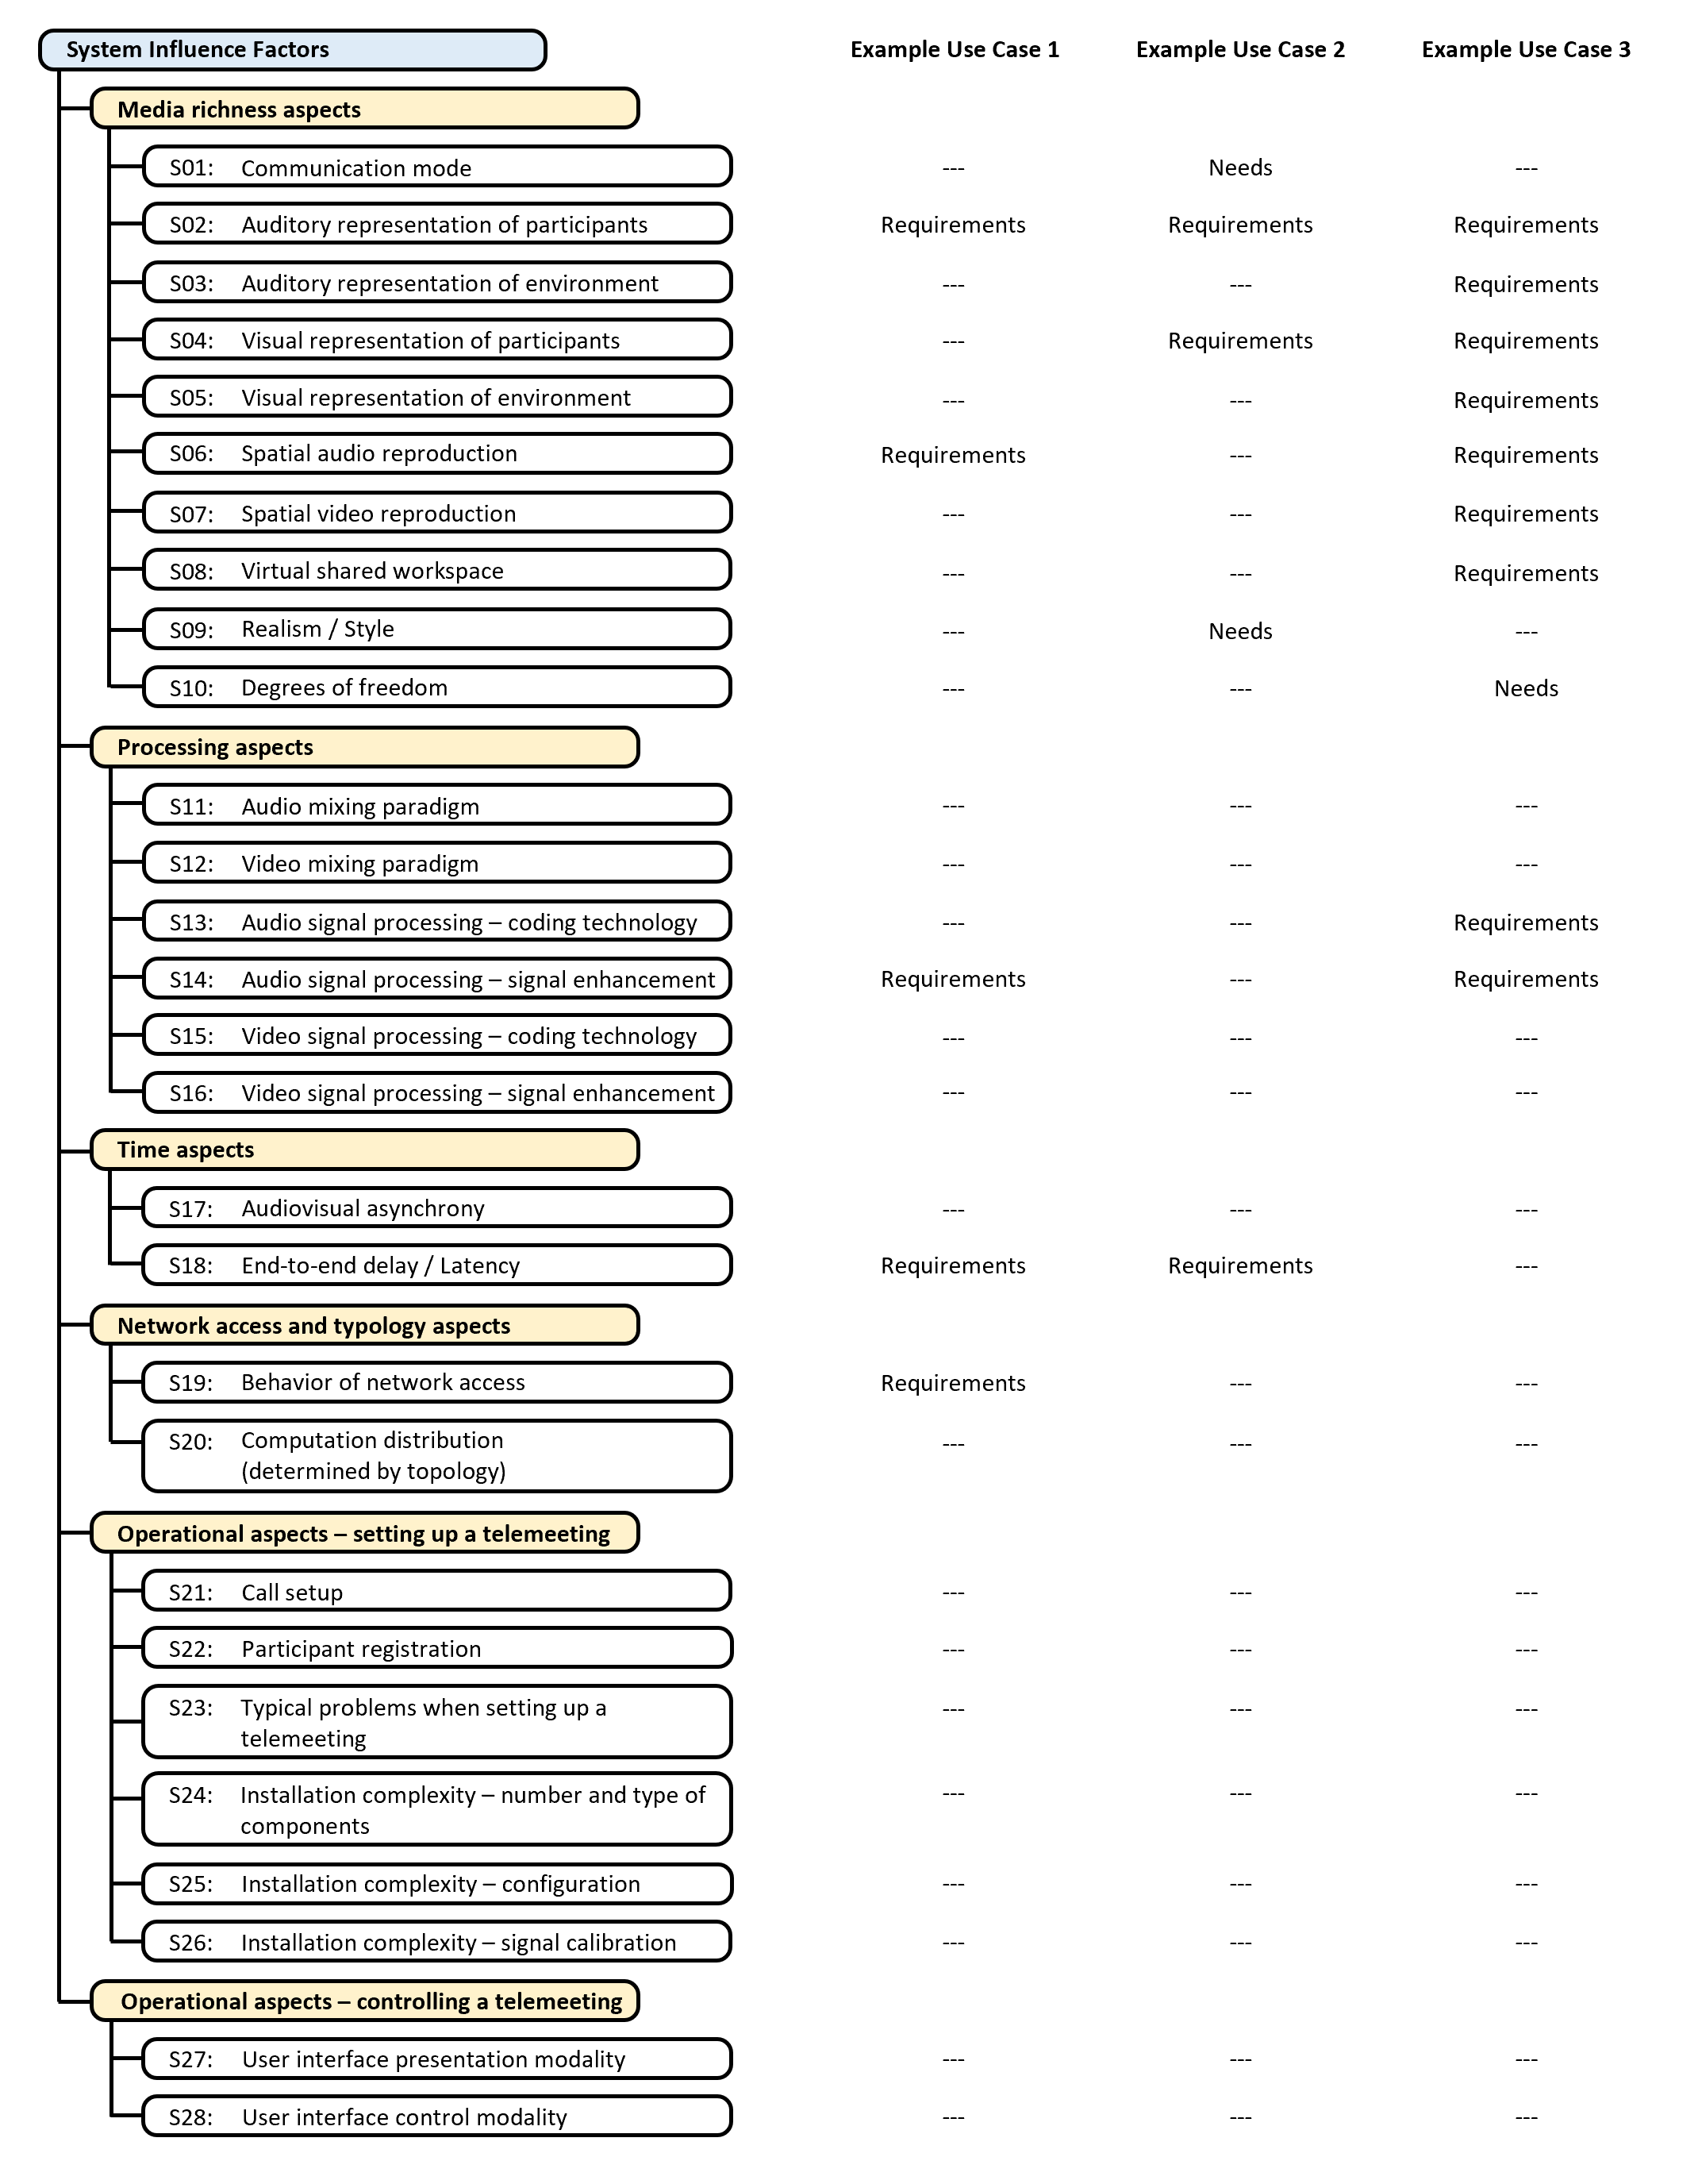
FIGURE I.1. Overview of relevant attributes for the three Example Use Cases 1 to 3 – part 1.

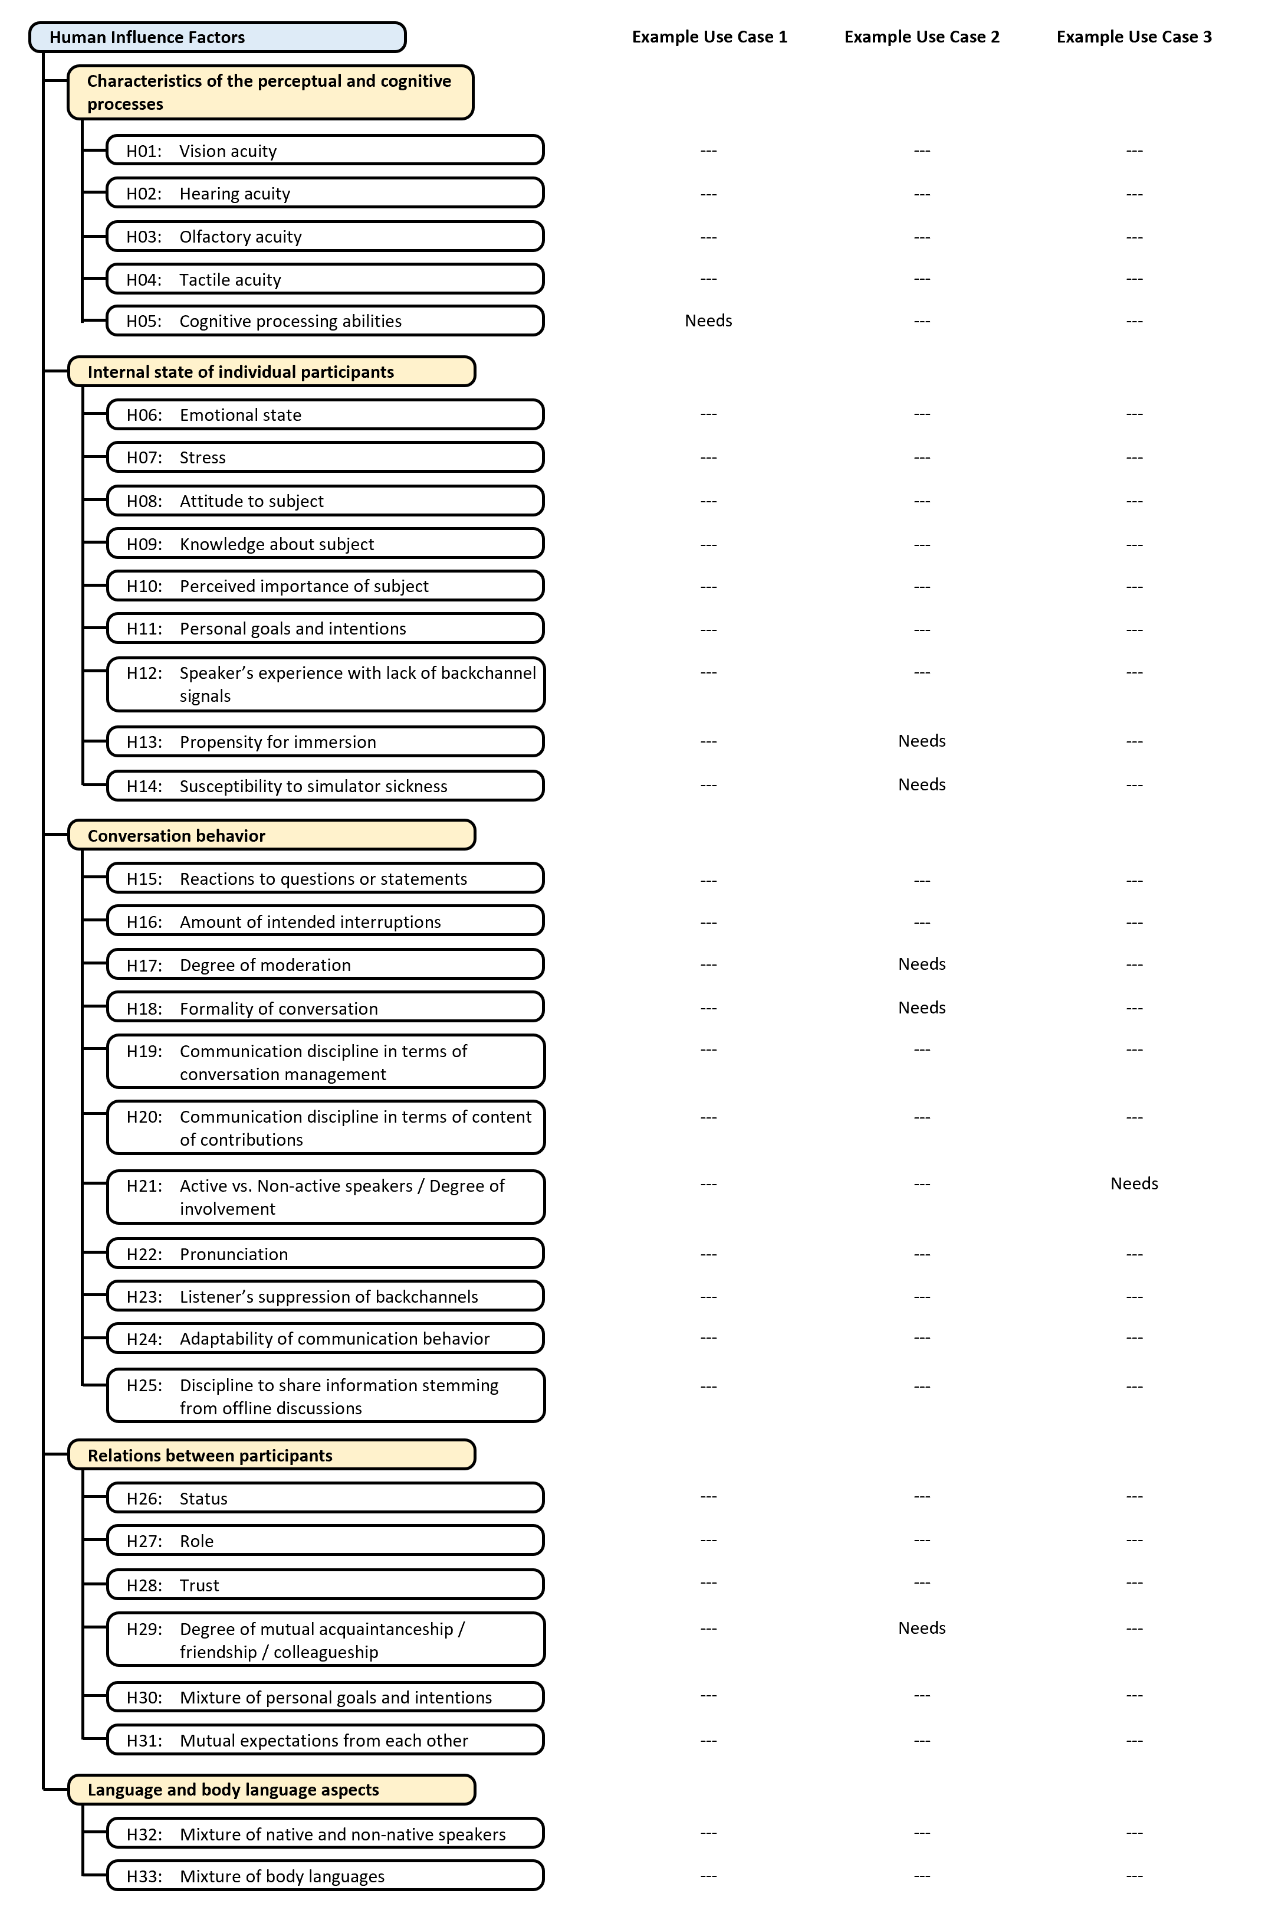
FIGURE I.2. Overview of relevant attributes for the three Example Use Cases 1 to 3 – part 2.
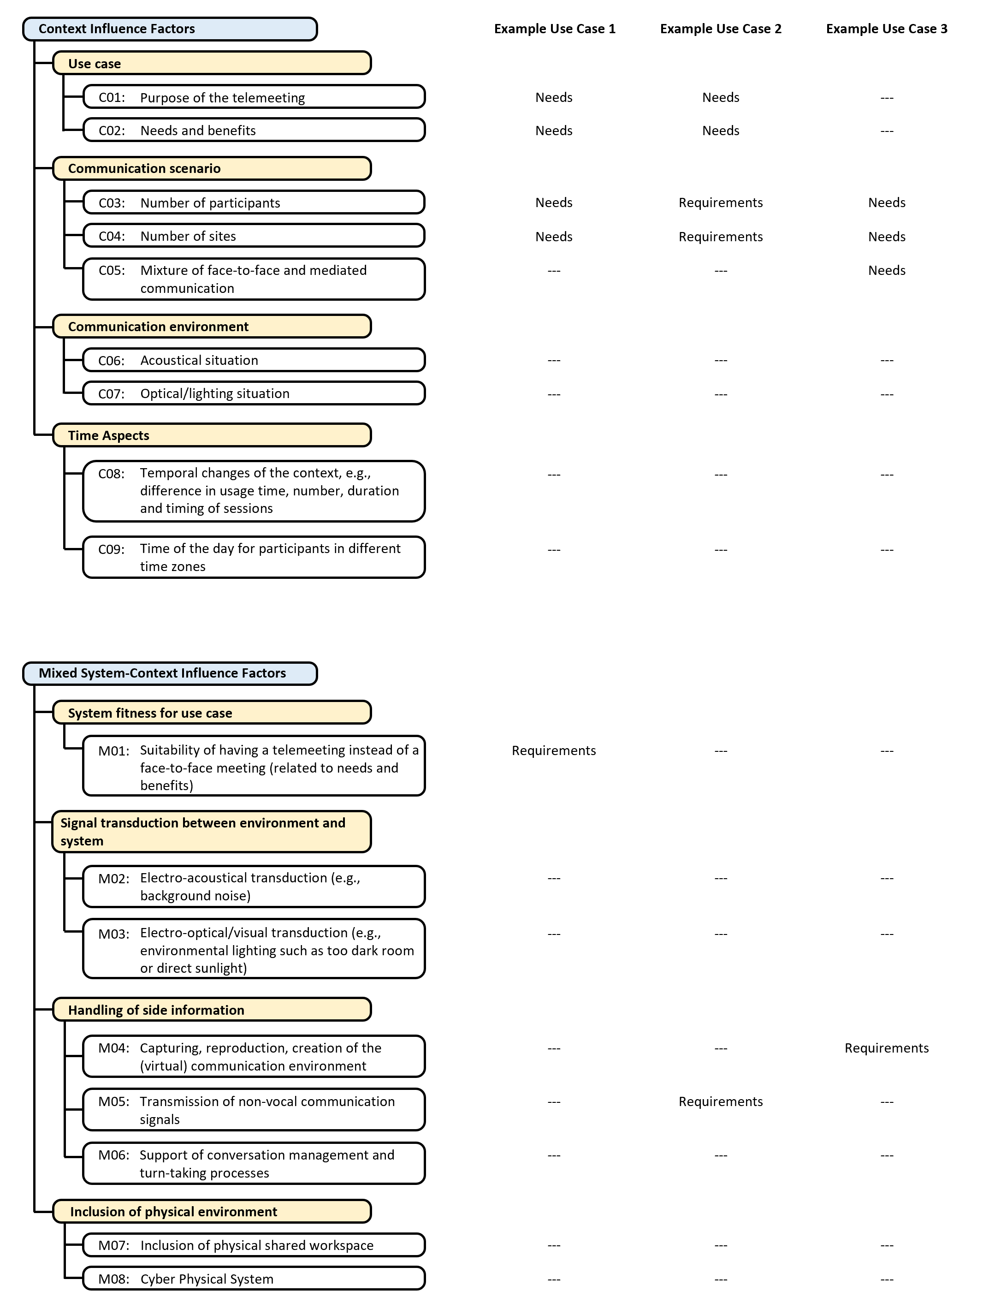
FIGURE I.3. Overview of relevant attributes for the three Example Use Cases 1 to 3 – part 3.

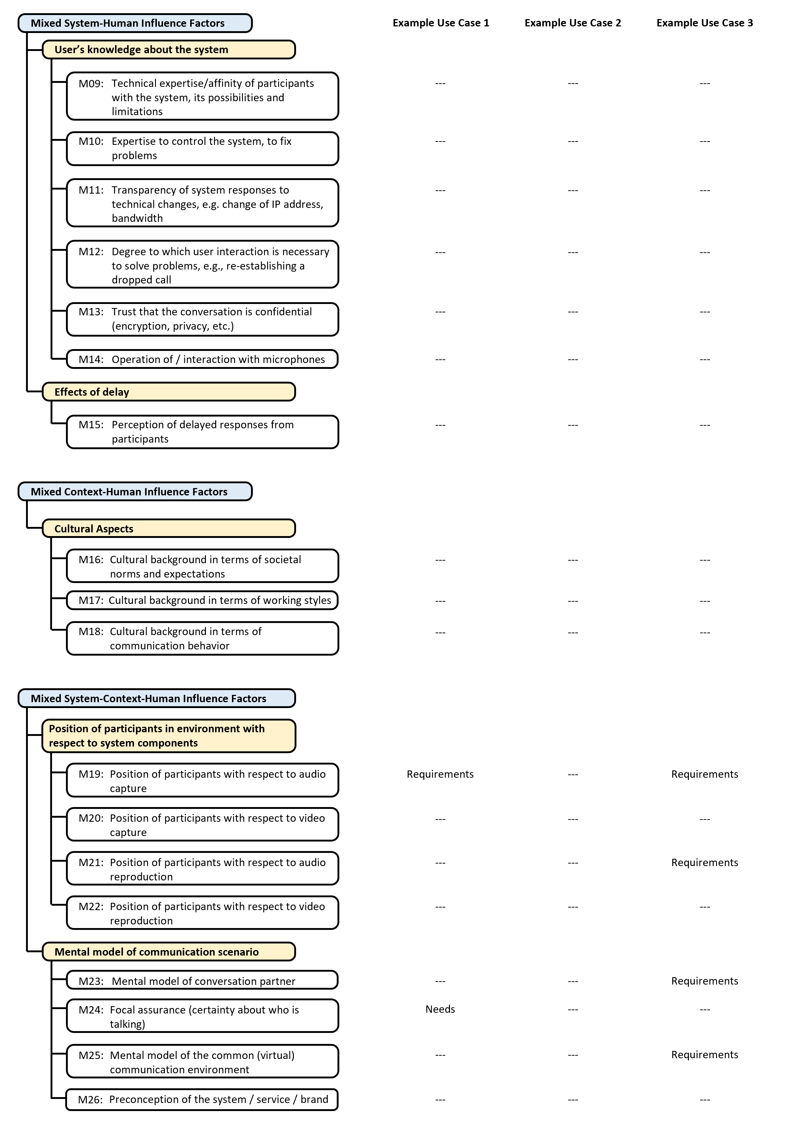
FIGURE I.4. Overview of relevant attributes for the three Example Use Cases 1 to 3 – part 4.

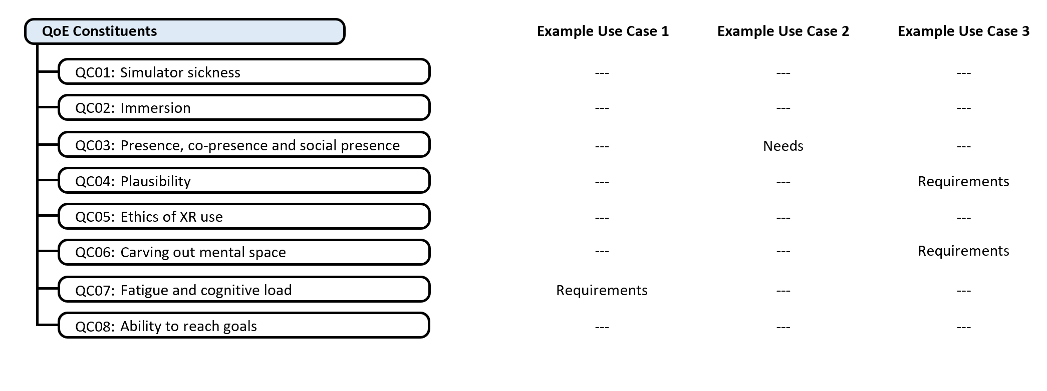FIGURE I.5. Overview of relevant attributes for the three Example Use Cases 1 to 3 – part 5.

I.1 Example Use Case 1: Multiparty, one-per-site, audio-only telemeeting in a business context, lasting for two hours
According to ITU-T Rec. P.1301, a multiparty one-per-site business telemeeting (N-Attributes C01 and C02) means that more than two sites are connected (N-Attribute C04) and at each site only one person is present (N-Attribute C03). Thus, the technical requirements in terms of sound capture and signal processing are similar to those of setups without immersive sound. Examples to be considered are the type and positioning of the microphone(s) (R-Attribute M19), as well as signal processing algorithms for automatic gain control, environmental noise reduction, echo cancellation, dereverberation and so forth (R-Attribute S14).
Concerning the sound reproduction, the situation can be analyzed as follows: Being a two hour long multiparty meeting, this example is challenging for participants in terms of experienced cognitive load and fatigue (R-Attribute QC07). To reduce such effects and make it a suitable replacement of a face-to-face meeting (R-Attribute M01), the system should provide a good spatial separation of the participant voices through adequate spatial representation (R-Attribute S02) and reproduction (R-Attribute S06). For headphone-based systems, for instance, this translates to the performance of the binaural synthesis in terms of the used cues (i.e., the head-related transfer functions or binaural room impulse responses) and the spatial and temporal precision of tracking the head orientation of the listeners (if any applied). Together with high speech signal quality (R-Attribute S14), reasonable end-to-end delay (R-Attribute S18) and reliable network behavior (R-Attribute S19), spatial separation helps to ensure a good focal assurance (N-Attribute M24). Furthermore, the system should take individual cognitive processing abilities into account (N-Attribute H05).

I.2 Example Use Case 2: Two-party meeting in a VR meeting room in a leisure time context, connecting close friends
With the purpose of fulfilling social needs of the participants (N-Attributes C01 and C02), this use case can be characterized by the need to create a feeling of co-presences or even social presence (N-Attribute CQ03) of two participants (R-Attribute C03) at two sites (R-Attribute C04). Thus, the two close friends in this example use case have the need to maintain their degree of mutual friendship (N-Attribute H29) which can be achieved by feeling connected to each other even over the physical distance between them. Moreover, the use case is also an example of a multimodal communication mode (N-Attribute S01) requiring a high degree of realism (N-Attribute S09). These needs translate into a VR environment that sets high requirements for the auditory (R-Attribute S02) and visual representation (R-Attribute S04) of the participants, which in turn can be challenging not only in terms of the technology but also in terms of perceptual effects such as the uncanny valley effect.
Notice that in such a VR environment, the auditory and visual representation of the environment should be designed such that individual differences of participants’ propensity for immersion (N-Attribute H13) and susceptibility to simulator sickness (N-Attribute H14) is taken into account.
Moreover, as the meeting is taking place in a leisure time between two friends (R-Attribute C03), the use case can also be characterized by a very low degree of formalism (N-Attribute H18) and moderation (N-Attribute H17) of the conversation. That means, the system should support a natural conversation flow close to a face-to-face situation, which can be achieved by adequately transmitting non-verbal communication signals (R-Attribute M05) and ensuring low end-to-end delay (R-Attribute S18).

I.3 Example Use Case 3: Multiparty collaboration connecting two physical meeting rooms via AR
This use case means that at least at one out of two sites (N-Attribute C04) multiple persons are present in the same physical room (N-Attribute C03), which eventually leads to a mixture of face-to-face and mediated conversation (N-Attribute C05). For contemporary systems without immersive sound (R-Attribute M04), this already translates into requirements for the sound capture and signal processing that are usually more challenging compared to Use Case 1 because multiple persons need to be adequately captured (R-Attribute M19). This in turn puts higher demands on the different signal processing stages (R-Attributes S13 and S14), for instance due to a variety of locations and distances between microphones and the persons. Moreover, if the benefits of spatial audio shall be fully exploited, not only a good signal to noise ratio is necessary but also the capturing of the direction and ideally a good separation of the speech signals from individual speakers in that room. Depending on the room setup, this in turn can translate into smart controls for close-talk table microphones or beam forming and source separation algorithms for microphone arrays.
Concerning the sound reproduction, the requirements for the spatial sound reproduction technology (R-Attributes S02, S04 and S06) are similar to non-interactive use cases. Considering loudspeaker-based systems as the appropriate approach for this use case, example challenges are the provision of sufficiently large sweet-spots for surround sound or HOA systems (R-Attribute M21), or the reduction of artifacts for focussed sources in WFS systems (R-Attribute S02).
Next to these considerations, this use case also concerns collaboration (R-Attribute S08), which results in a need for high degrees of freedom (N-Attribute S10) and involvement (N-Attribute H21). Combining these needs with the fact that multiple persons are present in one room suggests that the required communication mode uses AR. A good collaboration in such an AR experience could further benefit from a mental model of the common communication environment (R-Attribute QC06; R-Attributes M23 and M25) that is shared by all participants. These collaboration aspects translate into a set of technical requirements concerning the auditory and visual representations of participants and especially the environments (R-Attributes S02–S05). To the best of the authors’ knowledge, the capturing (R-Attribute M04), reproduction (R-Attributes S06 and S07), and creation of the (virtual) communication environment (R-Attribute S08), and for AR in particular the mixture of real and virtual environments (N-Attribute C05), is currently subject for further study. In the auditory domain, ongoing research on plausible (R-Attribute CQ04) representations of real acoustic rooms in virtual environments and on the consideration of neighbouring rooms that are acoustically coupled by open doors etc. could form the basis for respective applications.

Appendix II
Examples of values and descriptors that may be used in the Telemeeting Profile Template
(This appendix does not form an integral part of this Recommendation.)
The Telemeeting Profile Template can be considered as a set of attribute-value-pairs, whereas this recommendation refers to the values as descriptors, as those descriptors are not necessarily numerical values. As attributes it is recommended to use the Quality Influence Factors and QoE constituents listed in Clause 8 of this recommendation. With respect to the descriptors, this recommendation does not define a mandatory list of such descriptors. However, the examples of possible descriptors in this appendix (Figures II.1 to II.10 may be helpful to the users of this recommendation when filling in the Telemeeting Profile Template for a given set of telemeetings.

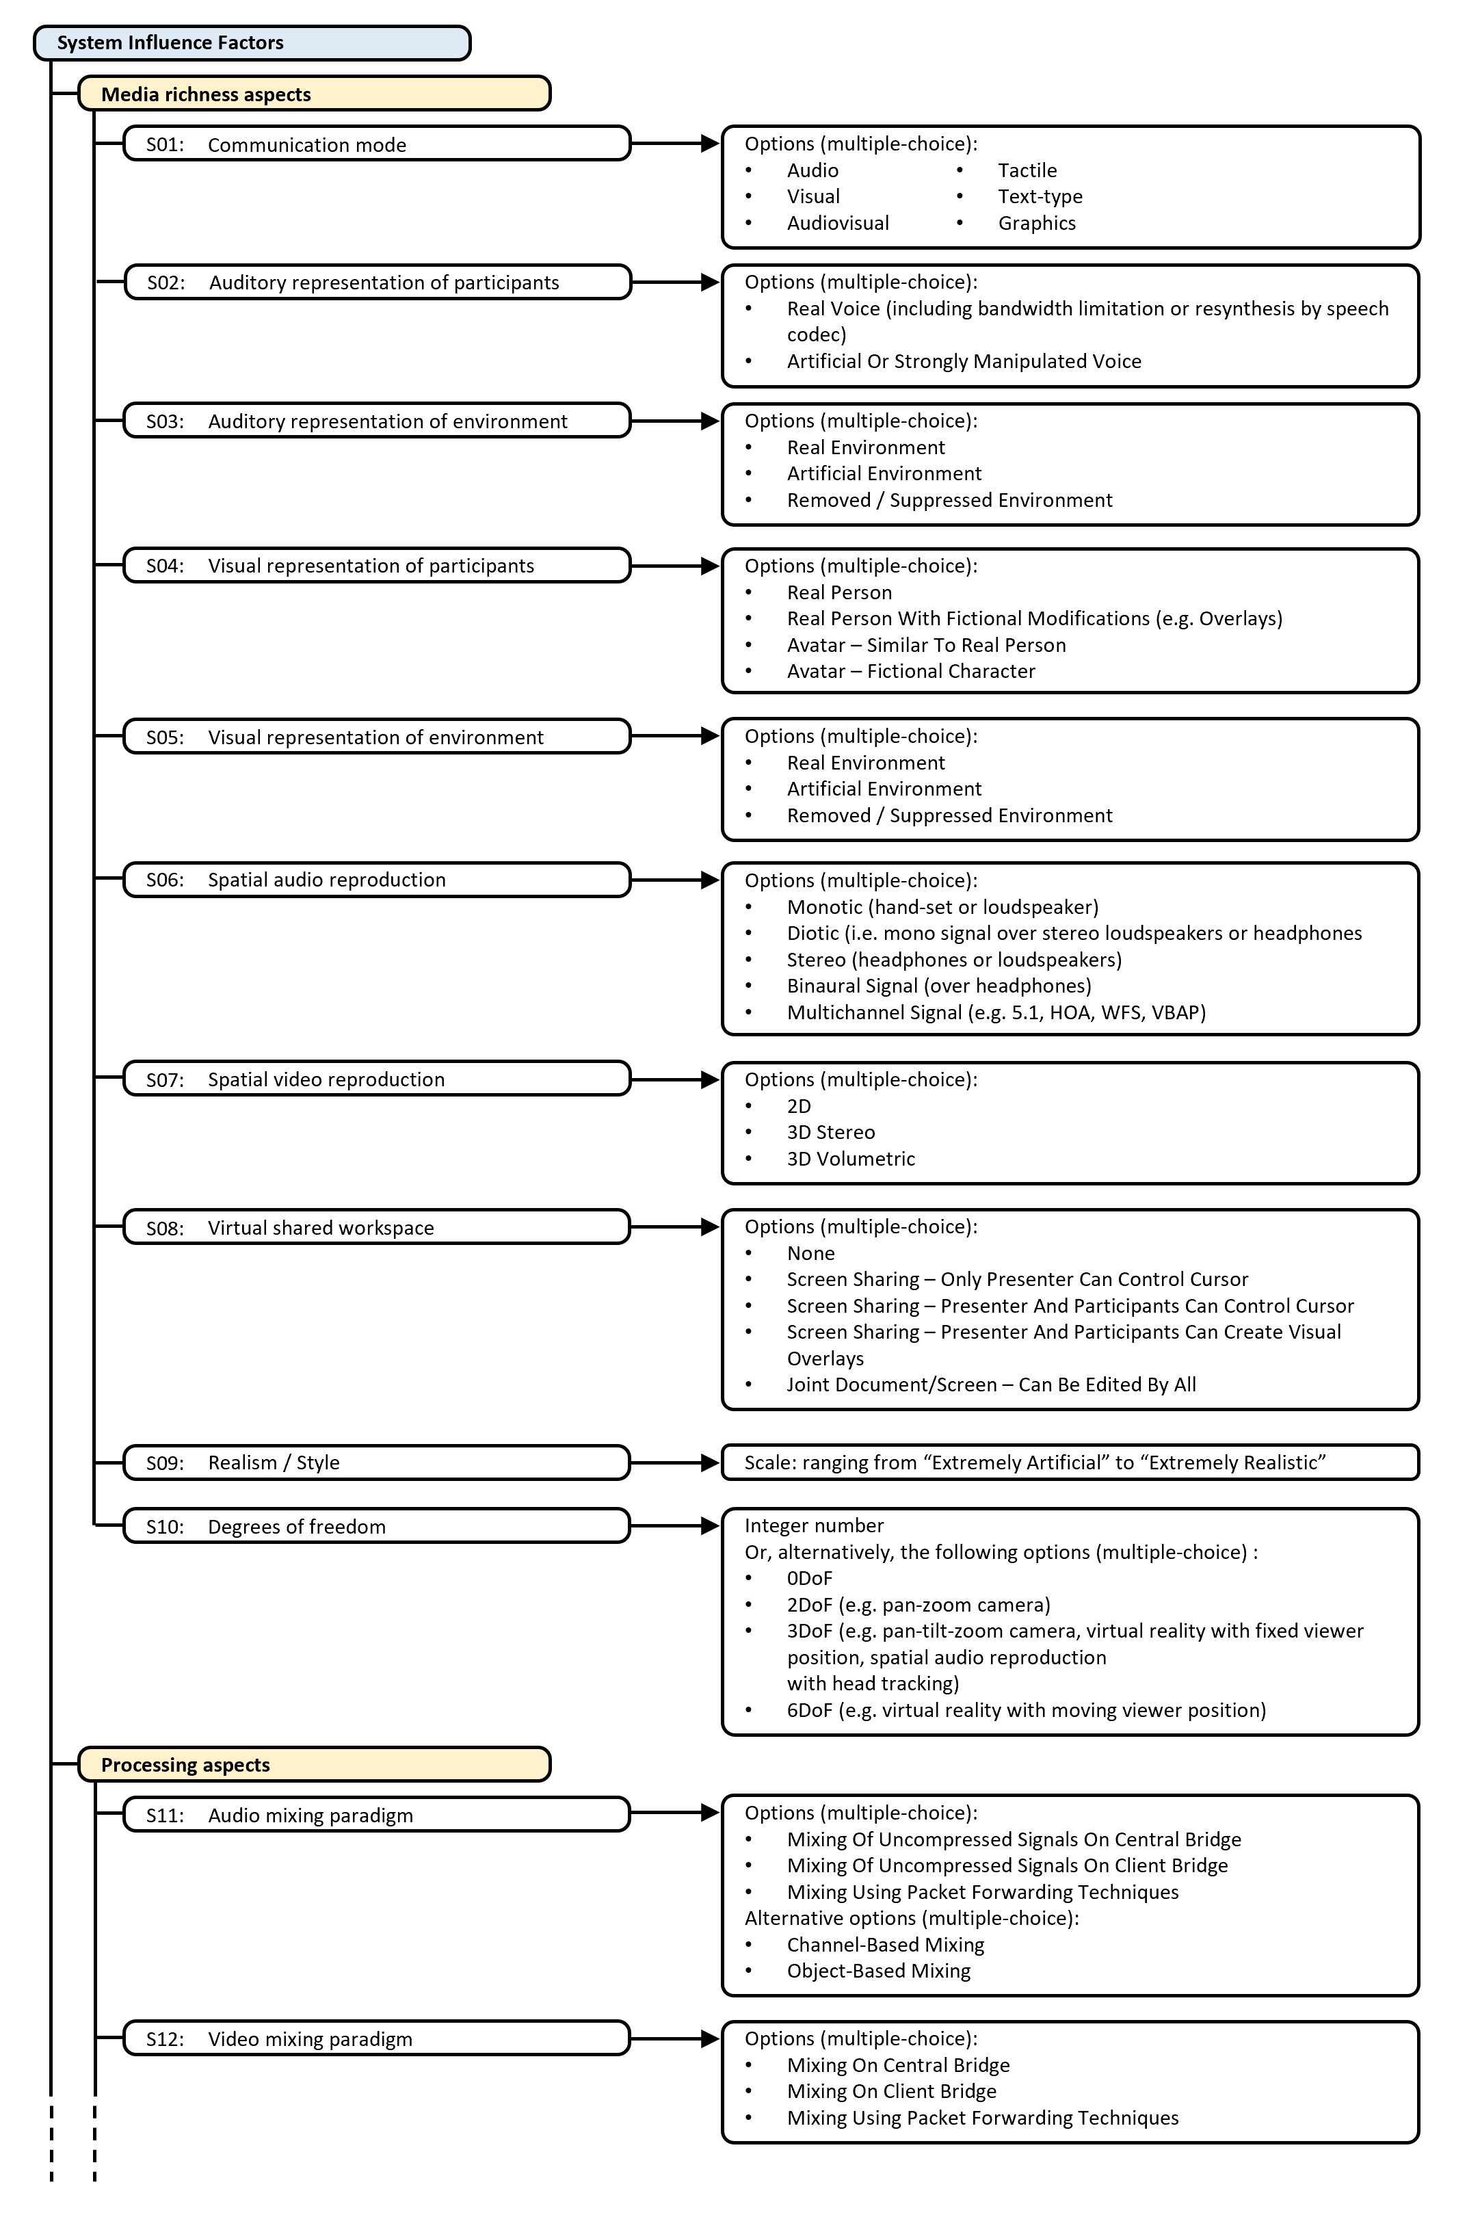
FIGURE II.1. Examples of descriptors for the Telemeeting Profile Template – part 1.
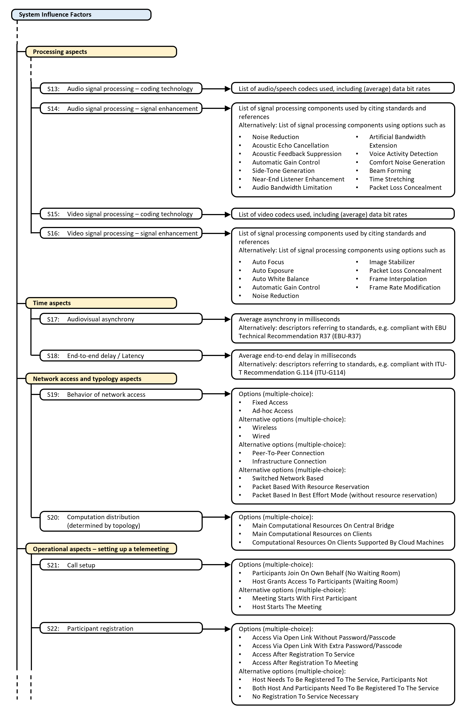
FIGURE II.2. Examples of descriptors for the Telemeeting Profile Template – part 2.
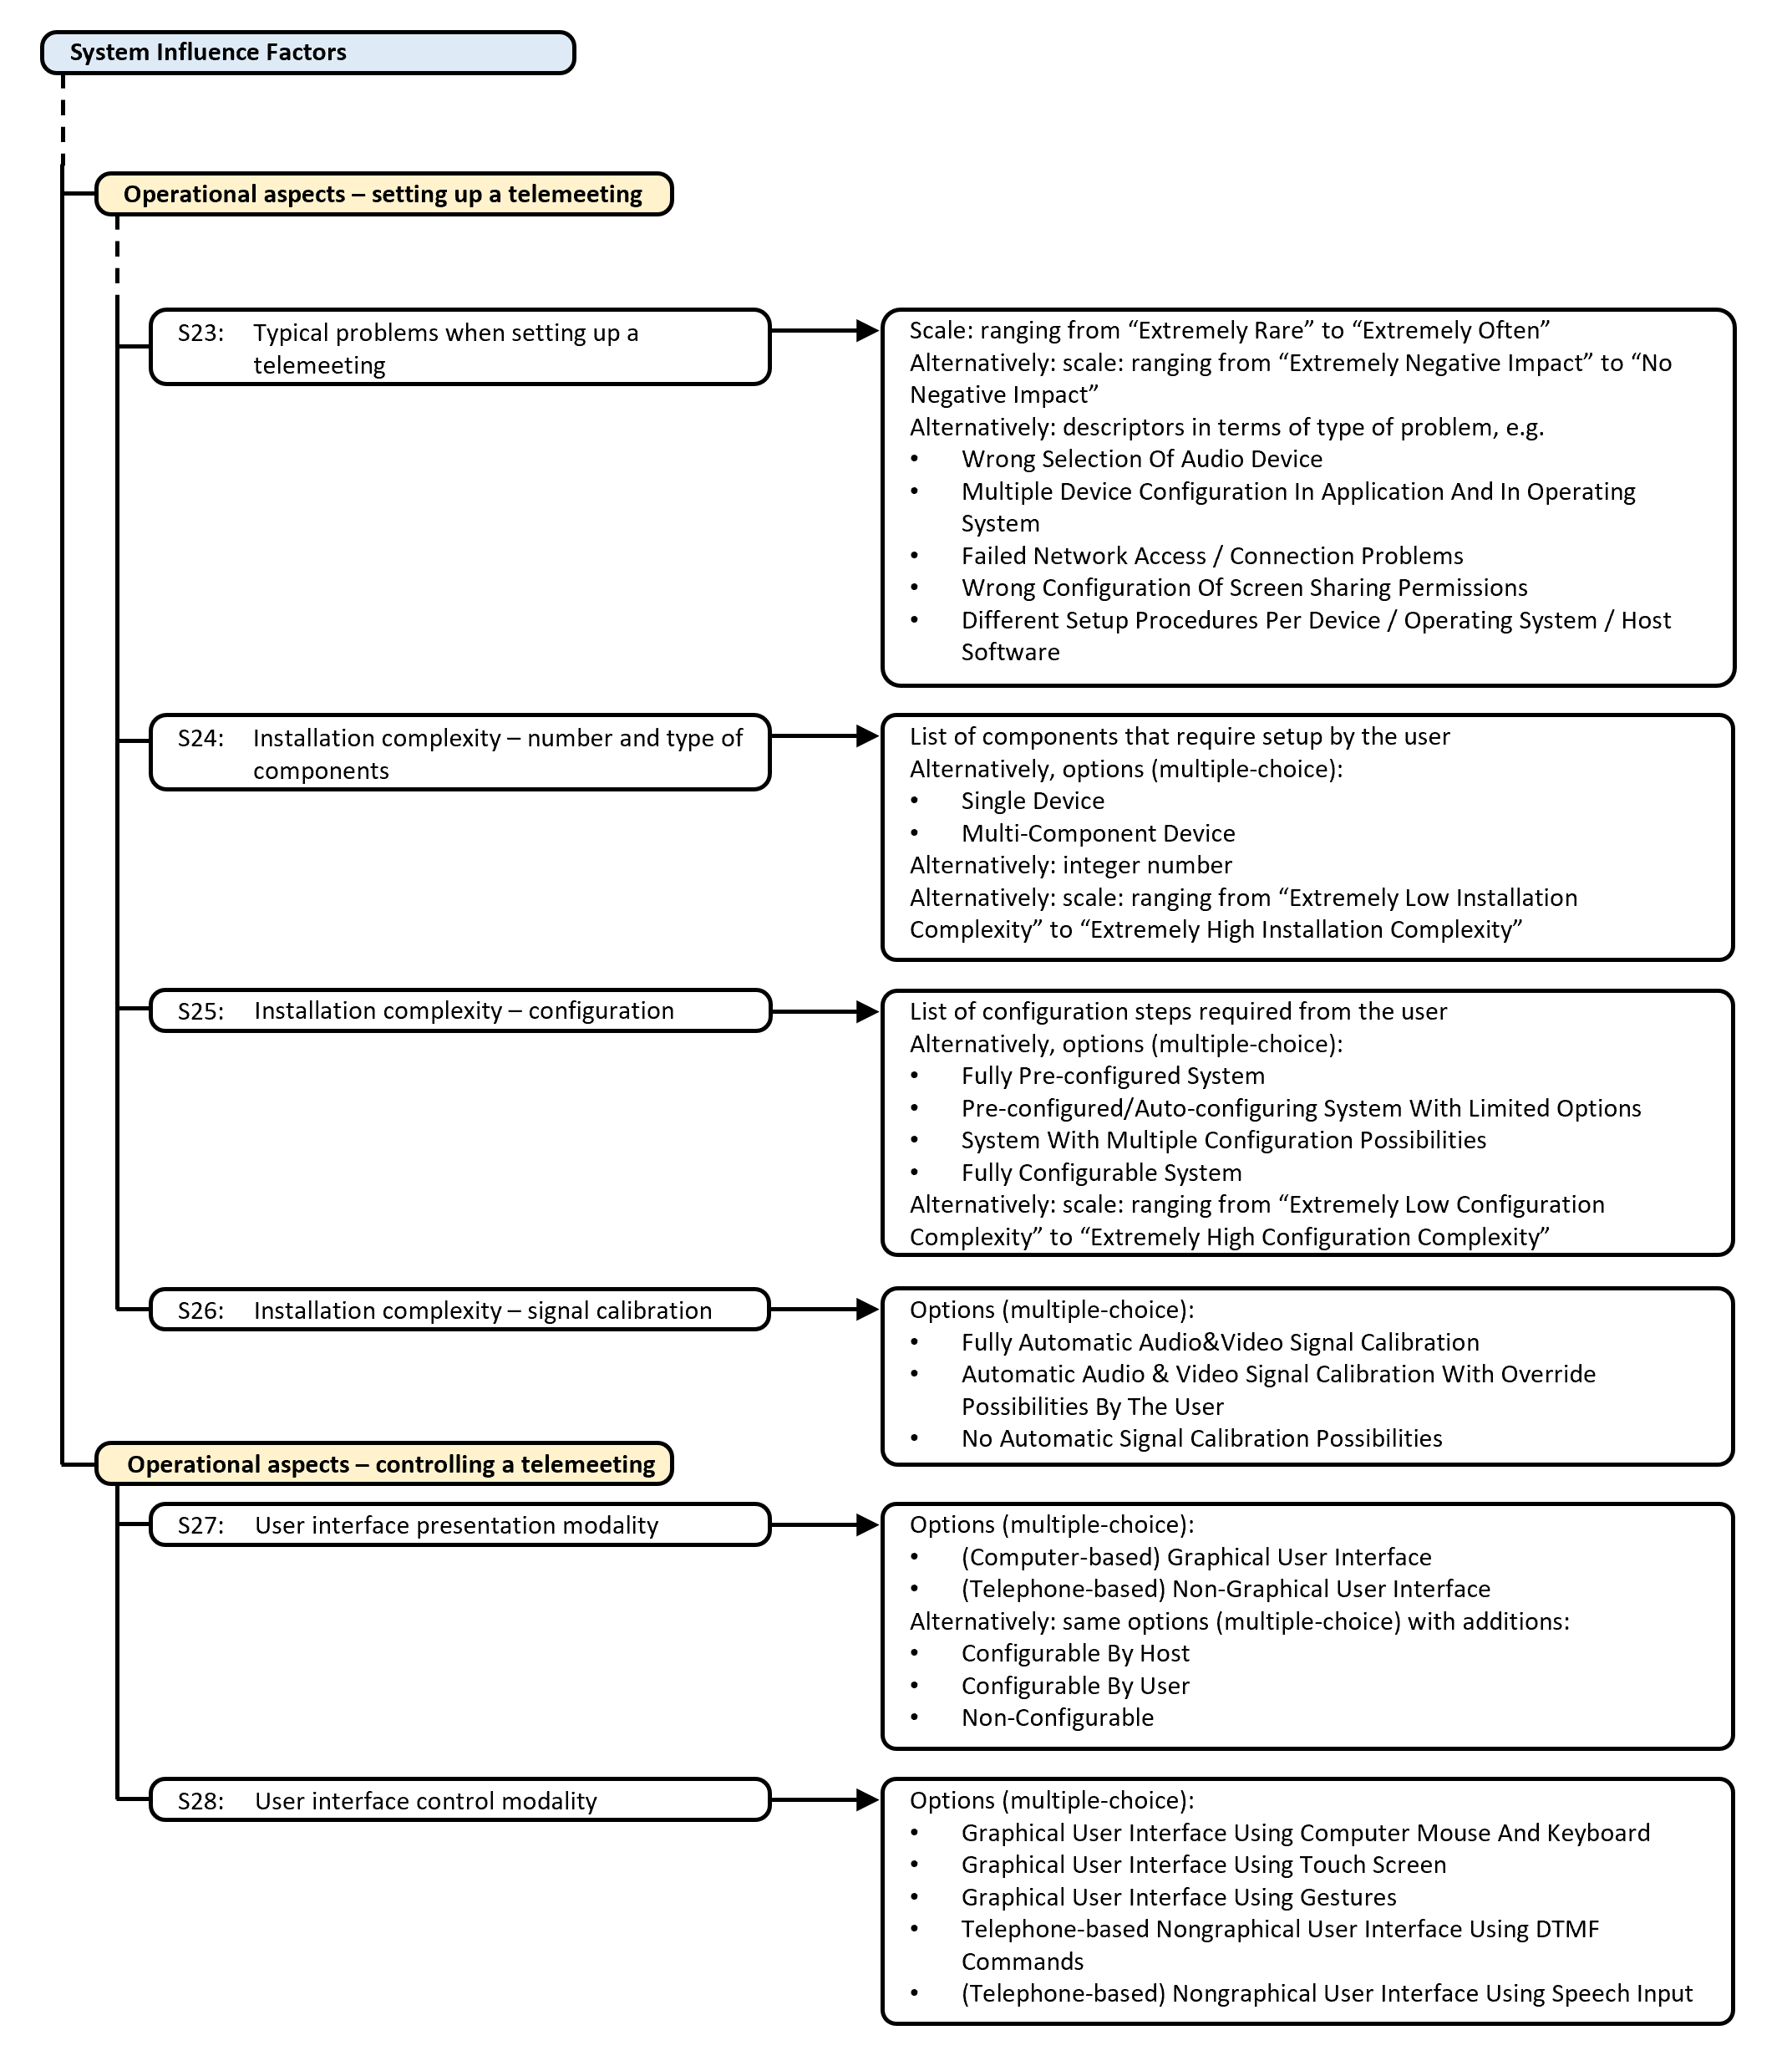
FIGURE II.3. Examples of descriptors for the Telemeeting Profile Template – part 3.

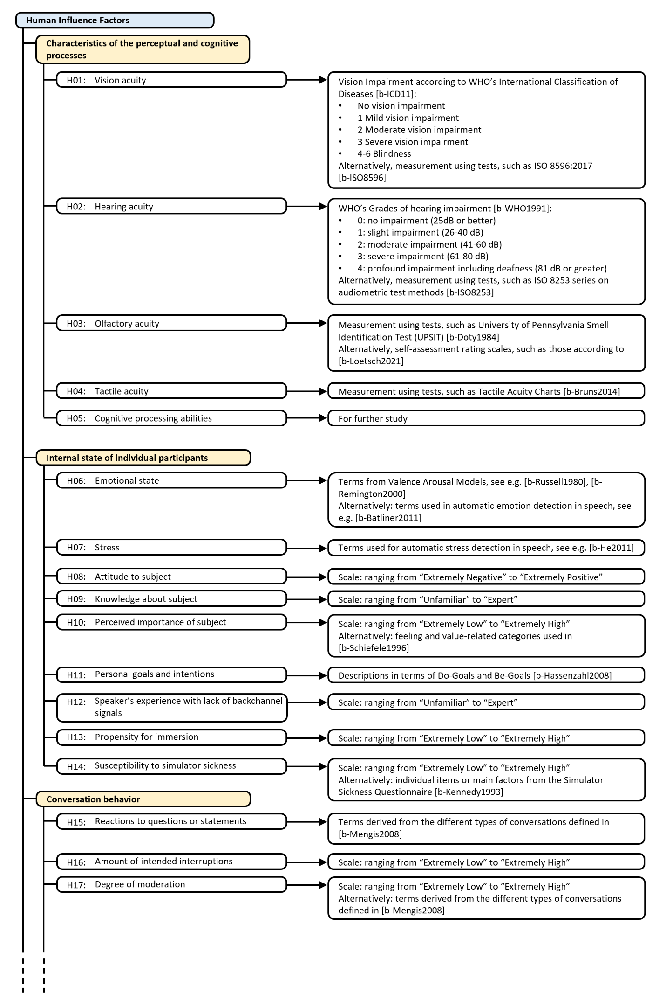
FIGURE II.4. Examples of descriptors for the Telemeeting Profile Template – part 4.
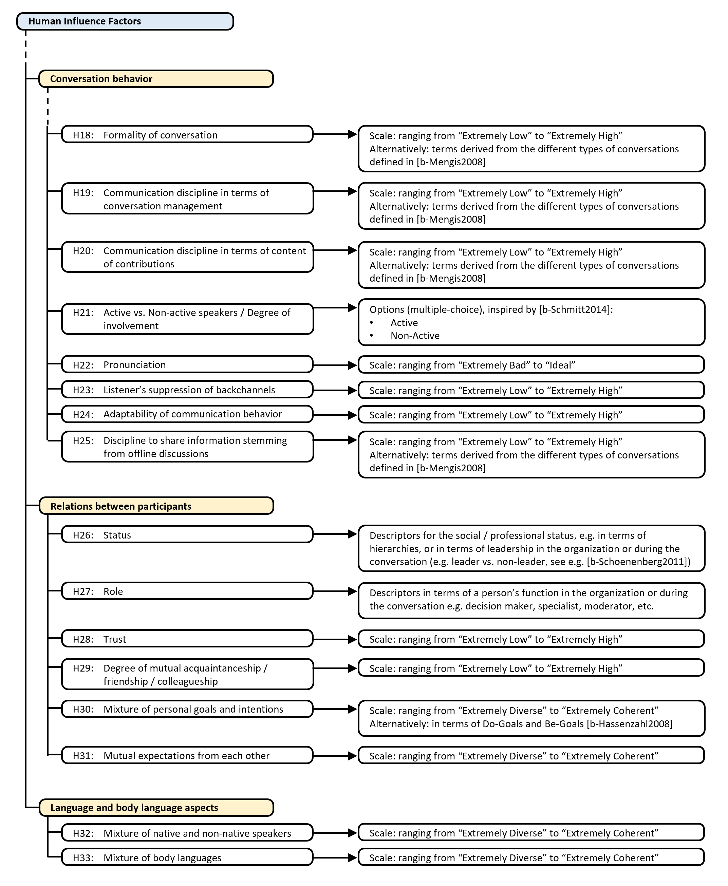
FIGURE II.5. Examples of descriptors for the Telemeeting Profile Template – part 5.

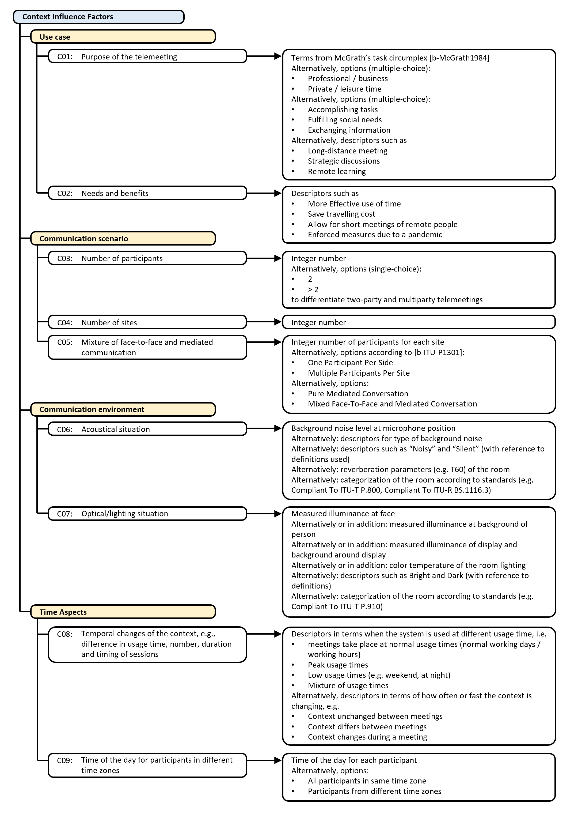
FIGURE II.6. Examples of descriptors for the Telemeeting Profile Template – part 6.

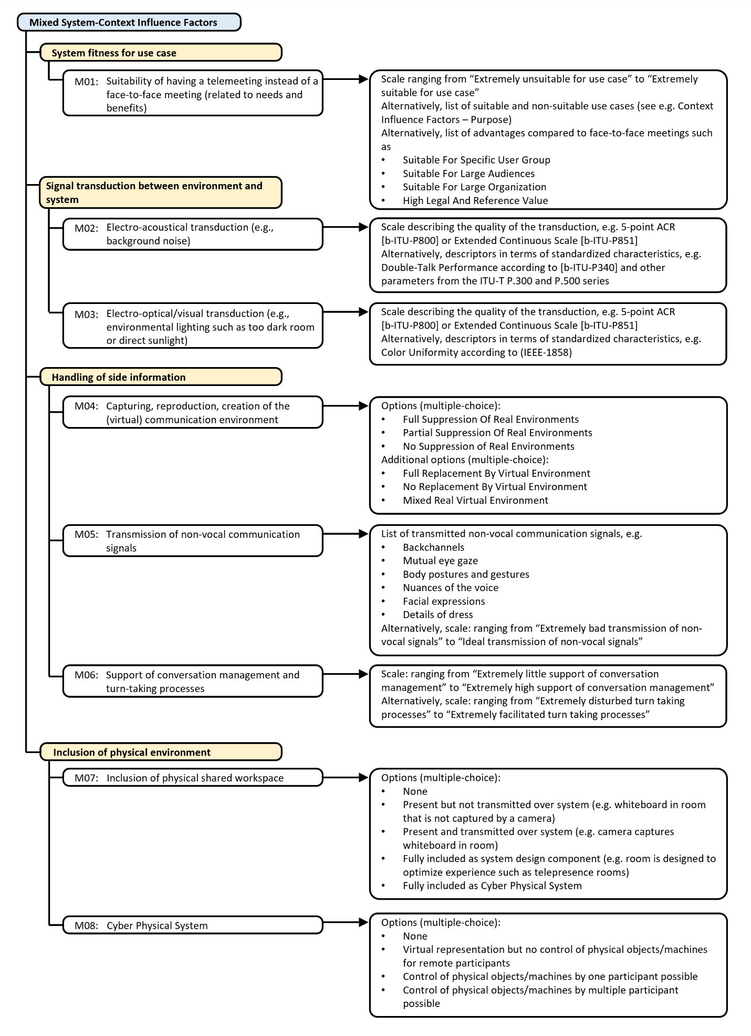
FIGURE II.7. Examples of descriptors for the Telemeeting Profile Template – part 7.

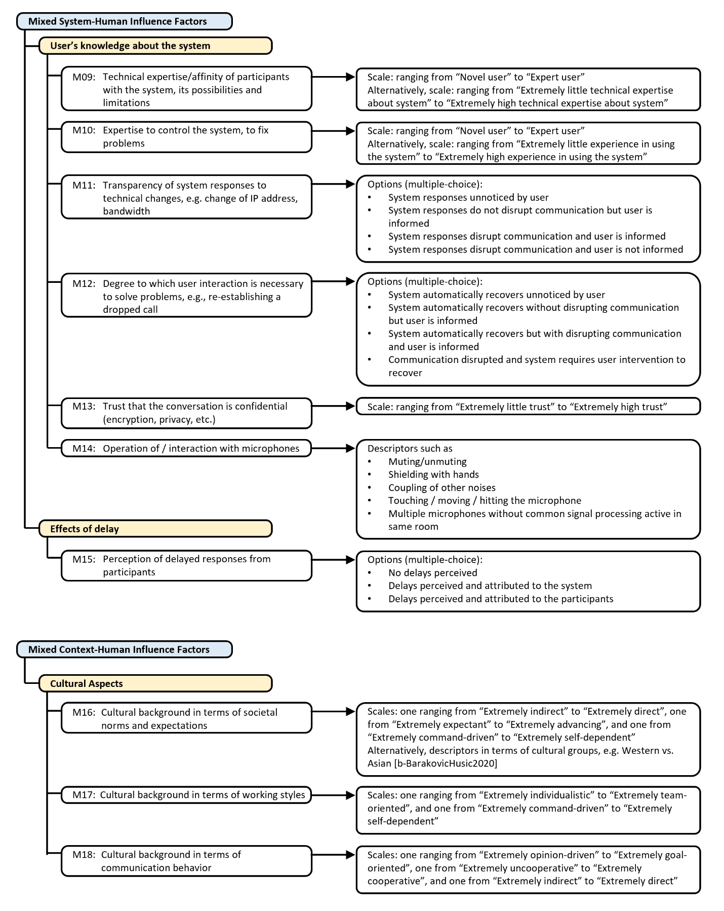
FIGURE II.8. Examples of descriptors for the Telemeeting Profile Template – part 8.

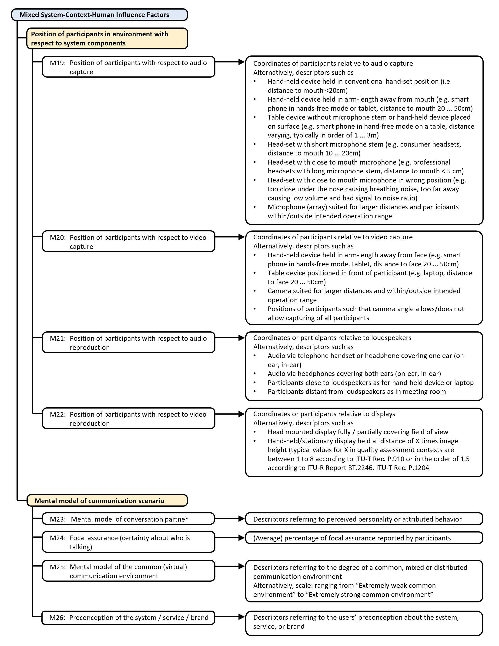
FIGURE II.9. Examples of descriptors for the Telemeeting Profile Template – part 9.

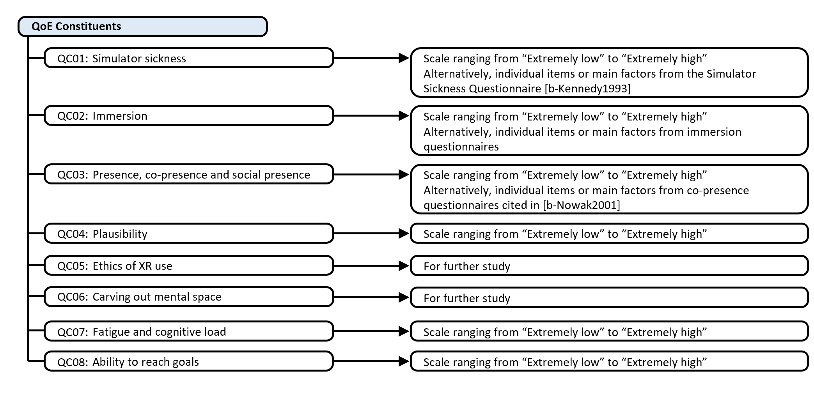
FIGURE II.10. Examples of descriptors for the Telemeeting Profile Template – part 10.

Bibliography

[b-BarakovicHusic] J. B. Husić, S. Baraković, E. Cero, N. Slamnik, M. Oćuz, A. Dedović, and O. Zupčić, ‘‘Quality of experience for unified communications: A survey,’’ Int. J. Netw. Manage., vol. 30, no. 3, p. e2083, May 2020, doi: 10.1002/nem.2083.
[b-Batliner] A. Batliner, B. Schuller, D. Seppi, S. Steidl, L. Devillers, L. Vidrascu, T. Vogt, V. Aharonson, and N. Amir, ‘‘The automatic recognition of emotions in speech,’’ in Emotion-Oriented Systems: The Humaine Handbook, R. Cowie, C. Pelachaud, and P. Petta, Eds. Berlin, Germany: Springer, 2011, pp. 71–99, doi: 10.1007/978-3-642-15184-2_6.
[b-Berndtsson] G. Berndtsson, J. Skowronek, Immersive sound for social interactions in extended reality (XR) - insights and current challenges, paper in the Proceedings of the 24th International Congress on Acoustics, ICA 2022, Korea.
[b-Bruns] Bruns P, Camargo CJ, Campanella H, Esteve J, Dinse HR, Röder B (2014). Tactile acuity charts: a reliable measure of spatial acuity. PLoS One. 2014 Feb 4;9(2): e87384. doi: 10.1371/journal.pone.0087384. PMID: 24504346; PMCID: PMC3913609.
[b-Doty] Richard L. Doty, Paul Shaman, Michael Dann (1984). Development of the university of Pennsylvania smell identification test: A standardized microencapsulated test of olfactory function. Physiology & Behavior, Volume 32, Issue 3, Pages 489-502. doi: https://doi.org/10.1016/0031-9384(84)90269-5.
[b-Hassenzahl] M. Hassenzahl, ‘‘User experience (UX): Towards an experiential perspective on product quality,’’ in Proc. 20th Int. Conf. Assoc. Francophone d’Interaction Homme-Mach. (IHM), 2008, pp. 11–15.
[b-He] L. He, M. Lech, N. C. Maddage, and N. B. Allen, ‘‘Study of empirical mode decomposition and spectral analysis for stress and emotion classification in natural speech,’’ Biomed. Signal Process. Control, vol. 6, no. 2, pp. 139–146, Apr. 2011, doi: 10.1016/j.bspc.2010.11.001.
[b-ICD11] World Health Organization (2023). International Classification of Diseases 11th Revision. [Online]. Available: https://icd.who.int/en
[b-IEEE-1858] IEEE Standard for Camera Phone Image Quality, IEEE Standard 1858-2016 (Incorporating IEEE Std 1858-2016/Cor 1-2017, IEEE Standards Association Board of Governors, 2017, pp. 1–146, doi: 10.1109/IEEESTD.2017.7921676.

[b-ISO8253] International Standardization Organization (2010). ISO 8253 Acoustics — Audiometric test methods.
[b-ISO8596] International Standardization Organization (2017). ISO 8596:2017 Ophthalmic optics — Visual acuity testing — Standard and clinical optotypes and their presentation.
[b-ITU-R BS.1116.3] Recommendation ITU-R BS.1116-3 (02/2015), Methods for the subjective assessment of small impairments in audio systems
[b-ITU-R BT.2246] International Standardization Report ITU-R Rep. BT.2246-7 (2020), The Present State of Ultra-High Defnition Television, International Telecommunication Union, Geneva, Switzerland.
[b-ITU-T G.114] Recommendation ITU-T G.114 (05/2003), One-way transmission time.
[b-ITU-T P.340] Recommendation ITU-T P.340 (05/2000), Transmission characteristics and speech quality parameters of hands-free terminals
[b-ITU-T P.800] Recommendation ITU-T P.800 (08/1996), Methods for subjective determination of transmission quality
[b-ITU-T P.851] Recommendation ITU-T P.851 (11/2003), Subjective quality evaluation of telephone services based on spoken dialogue systems
[b-ITU-T P.910] Recommendation ITU-T P.910 (04/2008), Subjective video quality assessment methods for multimedia applications
[b-ITU-T P.1204] Recommendation ITU-T P.1204 (01/2020), Video quality assessment of streaming services over reliable transport for resolutions up to 4K
[b-Kennedy] Kennedy, R.S., Lane, N.E., Berbaum, K.S., and Lilienthal, M.G. (1993), Simulator sickness questionnaire: An enhanced method for quantifying simulator sickness, The International Journal of Aviation Psychology, Vol. 3, No. 3, pp. 203–220. https://doi.org/10.1207/s15327108ijap0303_3
[b-Loetsch] Lötsch J, Hintschich CA, Petridis P, Pade J, Hummel T (2021). Self-ratings of olfactory function and their relation to olfactory test scores. A data science-based analysis in patients with nasal polyposis. Applied Sciences, Volume 11, Number 16, art. 7279. Pages 1-16. Doi: 10.3390/app11167279
[b-McGrath] McGrath, J.E. (1984), Groups: Interaction and performance. Englewood Cliffs, NJ, Prentice-Hall.
[b-Mengis] Mengis, J. and Eppler, M.J., (2008), Understanding and managing conversations from a knowledge perspective: An analysis of the roles and rules of face-to-face conversations in organizations, Organization Studies Vol. 29, No. 10, pp. 1287–1313. doi: 10.1177/0170840607086553
[b-Nowak] K. Nowak, ‘‘Defining and differentiating copresence, social presence and presence as transportation,’’ in Proc. Presence Conf., Philadelphia, PA, USA, 2001, pp. 1–23.
[b-Olusanya] Olusanya BO, Davis AC, Hoffman HJ (2019). Hearing loss grades and the International classification of functioning, disability and health. Bull World Health Organ. 2019 Oct 1;97(10):725-728. doi: 10.2471/BLT.19.230367. Epub 2019 Sep 3. PMID: 31656340; PMCID: PMC6796665.
[b-Qualinet] Qualinet White Paper on Definitions of Quality of Experience (2012). European Network on Quality of Experience in Multimedia Systems and
Services (COST Action IC 1003), Patrick Le Callet, Sebastian Möller and Andrew Perkis, eds., Lausanne, Switzerland, Version 1.2, March 2013.
[b-Reiter] Reiter, U., Brunnström, K., de Moor, K., et al. (2014), Factors Influencing Quality of Experience, Quality of Experience - Advanced Concepts, Applications, Methods. Eds S. Möller and A. Raake, New York, Springer, pp. 55–72.
[b-Remington] N. A. Remington, L. R. Fabrigar, and P. S. Visser, ‘‘Reexamining the circumplex model of affect,’’ J. Personality Social Psychol., vol. 79, no. 2, p. 286, 2000.
[b-Russell] J. A. Russell, ‘‘A circumplex model of affect,’’ J. Personality Social Psychol., vol. 39, no. 6, pp. 1161–1178, Dec. 1980.
[b-Schiefele] U. Schiefele, ‘‘Topic interest, text representation, and quality of experience,’’ Contemp. Educ. Psychol., vol. 21, no. 1, pp. 3–18, Jan. 1996, doi: 10.1006/ceps.1996.0002.
[b-Schoenenberg] K. Schoenenberg, A. Raake, and J. Skowronek, ‘‘A conversation analytic approach to the prediction of leadership in two to six-party audio conferences,’’ in Proc. 3rd Int. Workshop Quality Multimedia Exper., Sep. 2011, pp. 119–124.
[b-Skowronek2022a] J. Skowronek, A. Raake, G. Berndtsson, O. Rummukainen, P. Usai, S. N. Gunkel, M. Johanson, E. A. Habets, L. Malfait, D. Lindero and A. Toet, "Quality of Experience in Telemeetings and Videoconferencing: A Comprehensive Survey," in IEEE Access, doi: 10.1109/ACCESS.2022.3176369
[b-Skowronek2022b] J. Skowronek, A. Raake, G. Berndtsson, O. Rummukainen, P. Usai, S. N. Gunkel, M. Johanson, E. A. Habets, L. Malfait, D. Lindero and A. Toet. (2022). Telemeeting Profile Template [Data set]. Zenodo. https://doi.org/10.5281/zenodo.6553448
[b-Skowronek2022c] J. Skowronek, A. Raake, G. Berndtsson, O. Rummukainen, P. Usai, S. N. Gunkel, M. Johanson, E. A. Habets, L. Malfait, D. Lindero and A. Toet. (2021). Telemeeting Profile Template – Development Version. Hochschule für Technik - University of Applied Sciences, Stuttgart. Accessed: May 16, 2022. [Online]. Available: https://docs.google.com/spreadsheets/d/1uvr2ZRqEuW_xWBOi8UI8cUtRxb0qMJJChnHn5dDvYGU
[b-WHO1991] World Health Organization (2023). Report of the Informal Working Group on Prevention of Deafness and Hearing Impairment Programme Planning, Geneva, 18-21 June 1991. Available: https://apps.who.int/iris/handle/10665/58839
_______________________

