INTERNATIONAL TELECOMMUNICATION UNION |  | STUDY GROUP 9
TELECOMMUNICATION  STANDARDIZATION SECTOR  STUDY PERIOD 2013-2016 |  | TD 420 (GEN/9)
English only
Original: English
Question(s): | 2/9 | Geneva, 8-12 September 2014
TD
Source: | Editors P.3D-disp-req
Title: | Output - Draft New Recommendation P.3D-disp-req “Display requirements for 3D video quality assessment”
-------------
Editor Note: This document represents edits recommended by the Video Quality Experts Group (VQEG).
----------------
<Recommendation No.>
Draft New Recommendation P.3D-disp-req: Display Requirements for 3D Video Quality Assessment
Summary
This recommendation specifies the requirements for the selection of 3D displays when conducting subjective quality assessment experiments.

Keywords
<Optional>
Introduction

Compared to 2D video, several new issues have arisen in 3D video applications. Compared to 2D video, 3D display technologies still face some challenges. It is therefore important to take into account the potential sub-optimal rendering of the 3D display when assessing the 3D viewing experience. It is also important to characterize and report properly the 3D display characteristics in the context of subjective testing as this information helps in interpreting correctly subjective results. In particular, 3DTVs exhibit crosstalk to various degrees and can impact negatively the viewing experience.Crosstalk is a major factor in video quality, visual discomfort and visual fatigue problems.

1 Scope
This recommendation provides guidelines for the selection of 3D displays for consistent and repeatable subjective video quality assessment in the context of entertainment content at consumer quality. This recommendation also provides guidelines for appropriate room environmental constraints that ensure visibility of the stereoscopic effect.

1.1 Applications
The applications for the 3D display requirements described in this Recommendation include, but are not limited to:
- Minimum requirements for 3D display in the context of subjective quality assessment of 3D video;
- Consistent and repeatable quality assessment of 3D video sequences.
The applicable services for this Recommendation include:
- Cable TV
- Streaming video
- IPTV
- Mobile video applications
- Interactive video applications
This Recommendation is intended for use with stereoscopic 3D displays, such as:
- Linearly and circularly polarized glasses for view separation
- Active shutter glasses
- Stereoscopic and multiview lenticular array autostereoscopic displays
- Stereoscopic and multiview parallax barrier displays
- Multiple spectral bandpass filters, a type of enhanced color separation filters

1.2 Limitations
This Recommendation only applies to video quality assessment of coding and transmission error scenarios where the 3D video sequences are moderately to strongly degraded. More stringent display requirements may be needed to accurately assess quality in the presence of nearly lossless quality impairments (e.g., where the quality is nearly the same as the original 3D video).
This Recommendation contains insufficient information for the following applications. While most of the information provided herein applies, additional constraints are required.
Medical applications
- Immersive, virtual reality environments (e.g., gaming, caves, head mounted displays)
- Augmented reality
This Recommendation contains insufficient information on overall illumination and display brightness levels for:
- Mobile devices (e.g., laptops, tablets, phones)
The following display technologies are inappropriate for subjective testing, and as such fall outside the scope of this document:
- Anaglyphic color separation filters
This Recommendation is not intended for use with holographic displays, light field displays, volumetric displays., and stereoscopes (e.g., mobile smartphone 3D)

2 References

Normative References

Informative References
[ITU-T P.910] ITU-T Recommendation P.910 (2008), Subjective video quality assessment methods or multimedia applications.

[ITU-T P.911] ITU-T Recommendation P.911 (1998), Subjective audiovisual quality assessment methods for multimedia applications.

[IDMS1] International Committee for Display Metrology (ICDM) (2012), Information Display Measurement Standard

3 Definitions
This recommendation uses the following terms defined elsewhere.

3.1 Terms defined elsewhere:

None.

3.2 Terms defined in this Recommendation
This Recommendation defines the following terms:
3.2.1 Crosstalk: Crosstalk is the amount of light perceived by the non-intended eye due to incomplete inter-view isolation.
3.2.1 Overall illumination: The overall illumination is the light coming from all light sources in the room, notably including both the light coming from the display and from the ambient room illumination. This is measured in lux.
3.2.2 View: The video produced by a single camera sensor (i.e., 2D video).

4 Abbreviations and acronyms
None.

5 Conventions
None.

6 3D Display Requirements

6.1 Display Brightness and Overall Illumination
Display brightness (luminance) is measured as seen through the appropriate 3D glasses (if any). When doing the measurements, the system shall be used in 3DTV mode. This means for example in the case of an active shutter glasses TV, these glasses must be turned on and the measurement system must be synchronized with the shutter cycle. Refer to [IDMS1] for details on how to measure brightness for different types of displays.

6.2 Introduction to Crosstalk
Crosstalk is the amount of light perceived by the non-intended eye due to incomplete inter-view isolation.

In the context of subjective quality assessment of 3D video, a suitable 3D display must be selected such that the display does not affect the reliability and reproducibility of subjective results. However, crosstalk is a major contributor to quality loss and visual discomfort on stereoscopic displays. It can therefore greatly impact the quality of experience in the viewing of stereoscopic 3D content and the results of subjective quality assessment.
To achieve consistent results of 3D video quality assessment, it is important to understand the maximum amount of allowable display crosstalk. Subjective testing requires measurement or characterization means to adequately select display equipment to conduct such subjective testing in a reliable and repeatable manner.
Several works in the literature and works presented to the Video Quality Experts Group have shown that objective physical measurements of 3D displays to characterize their crosstalk is not straightforward and repeatability of results is still an issue to solve. There are many parameters (e.g., distance, angle, characteristics of the measurement instruments) that make physical measurements difficult and many aspects (e.g., non-uniformity, spatial/temporal variation, anti-crosstalk mechanisms) that make crosstalk difficult to represent as a single value.

6.3 Crosstalk measurements
[IDMS1] provides means of measuring crosstalk with respect to different display technologies.

6.3.1 Grey-to-grey crosstalk
Crosstalk is not necessarily only due to leakage of unintended white image/level onto intended black image/level but also to other grey-to-grey configurations (other grey-to-grey configurations may produce as perceivable/visible crosstalk)
The selection of a 3D display for subjective quality assessment of 3D content should not be based only on the measure of crosstalk using the leakage of light signal from the open to the blocked channel, using a white image as the open channel signal and a black image as blocked channel signal but should also consider the following aspects:
1. The spatial variation of the crosstalk
2. The angular variation of the crosstalk (crosstalk off the center axis)
3. Chromatic aspects

6.3.2 Angular influence
Two angular influences must be taken into account:
- A spatial measurement can record crosstalk variation depending on the eye gaze direction (e.g. position in the image). This gives already an angular indication of how the angular dependence of the Liquid Crystal Shutter and the display angular emission are combined. In the case of LCD displays, light polarization and its interaction with the glasses polarization analyzers create specific effects altering image and crosstalk homogeneity.
- Another angular variation depends on the observer’s position in front of the screen. The same effects of direction dependent light emission and of interaction between screen emission and glasses analysis will happen.
Because of the two points mentioned above, crosstalk measured at a specific angle can be dramatically more significant than a basic central measure on the screen normal axis. A single measurement at the centre of the screen is therefore not sufficient.

6.3 Crosstalk thresholds
Based on [b-Wang], [b-Seuntiens] and [b-Skala], a maximum of approximately 2% crosstalk is recommended. Higher values of crosstalk become visible and influence perception. At this point, the crosstalk can change the results of a subjective experiment.
Based on [b-Chen], [b-Hanazato] and [b-Kooi], at 5% to 6% crosstalk becomes sufficient to cause visual discomfort or impact visual quality. At this point, the crosstalk may render the experiment invalid.
The various crosstalk measurements techniques differ. Therefore, this threshold can only be an indication. Alternative thresholds may be more appropriate for some techniques recommended in [IDMS1], due to differences between measurement techniques.

7 3D Display Environment

7.1 Impact of Overall Illumination on Visual Comfort Zone
The overall illumination includes both the illumination coming from the display and from the ambient room illumination. See clause 6.1 for information on how to measure illumination. The overall illumination is measured at the position of the eye and pointed toward the display. It is reported that an overall illumination of at least 30 cd/m² is desirable [b-Patterson]. This allows the pupil to reach a diameter of 2 to 3 mm, which corresponds to sufficiently large depth of field (X diopters). Lower overall illumination will reduce the depth of field and thus the visual comfort zone. See [J.3D-fatigue] for consequences on visual comfort.

7.2 Distance between display and wall
Care should be taken regarding the interaction between the real world environment and the virtually displayed 3D scene. In particular, objects displayed with uncrossed disparity (behind the screen) may interfere with real objects behind the display, such as illumination installations and walls. This may have an impact on ability of observers to feel immersed in the 3D effect.

7.3 Ambient lighting
Undesirable interactions between lights and the display system must be avoided. Examples include:
- Ambient lights should be placed to minimize reflections on the screen as seen by the position of the viewer.
- Frequency interactions between the display and lighting must be avoided. The ambient lighting should either produce a constant illumination or have a high frequency (e.g., high frequency electronic ballasts for fluorescent tubes).
- Ambient lighting behind the 3D display should not shine directly at the viewer.

Appendix I
Perceptual 3D Video Comparison of Various 3D Display Monitors
(This appendix does not form an integral part of this Recommendation)

Using various 3D display monitors, subjective tests were performed to understand the relationship of subjective scores of the 3D display monitors. The Nantes-Madrid 3D Stereoscopic Sequences Part 1-Database Coding and Spatial Degradations 1 (NAMA3DS1-COSPAD1) was used for the experiments. It contains ten source sequences (SRC) with eleven hypothetical reference conditions (HRC). The H.264/AVC encoder with 3 QPs (32, 38, 44) and JPEG2000 still image coder with 4 bitrates (2, 8, 16, 32 Mbps) were used to generate coding impairments. Rescaling (↓4 downsampling) and image sharpening through edge enhancement processes were also included. Table A1 shows a description of the 3D displays used in the experiments. Table A2 shows the correlations between the subjective scores obtained by the 3D displays. As can be seen in the tables, all the 3D displays showed high correlations with the other 3D displays.

Table A1. Specifications of 3D displays.
Index | Diagonal (Inch) | Resolution | 3D Monitor Type
1 | 46 | 1920x1080 | Polarized Glass
2 | 47 | 1920x1080 | Shutter Glass
3 | 27 | 1920x1080 | Film-type Patterned Retarder
4 | 23 | 1920x1080 | Film-type Patterned Retarder
5 | 17.3 | 1920x1080 | Shutter Glass
6 | 15.6 | 1920x1080 | Auto-Stereoscopic

Table A2. Correlation table between each pair of the 3D displays.
Index | 1 | 2 | 3 | 4 | 5 | 6
1 | 1 | 0.961 | 0.981 | 0.977 | 0.971 | 0.960
2 | 0.961 | 1 | 0.968 | 0.952 | 0.940 | 0.941
3 | 0.981 | 0.968 | 1 | 0.981 | 0.963 | 0.956
4 | 0.977 | 0.952 | 0.981 | 1 | 0.960 | 0.952
5 | 0.971 | 0.940 | 0.963 | 0.960 | 1 | 0.965
6 | 0.960 | 0.941 | 0.956 | 0.952 | 0.965 | 1
Appendix II
Perceptual 3D Video Quality of TB and SBS formats with Different 3D Displays
(This appendix does not form an integral part of this Recommendation)

Presently, most 3D programs are encoded using the top-bottom (TB) and side-by-side (SBS) video formats. The perceptual 3D video quality of two 3D display monitors (polarized glass and shutter glass) is compared when 3D video sequences are encoded in the SBS and TB formats.

Table A2.1 provides a description of the two 3D display monitors. Ten source video sequences (SRC) were chosen with consideration of spatial and temporal information. The 3D video sequences were encoded using H.264 at 6 bitrates (2, 3, 4.5, 5.5, 7.5, and 15 Mbps). Subjective testing was performed for each display using 24 non-expert viewers after vision tests.

Table A2.1: Specifications of 3D display monitors.
Display | Type | 3D Type | Diagonal  Size | Resolution
1 | Laptop | SG (Active) | 17.3” | 1920x1080
2 | TV | FPR(Passive) | 55” | 1920x1080

Figures A2.1 and A2.2 show scatter plots of the MOS values for the TB and SBS formats. The correlation coefficients between the two display monitors were 0.951 (TB format) and 0.957 (SBS format). The experimental results show that the perceptual video quality of the two 3D display monitors correlated highly.

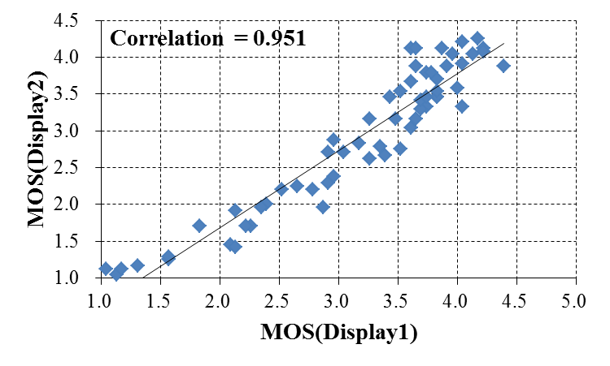
Figure A2.1. Scatter Plot (TB format).

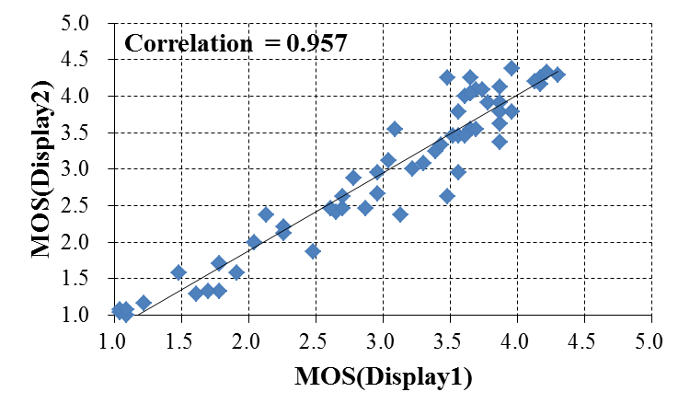
Figure A2.2. Scatter Plot (SBS format).

Appendix III
Open Questions
(This appendix does not form an integral part of this Recommendation)

Because of the problems mentioned in Clause 6.2, a proposed alternative approach to characterize the impact of the display crosstalk on perceived 3D visual experience is the use of subjective testing where participants are asked to perform a disparity discrimination task, with the idea that the accuracy of the subjects’ responses will be negatively impacted by the display crosstalk. Further experiments are necessary to examine the merits of such approach, how it compares to physical measurements, and how such task recognition accuracy may be considered as a potential criterion for 3D display selection.
Threshold values for the crosstalk methods described in [IDMS1] should be researched.
Research is needed into the interaction between the real world environment and the virtually displayed scene, particularly with regards to the distance between the display and the wall behind the monitor.

______ Bibliography
[b-Chen] L. Chen, Y. Tu, W. Liu, Q. Li, K. Teunissen, and I. Heynderickx. 73.4: “Investigation of Crosstalk in a 2-View 3D Display,” SID Symposium Digest of Technical Papers, volume 39, pages 1138–1141. Wiley Online Library, 2008.
[b-Hanazato] A. Hanazato, M. Okui, and I. Yuyama. “Subjective evaluation of cross talk disturbance in stereoscopic displays,” SDI 20th Int. Display Res. Conf, pages 288–291, 2000.
[b-Kooi] F.L. Kooi and A. Toet. “Visual comfort of binocular and 3D displays,” Displays, 25(2-3):99–108, 2004.
[b-Patterson] R. Patterson, "Human factors of 3-D displays," Journal of the Society for Information Display, vol. 15, p. 10, 2007.
[b-Skala] Skala V., “Cross-talk measurement for 3d displays”, 3DTV 2009 IEEE proceedings, ISBN 978-1-4244-4318-5, pp.1-4, (2009)
[b-Seuntiens] Seuntiens, P. J. H., Meesters, L. M. J., & IJsselsteijn, W. A. (2005). “Perceptual attributes of crosstalk in 3D images,” Displays, 26(4-5), 177–183.
[b-Wang] Wang, K., Hussain, M., Andrén, B., Brunnström, K., and Osterman, J., "Perception and annoyance of crosstalk in stereoscopic 3D projector systems", Proc Stereoscopic Displays and Applications XXV, Vol: 9011, A. J. Woods, N. S. Holliman, and G. E. Favalora Eds., paper 74 (2014)

________

